New Member Orientation
Rio Grande Rotary Club of Las Cruces #1310 of Rotary District 5520
Member Name _______________________
Rotary International is a worldwide service organization consisting of some 46,000 clubs and 1.4 million members in over 200 countries. Rotary club members provide humanitarian services, encourage high ethical standards in all vocations, and help build goodwill and peace.
About Our Club
The Rio Grande Rotary Club of Las Cruces (#1310) is an active group of men and women who meet at 11:50 a.m. every Tuesday year-round at the Andele Restaurant Banquet Room in Las Cruces, New Mexico.
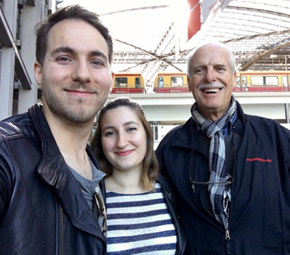
Chartered in 1975, our club has grown to 60+ members who participate enthusiastically in club business.
We look forward each week to invited speakers who talk about Rotary and many local, state, national and international topics.
We encourage members to take active roles in club leadership and in-service projects that benefit our community and the world.
We also sponsor social activities and offer opportunities for members to volunteer their services. We are committed to Rotary's 4-Way Test and the Object of Rotary.
To learn more about our club, visit our website: https://portal.clubrunner.ca/8183/ or our Facebook page: https://www.facebook.com/Las-Cruces-Rio-Grande-Rotary-93320022573/

Service Above Self
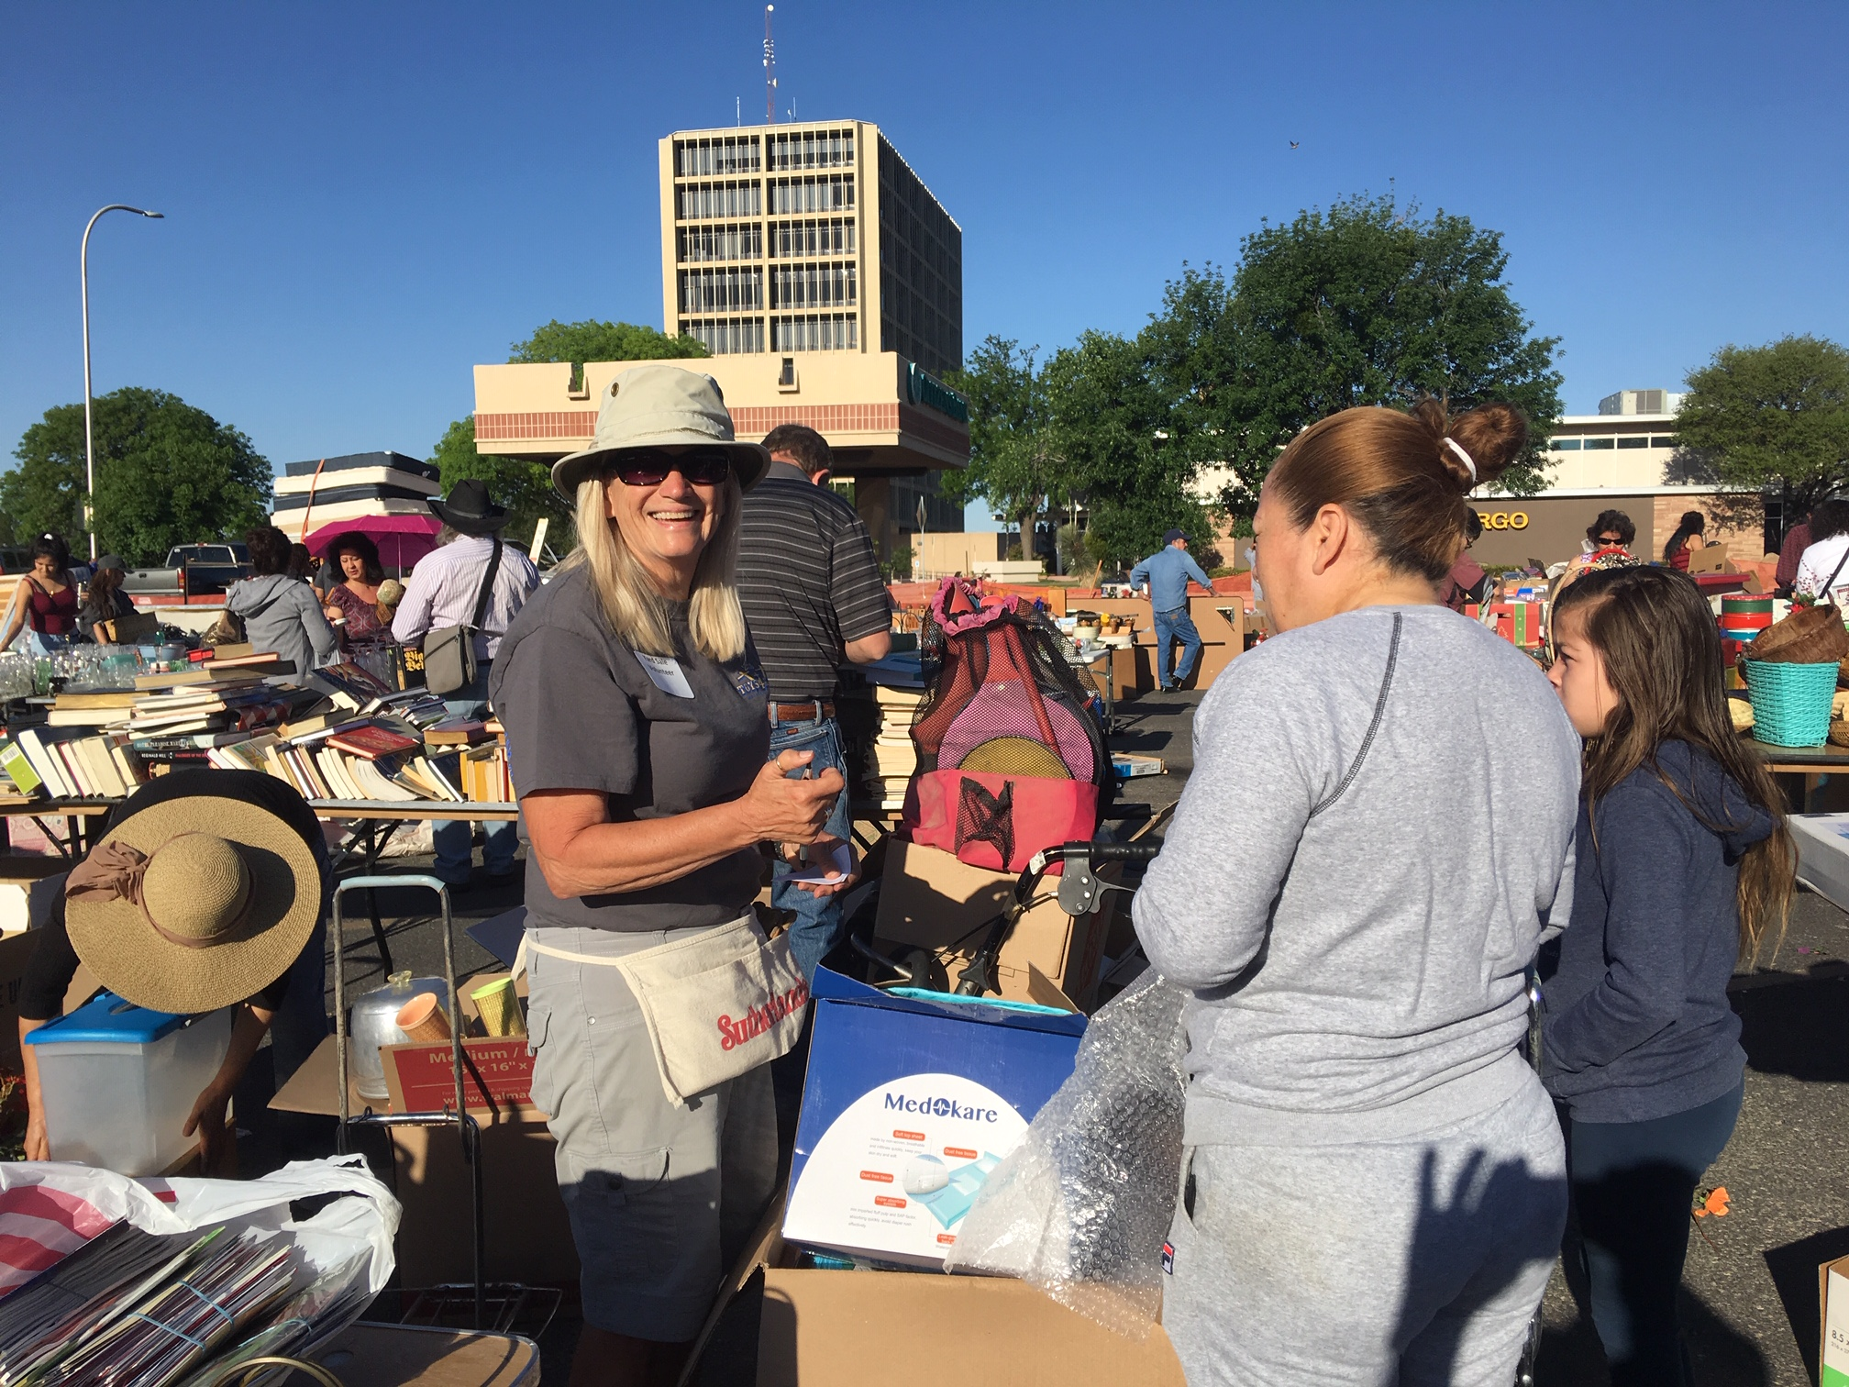
Our club conducts and participates in several community support and fundraising activities each year for a variety of service projects. Examples of the causes we support include:
- We sponsor a huge yard sale benefiting Mesilla Valley Hospice and have done this for more almost 20 years. Over this time, we’ve raised more than $200,000 to support this important healthcare organization.
- We support the Dress-The-Child Program every November and hold an annual Silent Auction to raise funds for it.
- We support literacy through our Annual Dictionary Day Program, in which we provide free dictionaries to 2,000+ third graders in 20+ schools in the Las Cruces Public School District. Dictionaries are purchased through club funds and delivered to the classrooms by club members and other invited volunteers.
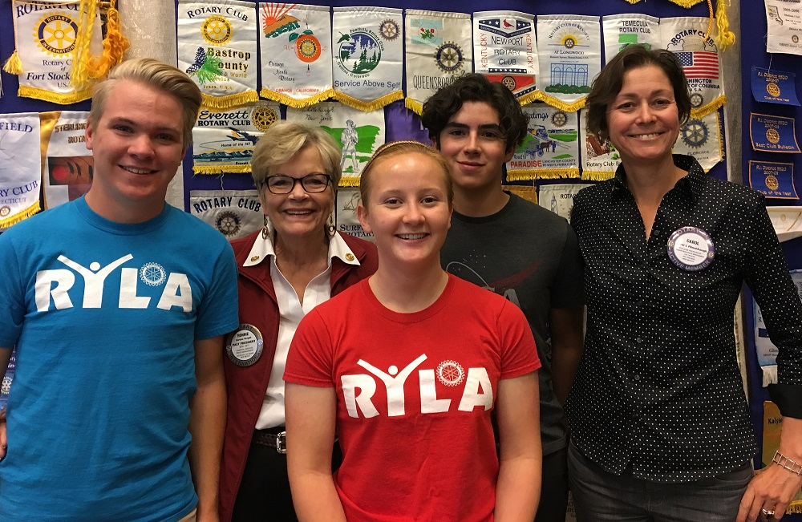
- We sponsor a Student Rotarian of the Month program from September to April, through which outstanding juniors from local high schools attend weekly meetings as guests, enabling us to meet the leaders of tomorrow. Students are asked to participate in writing an essay on what they have learned about Rotary and how Rotary may help them in their future life. Cash awards of up to $1,500 are awarded the best essays.
- We sponsor other events such as our Annual Rotary Golf Charity to support various local causes.
- We support the annual Taste of Las Cruces with other local Rotary Clubs to benefit the Casa de Peregrinos Emergency Food Program.
- We participate in our District 5520’s Student Youth Exchange Program to raise funds & host students.
- We support the District Rotary Youth Leadership Award (RYLA) program which sends local incoming seniors to leadership camp near Mountainair, NM each summer. Learn more about RYLA on our website or by clicking here.
- We have an ongoing international matching grant projects with several Rotary clubs in District 4110 in Northern Mexico.
- We substantially support The Rotary Foundation each and every year.
DUES AND FINANCIAL OBLIGATIONS (Dues are paid in advance)
Club Dues (Weekly w/Lunch): |  | Club Dues (Weekly – No Lunch):
Quarterly Dues (RI, District) | 70.50 | Quarterly Dues (RI, District) | $70.50
Every Rotarian Every Year | 25.00 | Every Rotarian Every Year | 25.00
Weekly Banquet Room + Meals 13 x $16/quarter | 208.00 | Weekly Banquet Room 13 x $7/quarter | 91.00
Dress the Child Meal/quarter | 14.00 | Dress the Child Meal/quarter | 14.00
Total Dues Invoiced Per Quarter | $317.50 | Total Dues Invoiced Per Quarter | $200.50
Initial Fees and Dues |  | Initial Fees and Dues
New Member Registration Fee (One-time)* | $150.00 | New Member Registration Fee (One-time)* | $150.00
First Quarter Total Including Initial Dues | $467.50 | First Quarter Total Including Initial Dues | $350.50

*$150 new member registration fee does not apply to transfers and returning members.

