WE INVITE YOU TO JOIN US FOR OUR SIGNATURE EVENT
ANNUAL Ottawa ROTARY GOLF-A-THON
Last year Golfers, Family, Friends & the community raised close to $60,000 for the Rotary Home
All event proceeds will support Respite Care programs at The Ottawa Rotary Home and the work of the Rotary Clubs in Ottawa.
The Ottawa Rotary Home Foundation Golf-A-Thon is one of the premier golf tournaments in the Ottawa area boasting All Day Golf, Three Excellent Meals, Raffle Table & Auction.

SPONSORSHIP OF THIS EVENT OFFERS THE OPPORTUNITY TO:
- Develop or continue an association with an important cause and respected organization;
- Host key clients in a fun and relaxed setting;
- Showcase your product/brand to a desirable target audience;

This Summary outlines various levels of sponsorship and related benefits. It can be further customized to meet your specific marketing needs.

We offer four key ways for you to get involved: Sponsorship, Gifts-in-kind, Corporate tickets, and Donations.
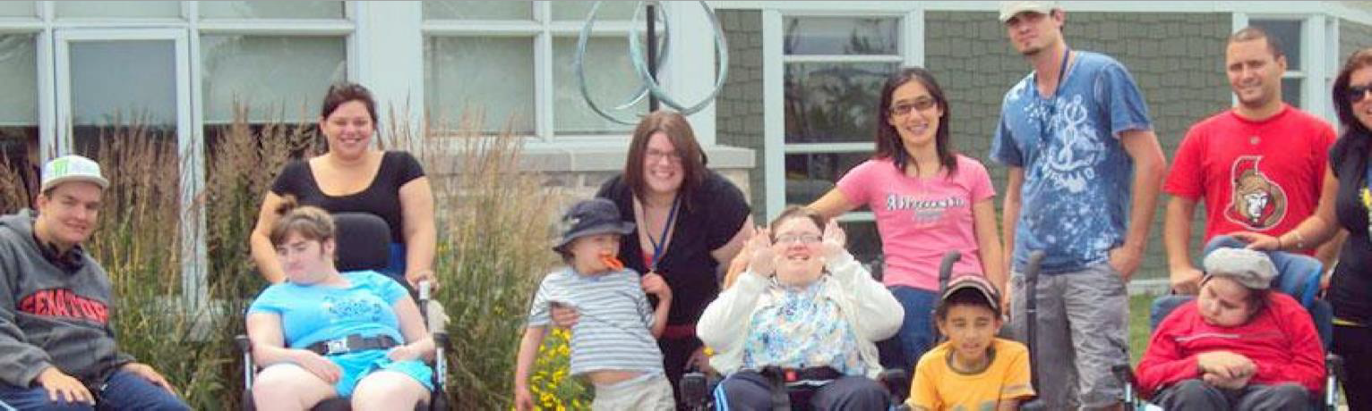
Sponsorship Opportunities - Rotary Home Foundation Golf-A-Thon

2019 Ottawa Rotary Golf a Thon Sponsorship Opportunities

Auction & Raffle Item Needed
Donations are also welcome for the Golf a thon Auction & Raffle Table and we be pleased to offer you prominent recognition for all of your incredible support. For more information please contact Cindy Wheeler at 613-822-5391 or by email at foundation@rotaryhome.on.ca.

- Premier $5,440
- Registration Table $3,264
- Box Lunch $2,720 Sponsored by, Welch LLP
- Golf Cart $2,720 Sponsored by, KPMG
- 19th Hole $1,500 Sponsored by, Quality Life Services
- Photography $1,904 Sponsored by, Stikeman Elliott LLP
- Breakfast $1,088 Sponsored by, International Ortho. Cons. Inc.
- Putting Green $1,088
- Beer Tasting $1,088
- Refreshment Cart $1,088
- Golf Ball Sponsor $1,088
- Hole in One $ 544
- Longest Drive $ 544 Sponsored by, Coherent Advice Inc.
- Closest to the Pin $ 544 Sponsored by, Clayton Law Professionals
- Straightest Drive $ 544
- Hole Sponsors $ 400 Multiple Sponsors

2019 Ottawa Rotary Golf a Thon SPONSORSHIP
- PREMIER SPONSOR - $5,440  20 DAYS OF CARE AT THE ROTARY HOME  - REGISTRATION SPONSOR - $3,264  12 DAYS OF CARE AT THE ROTARY HOME  - BOX LUNCH SPONSOR - $2,720  10 DAYS OF CARE AT THE ROTARY HOME  - GOLF CART SPONSOR - $2,720  10 DAYS OF CARE AT THE ROTARY HOME  - PHOTOGRAPHY SPONSOR - $1,904  7 DAYS OF CARE AT THE ROTARY HOME  - “19TH HOLE” SPONSOR - $1,904  7 DAYS OF CARE AT THE ROTARY HOME  - BEER TASTING SPONSOR - $1,088  4 DAYS OF CARE AT THE ROTARY HOME  - BREAKFAST SPONSOR - $1,088  4 DAYS OF CARE AT THE ROTARY HOME | - PUTTING GREEN SPONSOR - $1,088  4 DAYS OF CARE AT THE ROTARY HOME  - REFRESHMENT SPONSOR - $1,088  4 DAYS OF CARE AT THE ROTARY HOME  - GOLF BALL SPONSOR - $1,088  4 DAYS OF CARE AT THE ROTARY HOME  - HOLE IN ONE SPONSOR - $544  4 DAYS OF CARE AT THE ROTARY HOME  - LONGEST DRIVE SPONSOR - $544  2 DAYS OF CARE AT THE ROTARY HOME  - STRAIGHTEST DRIVE SPONSOR - $544  2 DAYS OF CARE AT THE ROTARY HOME  - CLOSEST TO THE PIN SPONSOR - $544  2 DAYS OF CARE AT THE ROTARY HOME  - HOLE SPONSOR - $400  1 DAY OF CARE AT THE ROTARY HOM

Sponsor Name: Contact Name: Address:
Email: Phone:

Payment Amount: $
- Cheque  MasterCard or Visa (circle)  Amex

Card No: Name (on card):
Expiry Date: _ _ / _ _ CVC_______

Signature:

All information is strictly for the use of this event and will not be used for other purposes.

For more information please contact: Cindy Wheeler at 613.822.5391 or foundation@rotaryhome.on.ca

PLEASE RETURN THIS FORM TO:
The Ottawa Rotary Home Foundation, 823 Rotary Way, ON K1T 3W6
Phone: 613.822.5391 Fax: 613.822.8778 Email: foundation@rotaryhome.on.ca

