Working in Nepal
Projects by the Rotary Club of Wahroonga
The Rotary Club of Wahroonga has an established program of support for the people of the Arupokhari region of Gorkha in Nepal. The support over the years has included
- Re-establishing drinking water to a number of villages after the earthquake moved watercourses,
- Rebuilding Bhawani hostel in Manbu village
- Presentation of primary and secondary teacher professional development sessions.
- Renovation and building of classrooms at various schools.
The Arupokhari Region is in the Gorkha district in the centre of Nepal to the north-west of Kathmandu, very close to the epicentre of the earthquake on 25 April 2015. Travel to the villages requires a seven to eight-hour journey by four-wheel drive followed by a one-hour walk climbing over 800 metres to the villages. In the hills the 'roads' are rarely used very poor tracks. Day to day transport is walking in steep terrain.

Drinking Water Supply Project
The Rotary Club of Wahroonga which provided $7,500 and the Rotary Club of Chatswood which provided $10,000 successfully applied for District Simplified Grants of $5,000 each, for a total of $27,000 to fund earthquake reconstruction and aid projects in Nepal. The funds were applied to a Drinking Water Supply Project in Dharapani School & Village and Katunje, Ratmate, Khahare, Siraan and Lamagaun Villages Gorkha, Nepal.
Local tradesmen used locally available labour and materials to undertake the construction work. For example, the only local source of sand to mix with cement was to hire local labourers to carry sacks of sand from the Budi Gandaki River up to the construction site. Our Nepalese partner Sambhav Nepal co-ordinated the construction work under the supervision of a professional engineer. SambhavNepal.org

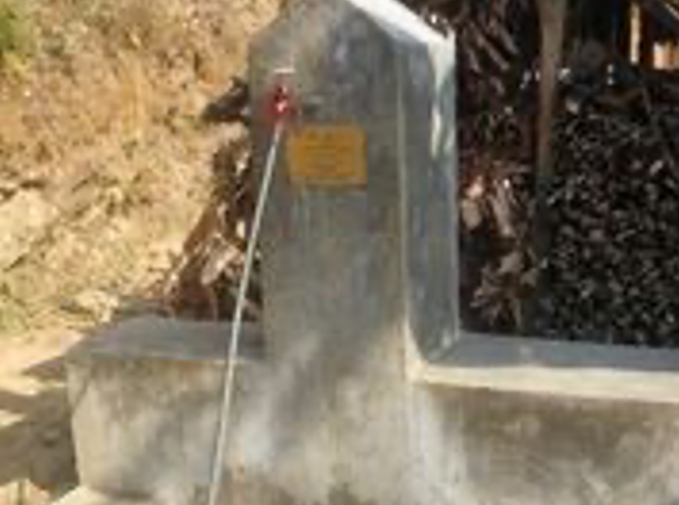

Bhawani Hostel
Bhawani Secondary School in Manbu village takes students from surrounding villages including some who live beyond a sensible day return walk to school. Over 100 students aged between 8 and 20 years board during the week at the hostel. Manbu is towards the upper limit of the habitable zone in the Himalayas and is very cold at night in winter, and especially cold for students trying to sleep during a storm in a room with no heating, no insulation, no ceiling, no glass in the windows and hard stone walls. The hostel was all but demolished in the earthquake but everything takes time. Some of the students are still living in tents.

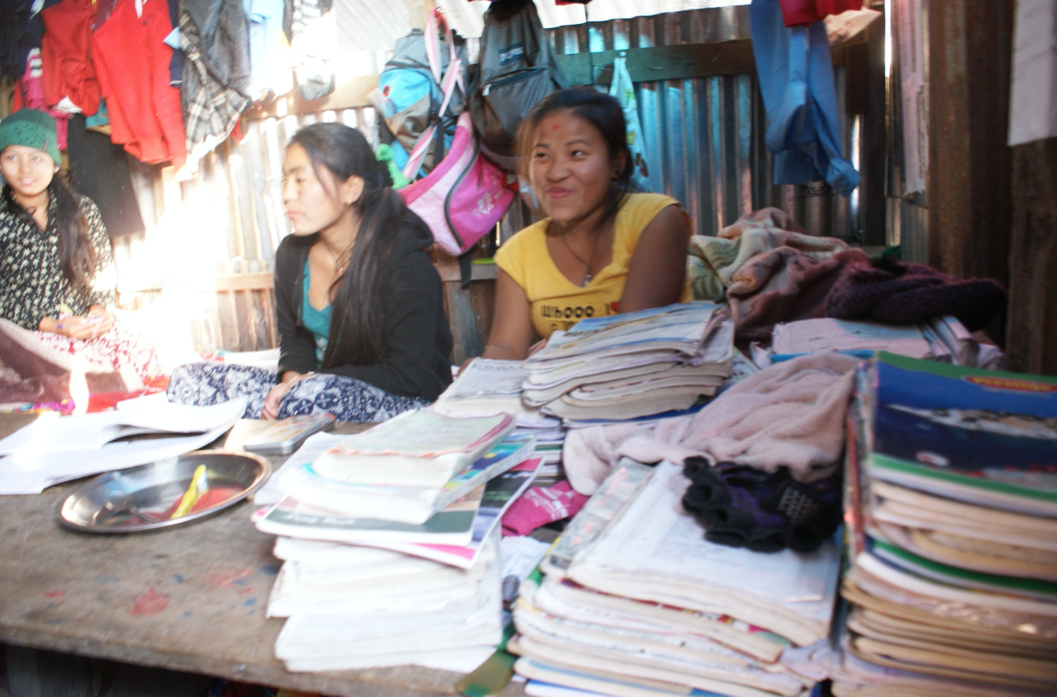

Girls studying in their room in the hostel –
not a tent but a shed made of corrugated iron sheeting

Three 8-room buildings have been completed with nearly 100 students now in a much warmer environment. We are also raising money for building more hostel buildings and furnishings, especially bedding and floor coverings.

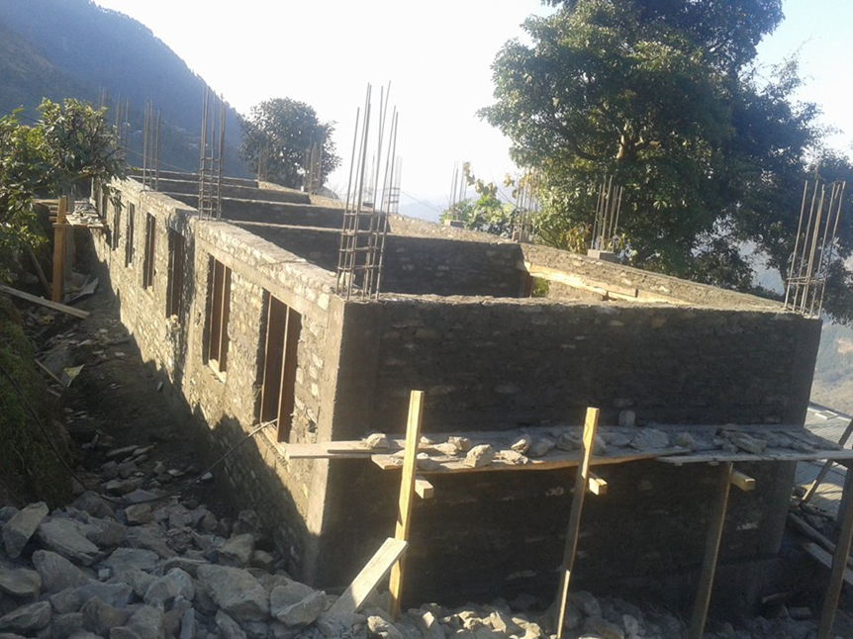
The ground floor of the new hostel being built at Bhawani School.

We often receive donations for the teachers or for the students in the hostel. One group across NSW spends time knitting brightly coloured woollen jumpers, beanies and half gloves. I was asked how many students lived in the hostel. When I picked the donation up, I found it was 70 gloves, beanies and jumpers – and the next year there were enough woollen garments for more than 100 students.

Another donation came from a dentist who gave enough toothpaste and toothbrushes for every student in the hostel

Days for Girls
Days for Girls (DfG) is known around the world for providing washable feminine hygiene products so girls are able to easily deal with their periods thus allowing them to attend school on a regular basis. When girls miss school one week in each month, they end up leaving school – it is just too hard to keep catching up. It is well known that if girls get an education, families and communities benefit. {In Bhutan, I saw a government sign that said “If you educate a boy, you educate a man, if you educate a girl, you educate a community"}
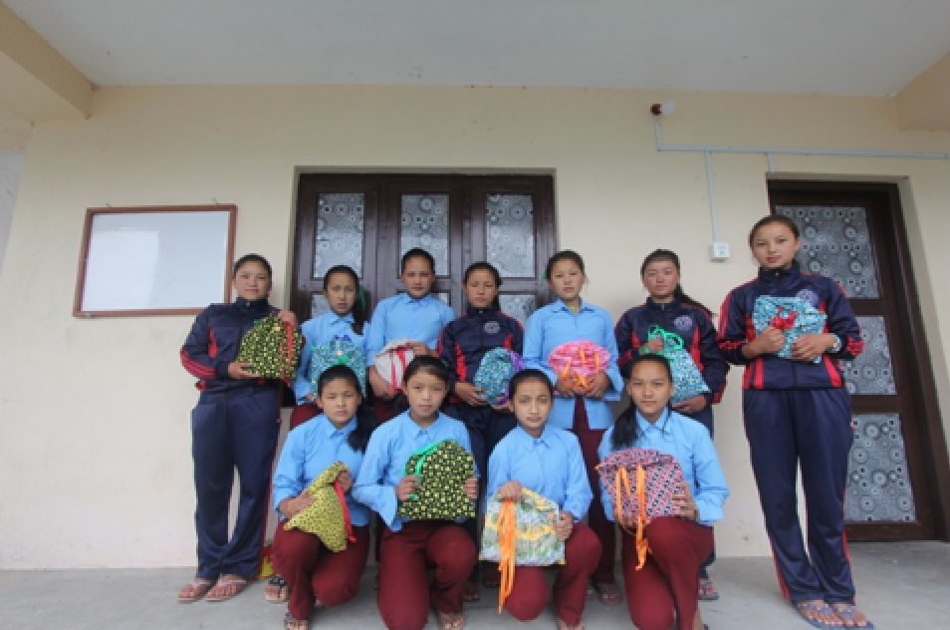
Girls from hostel with Days for Girls kits
Teacher Training
Teacher training has grown to become a key focus for our work in Nepal. Each January since 2011, a group of teachers has worked in one or two schools to give professional development classes to the primary and secondary teachers. Each January a group of 2 - 14 people, including teachers, travel to Bhairabi and Manbu. Primary teachers do not receive any teacher education – they simply move from the classroom to being the teacher. This used to occur when the student/teacher finished Year 8 but has recently been raised to Year 12.
We conduct two sessions each day covering classroom management (to reduce the amount of shouting and hitting in class), ways to teach particular topics like measurement, fractions and decimals learning activities outside the classroom, making resources for English, Science and Mathematics. Many teachers walk more than 2 hours each way so they can attend.

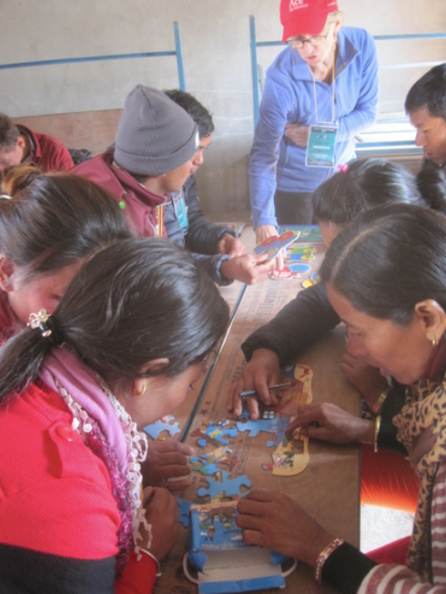 | 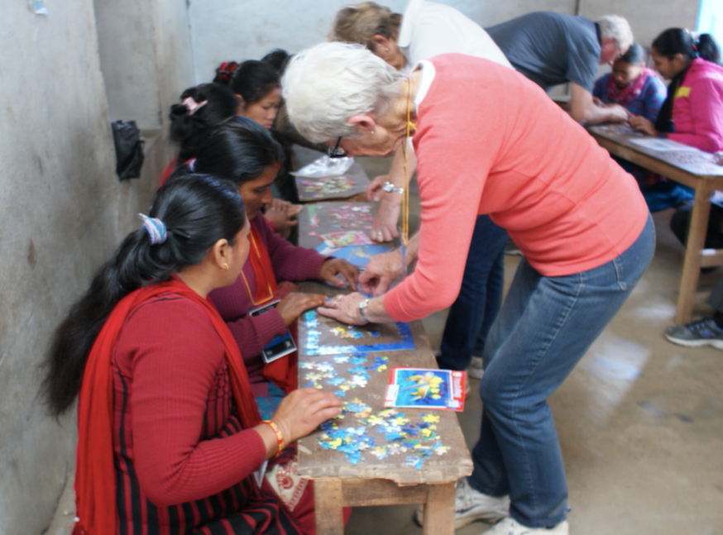
Doing jigsaws for the first time!

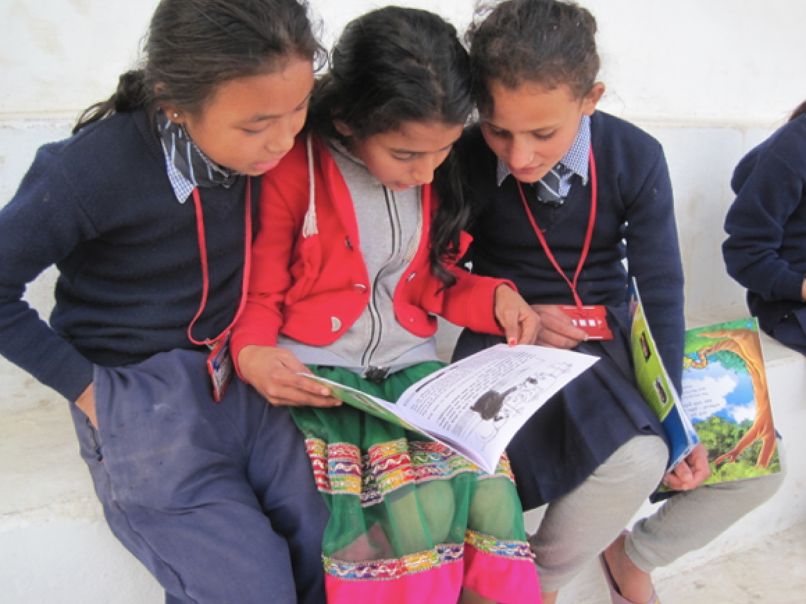
Reading in Nepali and English – the books are bilingual

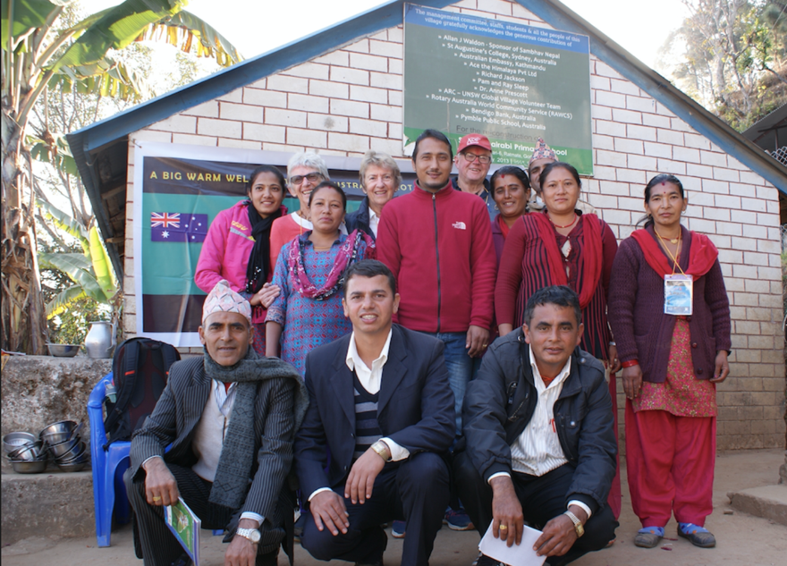
The volunteer group from Rotary Club of Wahroonga
with teachers from Bhairabi School.
Rebuilding schools.
Even though all the schools in the region were badly damaged in the earthquakes, the government has only recently decided on the construction techniques to be used in rebuilding them. Classes are still being held in tents, half demolished buildings and even buildings that are so damaged they should be demolished. It is only now that we can use the money raised immediately after the earthquake to complete the refurbishment/rebuild.
Bhairabi school in Ratmate village, Dharapani school, and Bhawani school in Manbu village have new classrooms. Many countries have donated money.
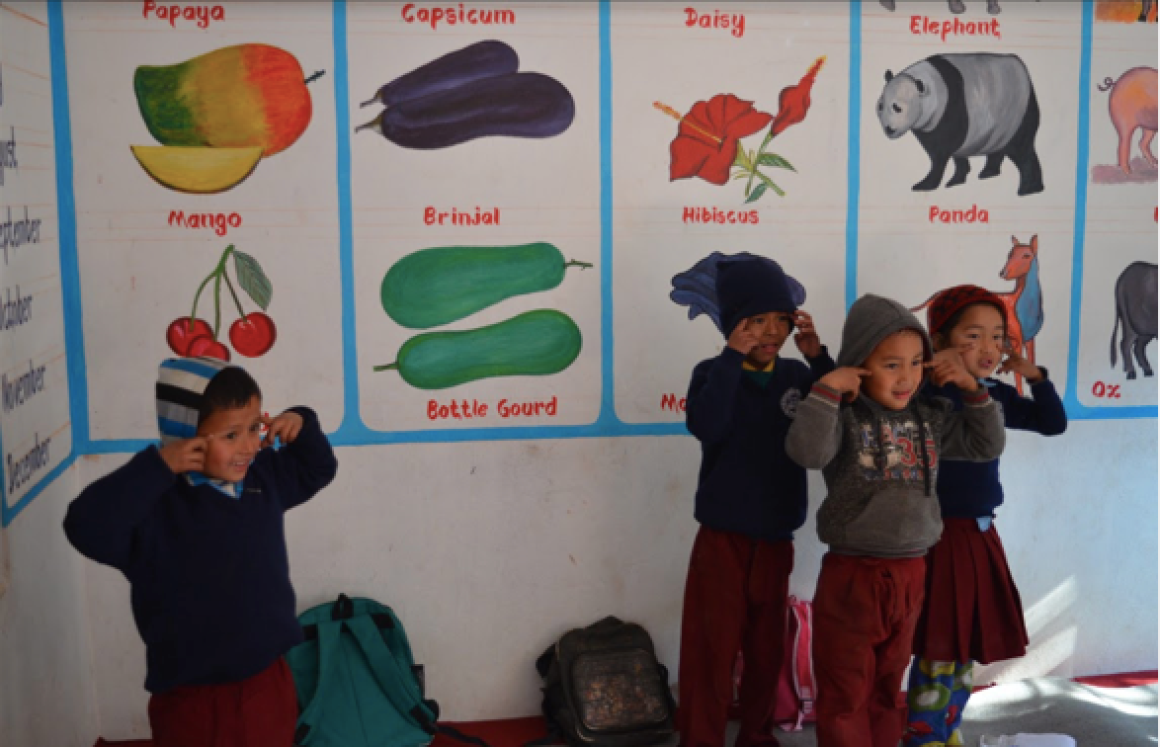
Head, shoulders knees and toes in the new kindergarten classroom in Bhawani school.
On March 18, 2017 the Rotary Club of Wahroonga held a Nepali Cultural Evening in conjunction with the Ku-ring-gai Council's International Women's Day initiative. More than 150 people enjoyed Nepali dancing and the rebuilding of the hostel at Bhawani School. All in all, our projects have made an enormous difference over a number of years. We now have villages with drinking water, three Bhawani hostel buildings are completed, teachers are gaining professional development to help student learning, and schools are being rebuilt – this is a consistent project of the Rotary Club of Wahroonga.

Due Diligence and Sustainability:
A key element of our work in Nepal is that the projects are administered well and that they are sustainable. With Anne Prescott's help, we have developed a personal link with local community leaders who ensure all work is completed and that funds are used appropriately. We have also worked with the Rotary Club of Mt Everest who have also been assisting with coordination. All projects are aimed at sustainability through the teaching of English, Science and Maths to both teachers and students.

