  - Interim Report

Chatelech interact club

January 12, 2018
To whom it may concern:
RE: Interact Club Interim Report

Please find the ChatelechInteract Interim Report below. The report summarizes the club’s progress from September 2017 to January 2018, our goals for the remainder of the year as well as our identified milestones for the year.
Chatelech Interact Club has completed two community projects and one international project so far, this school year. Both our community projects involve fundraising for disaster relief and community enhancements. Our future projects goals include donating to a significant international cause and focusing more time for service to the school.
I trust this report meets your expectations. If you have any questions or concerns, please do not hesitate to contact me.
Yours Sincerely,
Isurika Bandara
President, Chatelech Interact Club

Chatelech interact club

  - A SUCCESSFUL
  - Dance

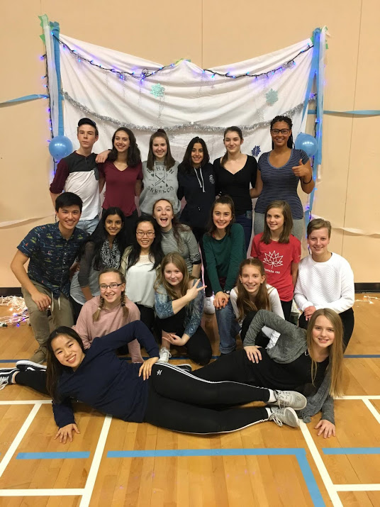
  - Interim Report

Projects and Events:
- We concluded that the Sunshine Coast Food Bank and the Sunshine Coast Habitat for Humanity are our local projects for the year
- Our international project is still in progress
- Started emailing “penpals” in a school in Ndandini, Kenya
September:
- Participated in Clubs Day at Chatelech Secondary and had 29 students sign up to join our club. It was an impressive increase in active members since last year with only 7 members involved.
December:
- 6 of our members attended to the Richmond Interact Conference at Hugh Boyd Secondary School. We had the opportunity to meet with other clubs in District 5040 and work together in groups to solve environmental and human conflicts happening around the world.
Members of the club pose for a quick photo during clean up after the dance!
- We had shifts to help at the kettle campaign at the entrance of Independent and raised over $500 for the Salvation Army
- Held a successful Grade 6/7 Snow Globe Dance in the Chatelech gymnasium
- Participated in a collaborated event with the Elphinstone Interact Club and ran the concession at the SD 46 North vs. South Hockey Game. All proceeds were donated to the Sunshine Coast Food Bank.

Fundraisers:
- Created a dance for majority of the elementary schools in the School District and raised over $650 for our local projects
- We are currently in the process of planning more fundraisers for the next upcoming months

FuturePlans:
- Arrange a date to present cheques to the Sunshine Coast Food Bank and the Sunshine Coast Habitat for Humanity
- Discuss with the club what our international cause will be and create goals for that project
- Planning on doing hot lunch once a month at Chatelech and depending on the success, possibly moving it to bi-weekly
- Holding a spring dance for grades 6/7 and possibly a year end summer dance for grades 5/6/7
- A few of our members will be attending to the Environmental Peace and Sustainability Conference held in Vancouver on February 10th
- Members of our club will also be attending to the District 5040 Peacing Together Conference in Squamish for a couple of days inMay.

