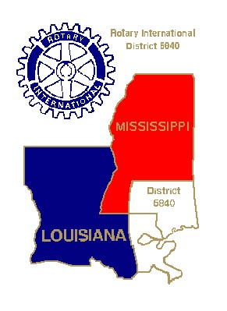

ROTARY DISTRICT 6840
DISTRICT VISION STATEMENT

We see District 6840 as the first resource for the clubs of our district, providing them with the skills to reach their individual goals and the knowledge to run successful clubs. The District will have active communication and personal interaction with club leadership as a key priority, articulating clear goals and objectives.

We see our district as being an effective convener, where clubs can find partner clubs to maximize their services, locally, regionally, nationally, and internationally. The district will also be proactive in seeking out partnerships that will enhance Rotary projects and initiatives.

And we see District 6840 as providing leadership to promote the good works of Rotary in southeastern Louisiana, southern Mississippi, and across the globe. Through this communication the opinion leaders of our region will know of our mission, our vision, our values, and our services so that Rotary will be recognized as we are: a thriving and purposeful group of engaged volunteers whose work is worthy of not only their attention, but their potential involvement and support.

May 23, 2014

