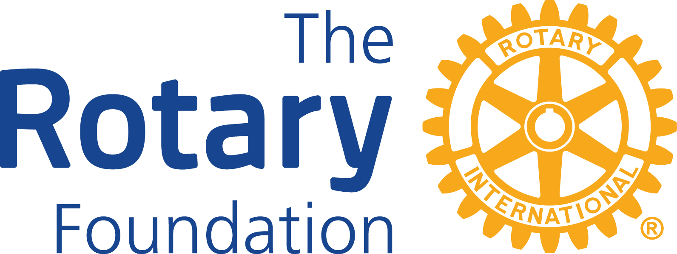

District 7120
District Grant Application Form
Rotary Year 2024-2025

District 7120 Rotary Club _____________________________

Street/PO Box _______________________________________

Town, NY Zip Code___________________________________

Name and Contact information for Person Responsible for Grant (GMS Attendee)

Name __________________________________________

Street/PO Box ___________________________________

Town, NY Zip Code ______________________________

Email address ___________________________________

Phone numbers __________________________________

Rotary District 7120 Clubs must use this form to apply for a Rotary 7120 District Grant (DG) Project and answer all the questions as outlined. Submit grant application to DG Chair Patrick Stack, no later than April 1, 2024 by sending an electronic copy to pkroc@outlook.com AND a by sending a hard copy to him at 79 Northcliffe Dr., Rochester, NY14616. (There are no longer any scholarship district grants.)

For the Rotary 2024-2025 year, District Rotary 7120 clubs are to note the following requirements for District Grants:
- Grants may be used for local projects or small international projects.
- Clubs may apply for one project grant per Rotary year.
- The grant applied for may not exceed $4,000, although the total project budget may exceed $4,000.
- In order to receive any grant, clubs must be qualified. Qualification includes signing a Club Memorandum of Understanding (MOU) and the District 7120 MOU Addendum for the current Rotary year and having a minimum of two (2) members (preferably the president-elect and foundation chair) complete a grant management seminar. (For clubs with fewer than 20 members, their Foundation Area Director/Assistant Governor may serve as the second attendee for qualification.)
- Submit an executed (signed) Club MOU (Memorandum of Understanding) and the District 7120 Addendum to the MOU for the 2024-2025 year with your application.
- Please note that all grant money will be disbursed only upon approval of the written final report which includes receipts for all purchases.
- While these grants do not need to be in an area of focus, they must meet the Mission of Rotary Foundation.*
- All Rotary Clubs applying for DGs are required to make a financial contribution toward the final cost of their projects.

*The Mission of the Rotary Foundation is to enable Rotarians to advance world understanding, goodwill, and peace through the improvement of health, the support of education, and the alleviation of poverty.

A. PROJECT DESCRIPTION (BE CONCISE)

- What is the purpose of the project?

- Provide a brief description of the project.

- How will it meet the needs of the community?

4. How does this project meet the Mission of the Rotary Foundation?

B. COOPERATING ORGANIZATIONS

List the cooperating organization(s), if any:
- Name of organization #1_______________________________________
Name of Contact Person _________________________________________
Telephone # ___________________________________________________
E-mail address _________________________________________________

Name of organization #2 _________________________________________
Name of Contact Person __________________________________________
Telephone # ___________________________________________________
E-mail address _________________________________________________

(Use another sheet, if you have more than 2 cooperating organizations.)

- Attach a letter(s) of support/participation/acceptance from each cooperating organization that specifically states the organization’s responsibilities and how organization(s) will cooperate/work with Rotarians on this project. Also, have cooperating organizations state in their letter of support/participation that they will take ownership of the equipment, maintain it, operate it, and secure the items purchased.

C. PROJECT COMMITTTEE

A committee of at least two Rotarians must be established by the applicant to oversee the project for its duration, even if it continues into another Rotary year.

Primary Contact* Secondary Contact*
Name _________________________ ________________________
Address _________________________ ________________________
E-mail _________________________ ________________________

Telephone _________________________ ________________________

*Primary & Secondary Contacts are responsible for submitting the final Grant Report by May 15, 2025.

- PROJECT BUDGET

Attach an itemized budget with documentation for the entire project.

- PURCHASE OF EQUIPMENT

Who will own equipment, maintain, operate, and secure items purchased with grant funds? Equipment cannot be owned by a Rotary Club or Rotarian.

- PROPOSED FINANCING

Rotary Club Share $

DG Requested $

Cooperating organization(s) $

TOTAL $

In the event your club receives partial funding or a reduce amount of the funds requested, will your club still go forward and complete the project or do a revised version of your project? Yes____ No_____
Note: Checking “NO” will result in no award in the event the full amount of the requested grant cannot be awarded.
- AUTHORIZATION

By signing below, I agree to the following:

- All information contained in this application is true and accurate, to the best of our knowledge;

- The club has agreed to undertake this project as an activity of the club.

Club President Club President-Elect Club GMS Attendee

Name____________________ _________________ _________________

Signature_________________ _________________ _________________

Date_____________________ _________________ _________________

REPORTS

Although both signatories above are ultimately responsible for completing
progress and final reports, one should take the primary responsibility for
submitting the reports to the District Grant Committee.

Final reports will be emailed within 30 days of project completion and not later than Thursday, May 15, 2025 to DG Chair Patrick Stack at pkroc@outlook.com
Failure to submit the closeout documentation by May 15, 2025 could result in the cancellation of your grant.
Club must retain original of report and receipts for 5 years in accordance with the Club MOU/Addendum and any club foundation policies.

By signing below, I take primary reporting responsibility for the above project. (GMS Attendee)

Printed Name _____________________________________

Signature ________________________________________

Date ________________

- The ________________ Rotary Club certifies it has contributed on an average per capita basis $35 or more to the Annual Fund of The Rotary Foundation during the Rotary year 2022-2023. If unsure, please contact your Club Foundation Chair.

DISTRICT APPROVAL

District 7120 Grant Committee has approved the above described
Application for use of District Grant Funds on _____ __, ____ in the amount of $_________.

Attested by:

District Grant Subcommittee Chair

Name: Patrick Stack

Signature _________________________

Date_______________

