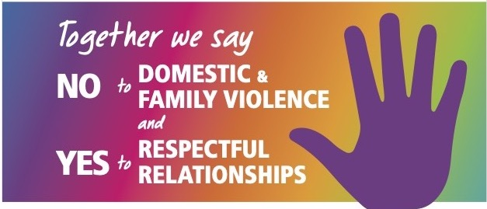

Date

Rotary is partnering with NSW police, community organisations and the public to highlight the issues surrounding domestic and family violence.

The “Say NO to domestic and family violence and YES to respectful relationships” campaign is being conducted by Rotary in Australia, New Zealand and across 14 Pacific Islands.”

“The issues surrounding domestic violence need to be addressed now,” said Rotary District 9685 Governor Christine Owen.

“We know that domestic and family violence is disturbingly common. It is a major cause of homelessness experienced by women, children and men.

“Deaths continue to occur and Rotary believes attitudes can be changed.

“We are partnering with other organisations to continue to highlight this issue and provide information to those experiencing violence and to educate the broader community.”

Each Rotary Club is determining its own project or fundraising activity and Rotarians will be joining in activities during the United Nations1 6 Days of Activism Nov 25th -Dec 10th 2023.

The first day of this campaign is the International Day for the Elimination of Violence Against Women and 10th December is Human Rights Day.

The Rotary Club of (insert your club name/s) is (include details of event – what you are doing, day and date, time, location).

(Any other relevant information).

For more information on this media release contact: name, position and mobile number and whether these contact details can be published.

