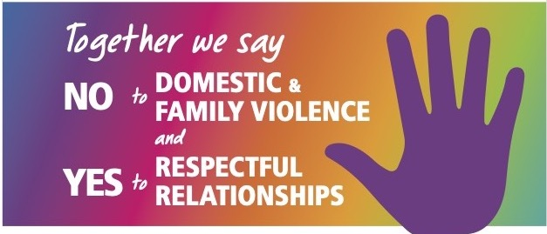

Date

Dear x
Rotarians across Australia, New Zealand and the Pacific Islands have joined together spread awareness, provide assistance, and offer resources to combat family and domestic violence.

We firmly believe that by working together, we can make a significant difference in reducing this pervasive issue, across our District, from Sydney Harbour ro the top end of the Central Coast and west to the Blue Mountains.
I am writing to seek engagement with your group. By joining hands, we can work together, as we both share the common goal of supporting individuals who have experienced abuse and violence within their homes.
During the United Nations “16 Days of Activism against gender-based violence” members of Rotary will be walking with people from other organisations to draw attention to the pressing issue of gender- based violence. The above period runs from 25th November (the International Day for the Elimination of Violence Against Women) to 10th December (Human Rights Day).
Rotarians are joining others to walk together to draw attention to this scourge on our local communities. We invite you to join us.
By participating in this walk, you'll not only help raise awareness but also demonstrate your commitment to the cause and our shared values.

Thank you for considering our invitation, and we look forward to the possibility of working closely with your group to make a positive change.
Local Walk details:
Date
Time
Location
Warm regards,
name
Position
Rotary Club of
Contact details

