To: All Rotarians in D5060
Re: The BEST Party Ever!

Dear Peter Schultz,
Do you know how powerful Rotarians are with their Rotary Foundation (TRF)?
Most of you know this, but maybe you are new to Rotary. TRF helps Rotarians (like us!) do great projects all over the world, with hundreds of million $$ in grants every year. The images below are links to a few stories that Rotarians have shared of TRF Funded projects:

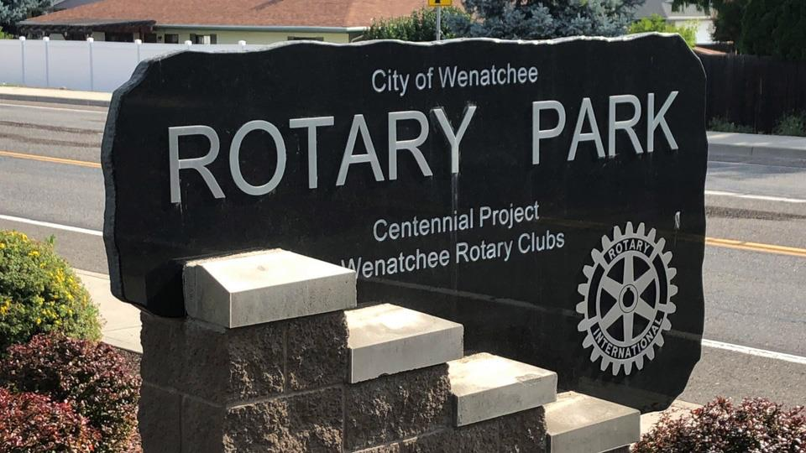 John McDarment from Wenatchee Sunrise R/C describes a multi-club local park project (2:49 / https://vimeo.com/349346046)
Tom Tochterman from Lake Chelan R/C describes a wheelchair project (1:46 / https://vimeo.com/358835761)
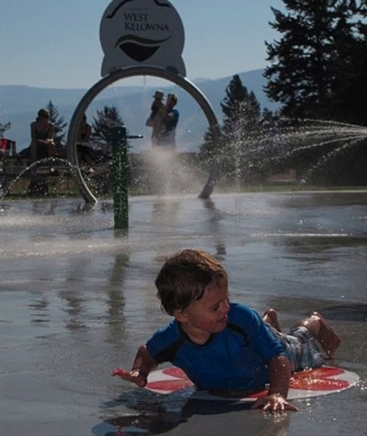Marjolein Lloyd from Kelowna Sunrise R/C describes a waterpark project (1:32 / https://vimeo.com/364413714)
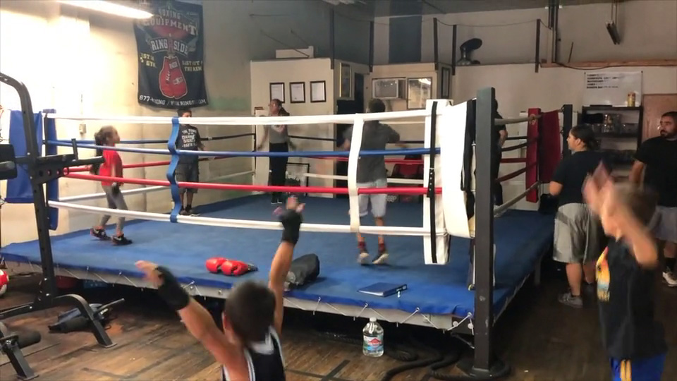 Cruz Ramos from Sunnyside Daybreak R/C and his wife Theresa describe their boxing club for youth (3:01 / https://vimeo.com/347681816)
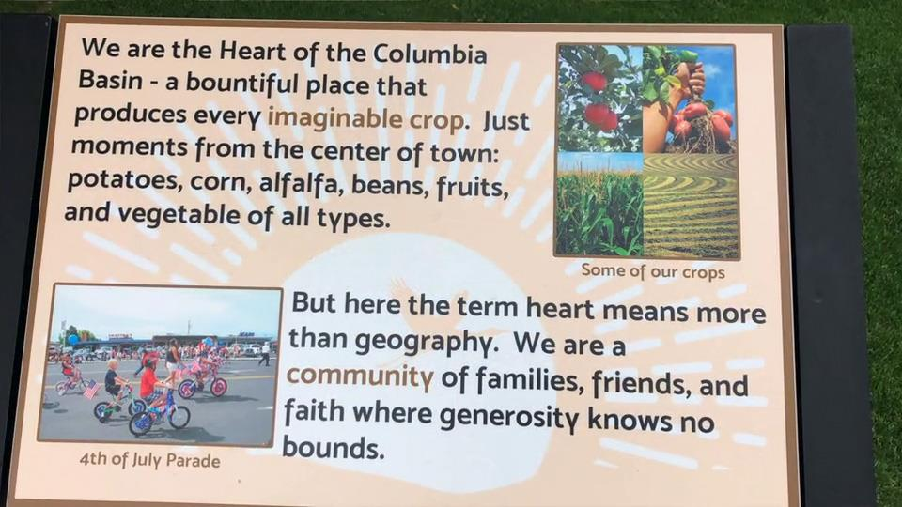Tudy Doolittle of the Othello R/C tells us about the Othello Historical Walk (1:40 / https://vimeo.com/359110639)
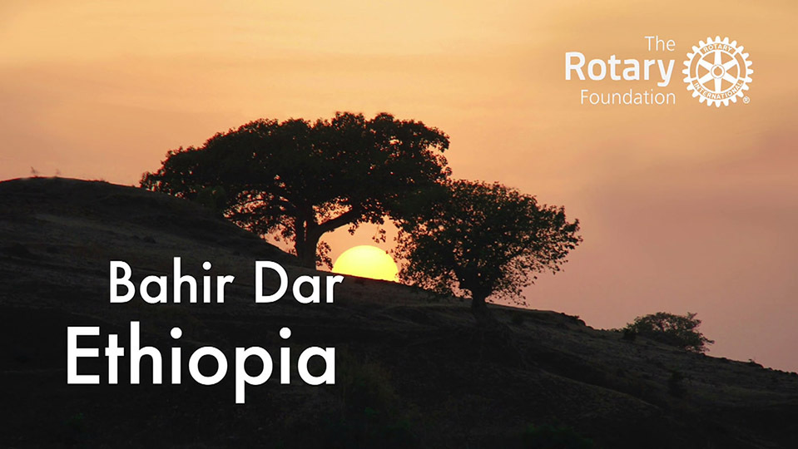Peter Schultz from Rotary Now! Kelowna describes a medical team's travel to Ethiopia to operate on burn victims and train locals (3:49 / https://vimeo.com/518359973)

(LOTS more stories and videos at rotary5060.org, look under DISTRICT-VIDEOS for full listing):

Do you plan to Donate to TRF this Year?
We can't do these projects without donating to the Annual Fund! We hope that you can find it in your heart and budget to donate to the TRF Annual Fund every year, no matter what level. Our goal is "EREY" (Every Rotarian Every Year)! If you can comfortably do it, try for the "Sustaining Member" level. That is a minimum of $100 USD each year (or $8.33 per month - which is $10.58 CDN - which is roughly 2.5 lattes!)

IF you plan to donate as a Sustaining Member this year, then...

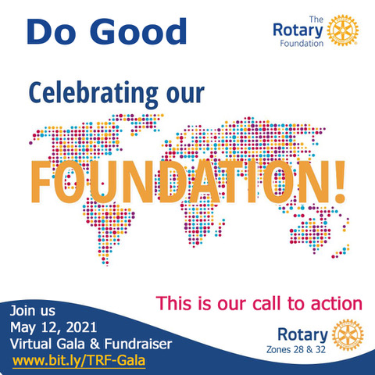
JOIN THE PARTY!!!

Make your $100 donation your ticket to the huge fundraising Gala event "Celebrating our Foundation!" Over 75,000 Rotarians invited from Alaska, all across Canada & northern USA!! Click on the image at the RHS to see a 2.5 minute video promo, or go to the Zone website for all the details and registration (use link bit.ly/TRF-Gala). Don't miss out:
- 5:00-6:00pm Wednesday 12 May (minimum $100 donation)
- Followed by District TRF Awards event @6:30pm
- Rotary Celebrities including...
  - R.I. Director Valarie Wafer
  - T.R.F. Trustee Dean Rohrs
  - Future R.I. President Jennifer Jones
  - P.R.I. Director Jeffry Cadorette
  - P.R.I. President Barry Rassin
  - PolioPlus Chair Mike McGovern
- Other Stars including...
  - World Champion Flair bartender Tom Dyer
  - Pop/Rock singer Barney Bentall
  - Rock & Roll Hall of Fame Guitarist Alex Lifeson (RUSH)
- AND MORE!!!!
REGISTER NOW at bit.ly/TRF-Gala!

Hope to see you there!

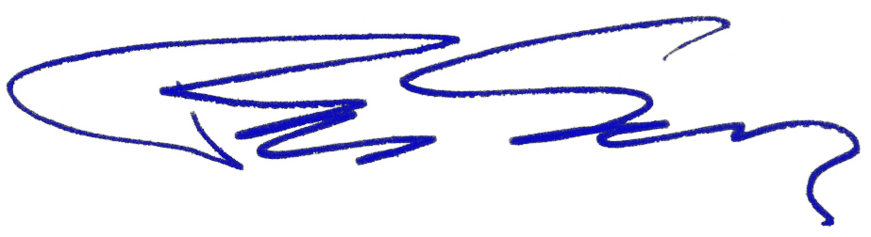

Peter Schultz, PhD, PDG
Zone 28+32 Innovative Club Advocate
District 5060 Governor 2019-2020
Rotary Now! Kelowna Charter Member
Email: Peter.Rotary5060@gmail.com
Cell: 250-470-9228

This email was automatically generated by ClubRunner on behalf of Rotary District 5060. Unsubscribe

