
To: Club Reps for Foundation Event Promotion
Cc: Governor's Council & AG's
Re: May 12 Gala & District Foundation Celebration

Dear Peter Schultz,
You are getting this either because I have your name as the Club Representative to help us promote this event, or your are the Club President of a club for which I don't have a name. If you DO NOT want to receive updates, please let me know and I'll remove you from the list, but please try to find somebody in your club (Foundation Chair?) to promote this!

(1) Promote the Fundraising Gala!

Please promote this with your club members. Fast-paced 60-minute variety show with great entertainment. $100 USD donation to the Rotary Foundation is roughly the same cost as 2-1/2 latte beverages each month! But our Foundation NEEDS your support. We currently have 29 registrants from our District representing 12 different clubs (list attached)... CONGRATULATIONS Upper Kittitas County for the BEST per-capita registration!! Over 75,000 Rotarians invited from Alaska, all across Canada & northern USA!! Click on the image at the RHS to see a 2.5 minute video promo, or go to the Zone website for all the details and registration (use link bit.ly/TRF-Gala). Don't miss out:
- 5:00-6:00pm Wednesday 12 May (minimum $100 donation)
- Followed by District TRF Awards event @6:30pm
- Rotary Celebrities including...
  - R.I. Director Valarie Wafer
  - T.R.F. Trustee Dean Rohrs
  - Future R.I. President Jennifer Jones
  - P.R.I. Director Jeffry Cadorette
  - P.R.I. President Barry Rassin
  - PolioPlus Chair Mike McGovern
- Other Stars including...
  - World Champion Flair bartender Tom Dyer
  - Pop/Rock singer Barney Bentall
  - Camilo the Magician
  - Rock & Roll Hall of Fame Guitarist Alex Lifeson (RUSH)
- AND MORE!!!!
REGISTER NOW at bit.ly/TRF-Gala!

(2) Promote the District 5060 Foundation Event

From 6:30pm right after the Gala, join your Rotary friends from the district. Start with a Stay-at-Home dinner and/or social visit, followed by hosts District Governor Richard DeRock & District Foundation Chair Pete Erickson celebrating your achievements this year with the Rotary Foundation:

You are invited to Register for the District 5060 Zoom Foundation Event.
When: May 12, 2021 06:30 PM Pacific Time (US and Canada)
Register in advance for this meeting:
https://us02web.zoom.us/meeting/register/tZYtcumgpjwuHtOfXrFZH4eAEXevNpINqLhZ
After registering, you will receive a confirmation email containing information about joining the meeting.

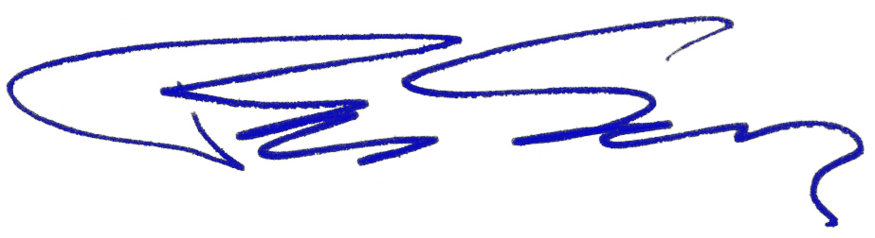

Peter Schultz, PhD, PDG
Zone 28+32 Innovative Club Advocate
District 5060 Governor 2019-2020
Rotary Now! Kelowna Charter Member
Email: Peter.Rotary5060@gmail.com
Cell: 250-470-9228

This email was automatically generated by ClubRunner on behalf of Rotary District 5060. Unsubscribe

