The Club Life Cycle
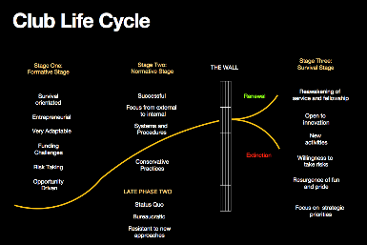What changes do you need to make to ensure your club survives and thrives beyond 2020?
All organisations, including Rotary Clubs, go through life cycles, just like living things.
When they are new, the Formative Stage, there is a “honeymoon” period where things are somewhat unknown but fun and very exciting. Those involved are anxious to learn more about their environment so that they can develop appropriate strategies to survive and thrive.
“By the seat of the pants” decisions are often made, cash is short and the organisation culture is highly adaptable and entrepreneurial. There are often risks early in the life of the organisation. There is no “normal” length of time for this stage: research and scientific groups, for example, might sit here for many years.
At some point the organisation will mature and, hopefully by then, will taste some success. The next phase, the Normative Phase, is born. Things become more certain and often the focus on the external environment and the beneficiaries gives way to more of an internal approach. The old flexibility is lost and conservatism and control move in, with emphasis on systems and procedures. Changes in the environment are largely ignored. The “S Curve” levels out.
Late in Phase Two, the risk is that the organisation will really close in on itself, resist change, lose the desire to hunt for new ways and will stagnate. Again, research shows no particular timeframe for this, but the organisation has reached “the wall”.
Some organisations sit at “the wall” for some time, stuck with their old products and services with sometimes steady, but declining demand. The need to change is indicated, but there is resistance.
There are three ways organisations get to “the wall”:
1. By shock. Key people leave, services become irrelevant, things like COVID occur, and matters beyond their control bring them to a panicked realisation that they won’t survive unless they act.
2. By evolution. What they have been doing no longer properly meets demands, environments change without them adapting and they become increasingly irrelevant.
3. By anticipation. Leaders understand that this process occurs, they monitor what is happening around them and, when timely, they take action.
Organisations are then faced with two outcomes: renew or die. Those continuing to do the same things without adaption will inevitably fall by the wayside.
So how do you renew, revitalise, rejuvenate your organisation? How do you enter a new “S curve”?
Faced with “the wall”, many commercial companies have changed their products and /or their markets and some even move into completely different industry sectors.
For renewal, Rotary clubs need to be open to change, experiment and rejuvenate their focus on people in need and their members. They need to bring fun back into their culture and make every single person feel valuable and valued.
They will probably need to find new Community Service projects and change meeting procedures to attract and retain members. They must continue to be seen as relevant. They might need to address new issues in society about which their public is concerned. They will certainly need to adopt changing technologies. Some more traditional and conservative people will find this renewal phase very challenging.
The club life cycle is a valuable concept to help you think about where your club is right now, and what needs to be done to ensure it remains viable with appropriate offerings through Club Service to members and through Community, Youth, Vocational and International Services for people in need.
Have a debate amongst members, and decide what changes you need to ensure your club survives and thrives beyond 2020.
