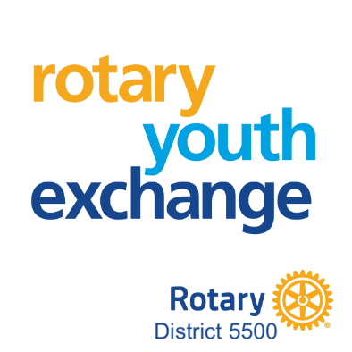
EXCHANGE DESTINATION
Rotary Youth Exchange D5500 maintains hosting arrangements with over 20 countries worldwide. Options change from year-to-year. Students have the opportunity to suggest their preferred country of exchange. However, as there are limited places in any one country, a preparedness to accept an exchange in any of the other available countries is necessary on the student's part. The District RYE Committee determines the final country destination.
A few past host countries D5500 has exchanged with include:
Argentina | Denmark | Japan | Sweden
Austria | Ecuador | Korea | Switzerland
Belgium | Finland | Norway | Taiwan
Brazil | France | Peru | Thailand
Chile | Germany | Slovakia
Czech Republic | Italy | Spain
*other countries are available and will be considered for an exchange and career goals.

