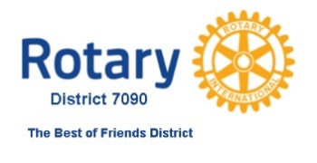
BEST OF FRIENDS HERITAGE ENDOWMENT FUND
To be established in 2022 to to honor our leaders past and present by establishing a Named Endowed Fund with the Rotary Foundation, designated to Annual Fund/SHARE.

Pledge Agreement

DONOR INFORMATION
Name or Club
Address
Country
Rotary ID or club
District # | 7090

PLEDGE INFORMATION

I/We pledge a total of US$______ to be paid by check
Pledge amounts of $1000 or more will be recognized on the district website in perpetuity as a Founding Heritage Society Member and will have the opportunity to make a toast at the Feb 23, 2022 Foundation Pre-Gala. Individuals who make a contribution of any amount will receive credit towards their all-time giving and status towards major donor and Arch Klumph Society member status. Individuals who make a minimum of $1,000 contribution will receive a benefactor ribbon to append to a PHF or Rotary pin. Note that the endowment program is not a qualifying program for Paul Harris Fellowship and points are not awarded.
This pledge will be effective upon receipt of this signed agreement.

The district is collecting contributions via cash and check, which will be held and submitted to Rotary once the fundraising goal has been achieved. At that time any credit for your personal contribution will be added to your Rotary record, and Rotary issued tax receipts will be provided where appropriate. Checks may be sent to . Make your check payable to: Rotary District 7090, Inc. write in memo “Endowment Fund” and mail it to: C/O Donald DeMeo 9 Pinegrove Park, Hamburg, NY 14075. Canadian contributions accepted USA only: Venmo account Rotary District 7090 Grants Business username @dadsad3

___ I/We wish to have our gift remain anonymous.

Promisor’s Signature(s)
Date:

Please submit this form to:
sandichard@gmail.com
For office use only
Tracked gift ID:

