Register Now: The Zone 28 & 32 Interact Convention 2022

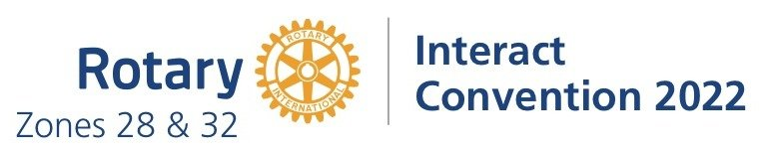

Dear Rotary Family,

The exciting Zone 28 & 32 Interact Convention (ZIC) is taking place October 20th-23rd, 2022 and we want to see students from your district there!

This is an opportunity for Rotarians to show their support for our young leaders who have been working very hard organizing this first-ever Zone event that includes Interact delegates from Canada, USA, Bermuda and St. Pierre et Miquelon!

Here's where your help is needed:

1. We are seeking Delegates.

If your club currently sponsors an Interact club please connect with them and consider sponsoring one or more delegates. Clubs & Districts in Zones 28 and 32 are able to reserve spots for Interact students and chaperones at the Zone 28 & 32 Interact Convention ahead of time. Each spot is $991 Canadian dollars ($850 registration fee plus a $141 refundable deposit).

2. We are seeking Donors/Sponsors.

If your club does not currently sponsor an Interact Club, kindly consider becoming a Donor/Sponsor of the event in support of youth leadership!

Thank you for your kind consideration. We also encourage you to take a look at our website (www.zoneinteractconvention.org) to learn more.

If you have any questions regarding the registration process, the event in general, or would like to invite our team to speak to your club/district leadership about the event please feel free to contact admin@zoneinteractconvention.org.

