Rotary Club of Ann Arbor
Color Purple

PURPLE, not maize and blue but PURPLE. The Rotary Club of Ann Arbor looked for new ways to raise funds for PolioPlus. Several members went to last year’s Rotary International convention in Hamburg and got some fresh ideas.

Paulie, the Purple Polio Bear, a 10 inch stuffed teddy bear wore a purple sweater sporting the End Polio Now logo. It was hand knit by Rotarians in the UK. Paulie took on a life of his own when he came to Ann Arbor as he was photographed everywhere by Rotarians and Rotaractors around town. Paulie’s photos were featured for the month leading up to World Polio Day on the club’s website, Facebook page and at meetings.

Then Paulie was auctioned off by District Governor “Sparky” Leonard at the club’s Polio Day Meeting for $2000 to his new owner.
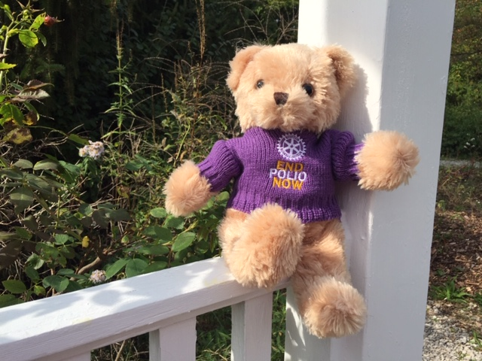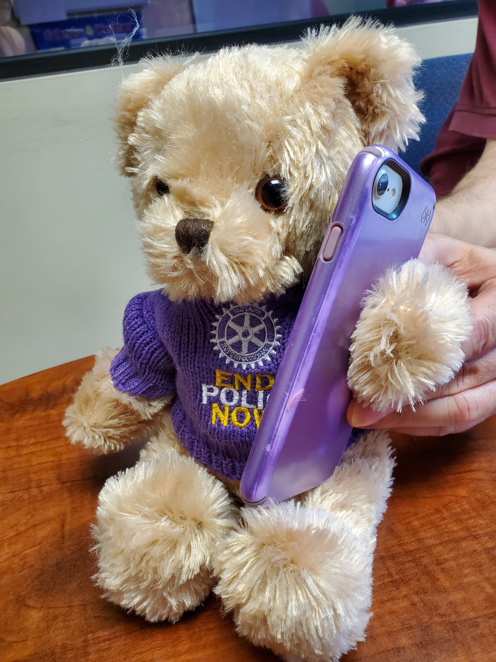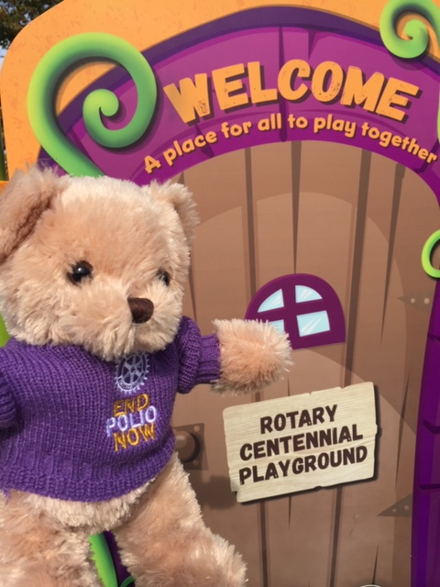
The second challenge to inspire Rotarians to give to PolioPlus came from President Rosemarie Rowney. She promised the club that she would color her hair PURPLE if they would double their giving to polio from last year’s commitments. It happened and the Rotary Club of Ann Arbor was proud to send in more than double their contribution this year to Rotary International. We offer this challenge to all clubs in District 6380 for next year.

