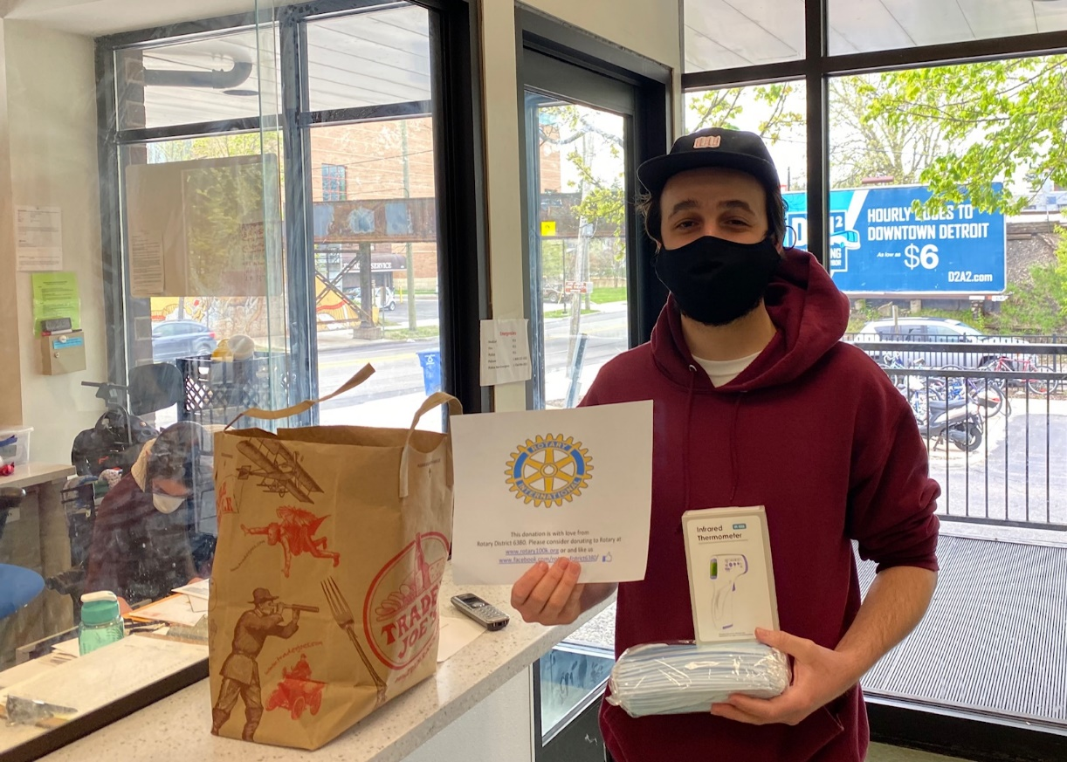
RCAA delivers non-contact thermometers and masks to
Shelter Association of Washtenaw County

Rotary Club of Ann Arbor Pandemic Response Fund raises $61,600
for COVID-19 Relief in the Community.

In April 2020, RCAA established the Disaster Response Committee which conducted a Pandemic Response Fund Campaign from May 1 – May 31! Rotary Club of Ann Arbor raised $61,600 for disbursement to non-profits serving vulnerable populations in the community to address the needs of COVID-19. In addition, RCAA donated $10,000 to the District 6380 100k Mask Challenge.
A brief application form was developed, and a committee established to review and recommend disbursement. Six grants have been made with more disbursements in the future.
Washtenaw Shelter Association of Washtenaw County – Non-contact thermometers and Staff Support
SOS Community Services – Food Pantry Support
The Corner Health Center – Summer Nutrition Program to provide health education and access to fresh fruits and vegetables (50 clients)
Packard Health – 105 Home BP Monitoring units for low income medically vulnerable clients to provide telehealth services
Peace Neighborhood Center – Providing vulnerable youth with online activities and tutoring during the summer months at main center and two public housing satellite centers
SafeHouse – Assistance with overtime staffing to meet increased demand for domestic violence and sexual assault services
We are very grateful for the generosity of Rotarians, community members and other Rotary Clubs. Special thanks to Rotary Club of Ann Arbor North and the Ypsilanti Rotary Club for their generous donations!!
We are proud to provide “Service Above Self”.

