- Re-UNION Celebration Dinner
- Wednesday, Feb 5, 2020 6:00 pm

- The Rotary Club of Ann Arbor returns to its historic home
- The newly refurbished
- Michigan Union, University of Michigan

SAVE THE DATE for this important event featuring dinner, music and an internationally known speaker

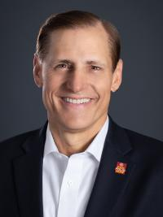
- John Hewko
General Secretary & Chief Executive Officer
Rotary International
- Rotary Club of Kyiv Ukraine
John Hewko is the general secretary and chief executive officer of Rotary International and The Rotary Foundation. The executive staff manages operations at RI World Headquarters, including member services and programs, finances, technology, development, strategy, legal services, with international offices in Buenos Aires, São Paulo, Zurich, New Delhi, Seoul, Tokyo, and Parramatta (Sydney).
From 2004 to 2009, Hewko was vice president for operations and compact development for the Millennium Challenge Corporation (MCC), a U.S. government agency established in 2004 to deliver foreign assistance to the world’s poorest countries.

