EYECARE KENYA PROJECT 2020

January 10, 2020 was the start of Eyecare Kenya’s 3rd annual eye care mission. Conceived and led by Rotarian Dr. Nelson Edwards, Eyecare Kenya provides eyecare for those in need in the Bahati constituency located in Nakuru Kenya, hosted by the Utumishi Rotary Club of Nairobi. This Rotary/VOSH eyecare team consisted of 18 people from 3 countries, 4 Rotary districts 10 Rotary clubs.
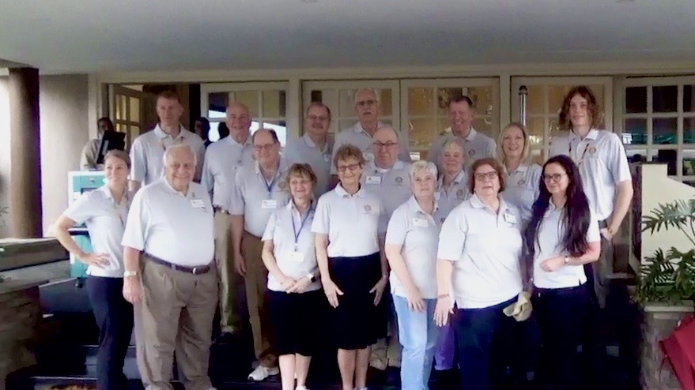
From Canada District 6380:
Terrance McNaughton Blenheim Rotary Club
Carman Titus Blenheim Rotary Club
From US District 6380:
Dr. Nelson Edwards M-36 Satellite of Livingson Sunrise
Dr. Lee Halsted Hartland Rotary Club
Lois Halsted Hartland Rotary Club
Mark Jaffray Livingston Sunrise Club
PDG Jeff Lichty Clarkston Rotary Club
Mary Sloan Clarkston Rotary Club
Rhonda Panczyk Rochester Rotary Club
Monica VanOvermeer Saline Rotary Club
Pam House M-36 Satellite
From US District 6360
Sally Ernest Lakeshore Rotary Club
From US District 5450
Steve House Brighton Rotary Club (Colorado)
From Kenya District 9212
David Muiru Utumishi Rotary Club

Also joining the team Dr. Aimee Bronson from Allendale Michigan, Dr. Brian Hayes from Pinckney Mi., retired Naval Captain John Eldridge from Alexandria, Va., and exchange student Elias Stich.
Elias is a District 6380 inbound student from Germany, upon hearing of the Rotary project in Africa he obtained required approvals and devised a fund raiser to cover costs as each trip participant pays their own way on the project. Elias purchased soccer balls to donate to students/schools in the areas where clinics were to take place. The balls were then ‘sold’ at Rotary clubs with the buyer signing the ball and leaving messages for the future student receipents. These soccer balls were a hugh success; the students were thrilled to receive the wonderful balls and just as thrilled to meet Elias who seemed to achieve a ‘rock star’ status with these children.

Our team provided eye care in 5 locations including Kiamaina, Bahati, Kabatini, Githioro and Nakuru, traveling 20+ miles daily in order to reach remote locations. Patients were registered with basic health and eye information, visual acuities checked, eye pressure measured and refractions performed to determine eyeglass prescriptions; doctors then performed examinations for eye health issues. Medications were dispensed as needed with several patients referred into the local health system for further care.
Although the team consisted of only 4 doctors this year we were able to increase the number of people served due to two factors:
First - Dr. Edwards established an “away team”, a group that traveled from our clinic sites to the local primary and secondary schools. This team screened students sending any with prescription or health issues to the main clinic site while those passing returned to class. Members of this team included Drs. Aimee Bronson and Brian Hayes, both VOSH experienced doctors, Monica VanOvermeer, Rhonda Panczyk, Terrance McNaughton, Carman Titus, Sally Ernest, Mark Jaffray and Lois Halsted. Team members noted the administrations for each school were more receptive this year, preparing rooms for the team for optimal results. Students, while complying with directions, remained very shy and smiled their thank you.
Second – The clinics capacity was greatly impacted by the addition of phoroptors, equipment that was purchased as a direct result of the grant this project received from the Rochester Rotary Club (Michigan). Dr. Edwards trained volunteers on this equipment to refract for basic prescriptions thereby saving doctor’s time for refining Rx and eye health needs.
With these two changes to the clinic 2,198 people in need were served!

Over 4,000 pairs of prescription eye glasses, 900 pairs of reading glasses (thank you Clarkston Rotary!), several hundred pairs of sunglasses, cases of medications, and serveral boxes of exam equipment accompanied the team to each clinic location. We are grateful and would like to acknowledge those who’s contributions made this possible.
Wisconsin Lions Club Foundation Our source for the prescription glasses. We also thank the Rotarians and team members that donated their time during the busy holiday season to sort this stock.
The Clarkston Rotary Club provided the funds for the reader glasses purchased.
Alcon, Inc. Donated over $100,000 (retail value) in medications. These drugs enabled doctors to dispense a 12-month supply to the patients that are without other resources.
Maui Jim A US manufacturer of highend sun eyewear donated glasses providing the best sun protection.
National Vision for the loan of an auto-refractor designed for children.
Rochester Rotary Club Their grant provided the funds for purchasing phoroptors and the support arms which allow this crucial piece of equipment to be held in place and adjusted to the patient.
We also thank the Hands of Mercy local Nakuru volunteers for their help and translations, The Nakuru Rotaract Club for their assistance at clinics, and the Honorable Kamini Ngunjiri, Member of Parliament and liaison with the Kenyan government.

As Rotarians we make this trip to provide eye care and eyewear to people that have no other means of obtaining this help. During our travels many of us become aware of additional needs such as children unable to attend school due to a lack of funds to purchase uniforms. Two of our Rotarians, Monica VanOvermeer (Saline Rotary) and Steve House (Brighton Co. Rotary) seeing this need founded a new group Hope4Kenya and with funds being handled by local Rotarians 24 children have been outfitted with the required uniforms and will now be educated.
Another Rotarian, Mary Sloan (Clarkston Rotary) heard of a young woman unable to complete her final year of education and obtain her teaching certificate due to a lack of money; Mary has opted to provide the funds.
A nursing student has a similar story, just a few months short of his degree his funds have run out. Rotarians Mary Sloan, Carman Titus (Blenheim Rotary) and Pam House (M-36 Satellite) are providing the means for him to complete his education.
Most of the schools we saw were poorly equipped such as a secondary school in Nakuru with 1 computer to serve 300+ students. We have commited to bringing in additional computers with next years clinic.
Eye care, education, equipment, as Rotarians we have seen the need and we take up the challenge.
We are PEOPLE OF ACTION !

Respectfully submitted, Pam House, M36 Satellite of Livingston Sunrise & Lois Halsted, Hartland Rotary

