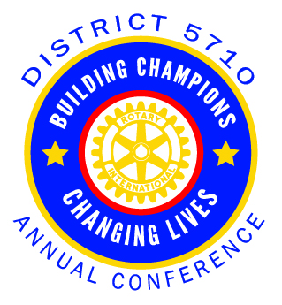
2022-2023
ROTARY DISTRICT 5710 CONFERENCE
SEPTEMBER 22-24, 2022
Hyatt Place Kansas City/Lenexa City Center
8741 Ryckert Street, Lenexa, KS 66219
District Conference Sponsorships
43 Rotary Clubs in Eastern Kansas and over 2100 Rotary members
____ Championship Sponsorship - $3,000 (One only)
As a Championship level sponsor your company name logo and profile will be showcased in event signage and conference program. This will be an opportunity to market your company to over 200 key business professionals in our District. You will be invited to address the attendees during a general session and a vendor table for promotions all during the day on Friday, September 23, 2022.
____ Divisional Sponsorship - $1,000
The Divisional Sponsorship level will include your company name and logo on print materials for the conference and opportunity to secure a vendor table for promotion activity on September 23, 2022.
____ League Sponsorship - $ 500
The League level sponsorship will include your company name and logo on print materials.
____ Interact Luncheon Sponsorship - $150
Sponsor Saturday lunch for the Interact and Rotaract members who are volunteering for the Saturday service projects.
____ Community Service Fan Sponsorship- $ 100 (Unlimited)
Any business, Rotarian, family member, or friend of a Rotarian are invited to become a Community Service Fan Sponsor for the Saturday’s International and local community service projects. All names will appear in the printed program and conference attendees will receive a Rotary t-shirt for working a service project.
For more information or questions, please contact Tim Deves at tim.deves@edwardjones.com
For guaranteed inclusion in the Conference program, please return by August 25, 2022.
Sponsor Name:_______________________________ Contact/Phone:_____________________________
Program Listing:______________________________ Email:_____________________________________
Address:____________________________________ City, State, ZIP:_____________________________ Send logo and graphics(with sponsorship level) to: Kinsey Honeyman at KinseyHoneyman@gmail.com
To make a payment by credit card, please go to https://tinyurl.com/5710DC2022
Then email your form to tim.deves@edwardjones.com

