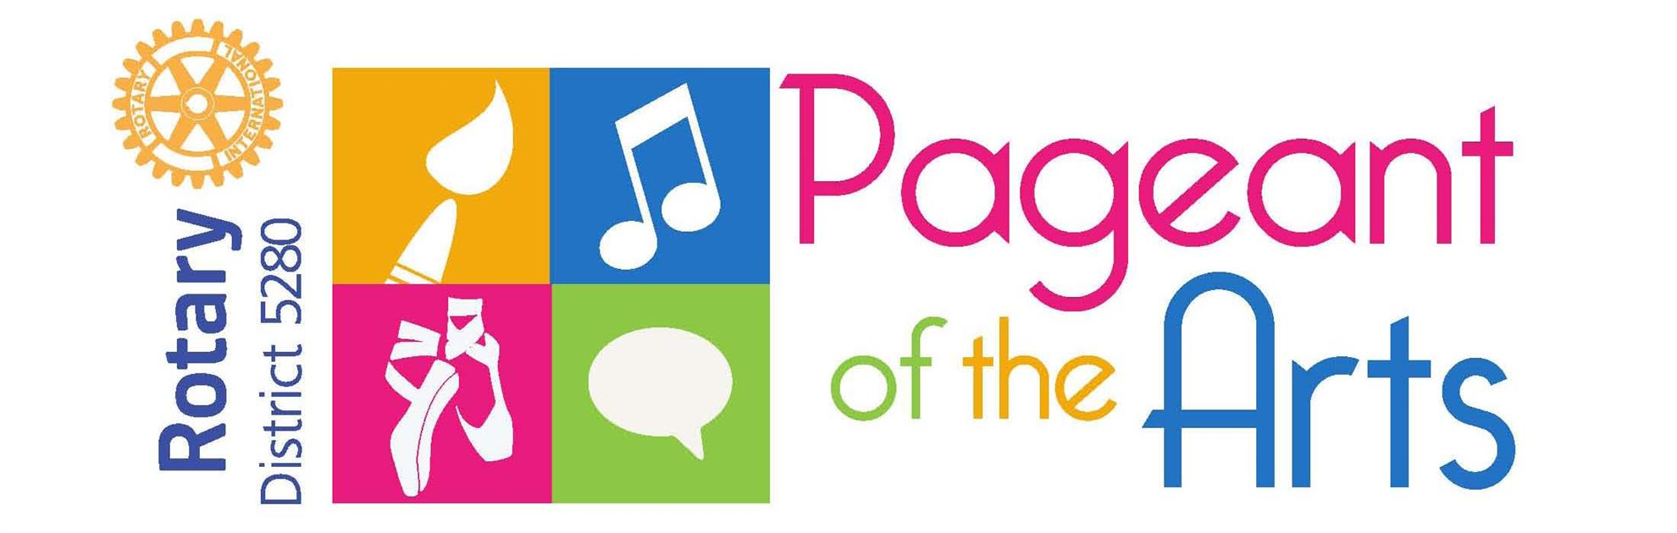

Showcase your talent

win prize money
Applications Due February 28, 2023

HIGH SCHOOL AGE CONTEST IN ONE OF 5 ARTS
- Areas of competition: ART (2 or 3d), DANCE, SPEECH, MUSIC/Instrumental, MUSIC/Vocal
- Prizes for each category: 1st place $1,000* 2nd place $500 * 3rd place $250.00
- This is a Two Step competition – at the local Rotary Club of __________________, compete on March ________, 2023
- Applications due by February 28.
- Winners then participate in District-wide competition (usually about 10-15 competitors in each category) Saturday, April 15, 2023.
- Citywide competition location: The Salvation Army Community Center, Glendale CA 91204
- Detailed rules for each contest at Rotary5280.org/Pageant-of-the-Arts.

- Contact your local Rotary Club, ____[club name]___________
- Call, text or email ___[club contact name and contact info]______

