Notes and pictures from Anna Wieczorek
Rotary Club of Edmonton member living in Warsaw, Poland
Supporting those leaving Ukraine including international students.
All pictures come from Anna. She also created the various graphic images.
Links to the recordings of the interviews with CBC Radio and Global TV also included.
Please page down to review all the pictures and notes particularly for the Suitcase Project. Anna pictured on the left of the photo below with a lady grateful for receiving a suitcase. Rotary Club of Edmonton financially supported Anna to receive suitcases for those in need.
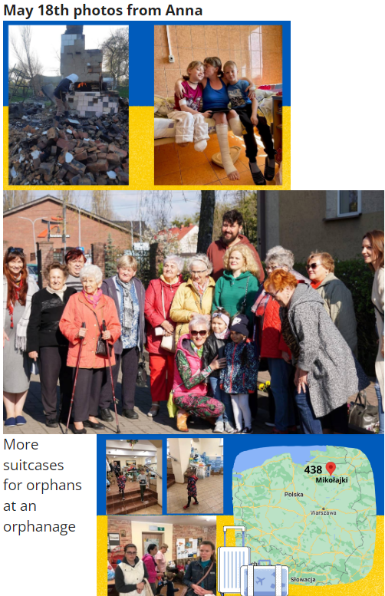
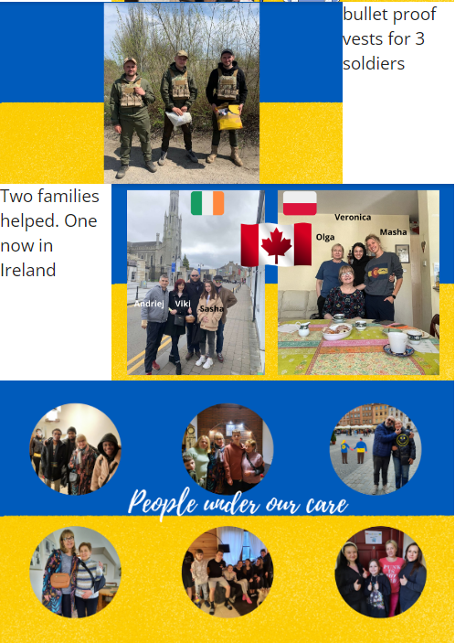
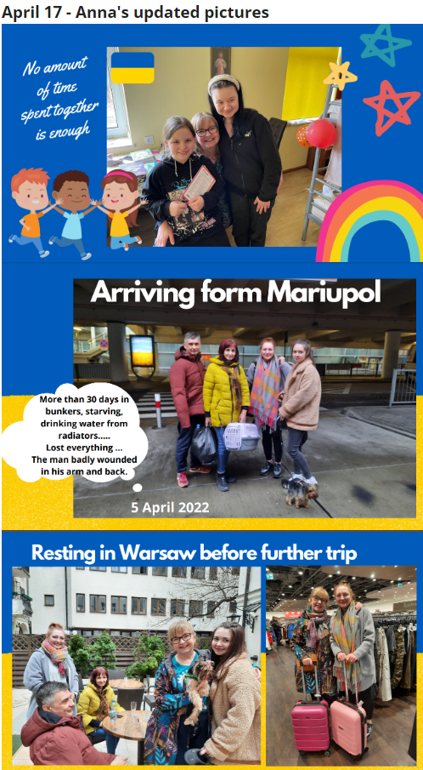

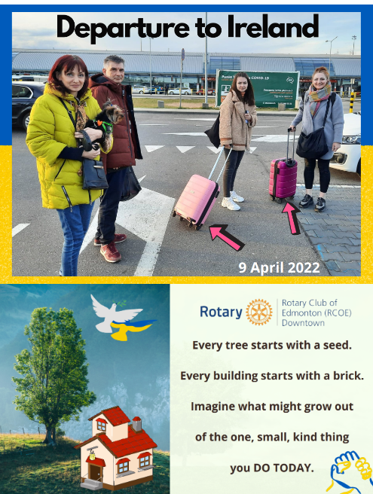

Anna's interviews by CBC radio and Global National News
Click for 9 minute interview with CBC Radio:
https://www.cbc.ca/player/play/2020522563754

Club president Jim Saunderson was also interviewed by the news media.
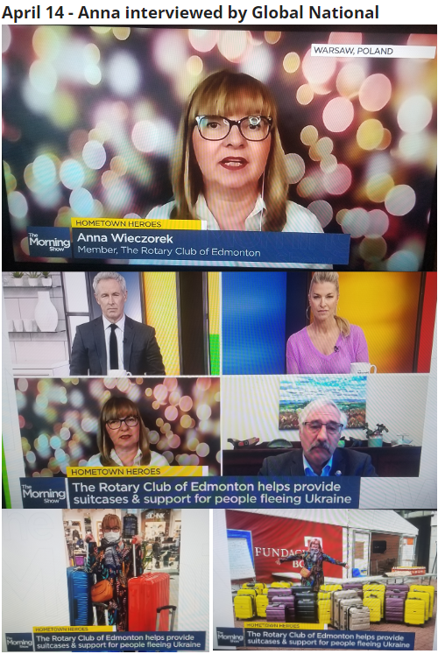
Club member Anna together with President Jim Saunderson were interviewed April 14th on Global National News about her service to refugees from Ukraine. Click here for the TV interview. Also listen to Anna and Jim interviewed by CBC Radio Edmonton on April 6th in the audio recording below.

April 13th - Anna received a thank you note from ladies from the Ukraine that needed shoes. Here is what they said:
Once again, thank you very much for your help. "Girls with unusual feet" :-) in their new shoes went to dinner and you can't see the worn ones anymore.
(translated from Polish)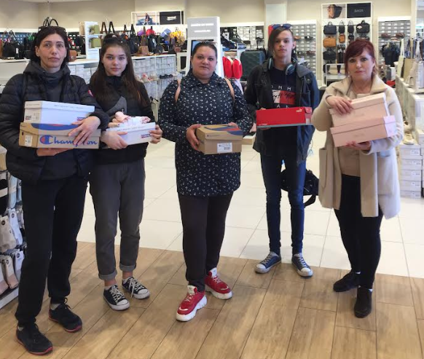

Letter from Anna April 5th:
Read about a Mariupol family that ended up with Anna after traveling to Russia then Georgia ending at Warsaw with "nothing" except their dog. Find out where the family is going with two pink suitcases.

