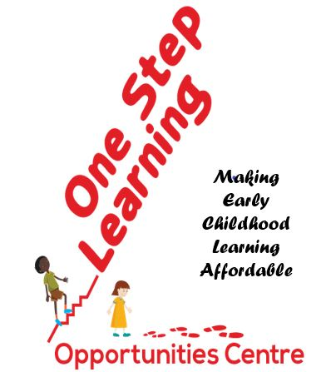 | CRA Charity Registration & Business # 771608478RR0001  Alberta Charitable Organization # 354251  Corp Access # 5122160921  Ghana Social Welfare # CR/AEEM/079/21 Category A  Ajumako-Enyan-Essiam- District CBO/NPO #s 665/666  Address:  15219 – 44 St. NW, Edmonton Alberta Canada T5Y3C4  Cell Phone: +1 780-717-4055  Email: john@onesteplearning.org  contact@onesteplearning.org  Website Learn more… www.onesteplearning.org
Date: January 02, 2023
Dear Rotary Club of Edmonton Downtown

Hello Gary and Rod

Happy New Year and all the best to you and Rotary Club Edmonton Downtown in 2023.

My recent trip to Ghana in December 2022 was quite fruitful, and informative. (Besides being stranded a couple of days in Toronto on my return but thank God, I made it home for Christmas on 23rd December).

The Centre is progressing effectively after one year of daycare operations. The 80 children on hand are becoming literates and they are happy to be at OSL each day. And so are their parents as I happened to sit in their PTA (Parent Teach Association) meeting. The program has made an impact. I also made connections with the nearest Rotary Club to OSL and managed to meet a few influential people.

First a big thank you again to Rotary Club Edmonton Downtown for the $2,500 donation. The Water Poly Tank has been purchased and delivered. Pictures and videos follow. As a matter of fact, with an additional donation from the Ghana Friendship Association of Edmonton, we managed to buy two Tanks. That makes it ideal for a wholesome project. Namely to supplement the supply of water for daily use at the daycare, and secondly for a playground water slide to be installed on the compound in due course when donations become available from other sources including Calgary Rotary Clubs we are pursuing.

Besides my initial contact with Accra Achimota Rotary Club before my trip, I connected with the closest active Rotary Club in the area and region that is near OSL. That is Rotary Club of Cape Coast Central (#9102). In fact, I got their representative, Past President, Mr. Albert Assibu, to visit OSL site. He was hugely impressed with the humanity project being undertaken by OSL for literacy. See pictures and videos.
For your records be informed that the Rotary Club of Cape Coast Central will now be the lead Rotary host of related OSL projects in Entumbil Ghana, in addition to our collaboration with Accra Achimota Club. The city Cape Coast happens to be in the same region and closest to the OSL site. The Club has already demonstrated their genuine interest and participation in the project framework through their visit on short notice and actions. Their coordinates:
Rotary Club of Cape Coast Central (#9102)
Contact: Mr. Albert Assibu, Pinto
Immediate Past President (Pinto)
Phone: 011-233-24 288-9883
Emails: rotarianpinto@gmail.com
Assibu1@gmail.com

The OSL Strategy Framework and Projects for the next 27 months to December 2024 that I shared with you earlier is still sound and validated by my visit. The goal now is for OSL Canada volunteers to continue soliciting for funding and collaborations with organizations like you to complete this foundation stage successfully. I will appreciate any leads you provide us to secure funding and collaborative relations. Please continue to spread the word about this noble project for OSL. We appreciate working with you

Sincerely
John Hagan, President
One Step Learning Opportunities Centre (OSL)
Phone: (+1) 780 717-4055
Email: jcbhagan@telus.net Ι or Ι John@onesteplearning.org
Website: www.onesteplearning.org contact@onesteplearning.org

