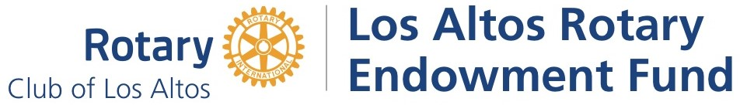

LARC Member Funding Request

Did you know that LAREF may be able to fund your project or volunteer effort? We invite you to submit this form in support of your community building and service-above-self efforts. Please describe collaboration efforts you are making with other Rotary Clubs, neighbors and LARC Rotarians on the back of this form

For LAREF Funding Requests:
Funding requests can be up to $1,500 maximum. The LAREF Board meets the 4th Thursday of each month, requests will be evaluated during these monthly meetings.

Rotarian Name: __________________________________________________________________________
Phone # __________________________Email: _________________________________________________
Name of Project: _________________________________________________________________________
How much is needed? ___________________________ How soon do you need it? ___________________

How/Where will the money be spent? _______________________________________________________

_______________________________Check payable to? ________________________________________
What is the goal of your project? ___________________________________________________________
_______________________________________________________________________________________

- Email this Form to: 1) laref@losaltosrotary.org, and 2) the current LAREF Co-Presidents.
- Request must be received at least three days before the 4th Thursday of the month for consideration at that month’s LAREF board meeting.
- After your request is approved and you conduct your project, you will need to provide receipts when requesting reimbursement.

Questions? Contact the LAREF Board President, or the LAREF Grants Committee Chair.

Los Altos Rotary Endowment Fund | P. O. Box 794 | Los Altos, CA 94023 | laref@losaltosrotary.org |
Nonprofit Tax ID number 94-2575930

Please make all REQUESTS consistent with LAREF Bylaws:

Section 3.14 Evaluation Criteria for Grants
The Grants Committee and the Board of Trustees shall be guided by a set of evaluation criteria in making recommendations as to grants to be made by LAREF for LARC. These criteria shall be as follows: to be eligible for consideration, the beneficiary must fall into a tax-exempt category, the grant must not directly benefit any Rotarian or member of a Rotarian’s family and the beneficiary must not advocate any sectarian or political viewpoint.
1. Major evaluation criteria shall be:
- The project benefits the greater Los Altos community, or supports a worthy local, national, or international program.
- The project benefits group of individuals, with the exception being for scholarships awarded to individual students.
- The program is of critical importance, i.e., “Will make a difference.” d. The individual member’s program’s ideals are consistent with those of Rotary.
- The project would be supported by the vast majority of LARC members.
2. Additional, minor evaluation criteria may be:
Rotarians are involved in the efforts of the project (as volunteers, not employees).
The grant has a specific one-time objective.
Other community organizations are partnering.
The project does not have other regular or natural sources of support. eg. LARC will receive recognition for the service or opportunity being provided.

____________________________________________________________________________________

Additional details about your request:

