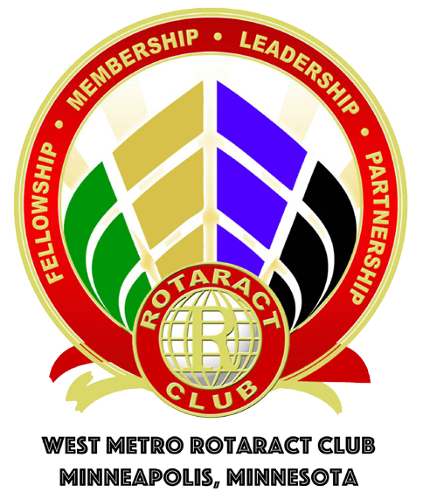

www.facebook.com/westmetrorotaractgroup
Westmetrorotaract@gmail.com
Tim Janssen, president: 952-917-9510

Meetings: Second Thursday each month at 6PM
Boardroom – Room D (downstairs on right)
Colonnade Building: 5500 Wayzata Blvd, Golden Valley, MN 55416

Meetings:
Date Topic Speaker
9/8/16 Make It. MSP Matt Lewis
10/13/16 Financial Planning for Eric Hemingway
Young Professionals Managing Partner, Hemingway Wealth
11/10/16 East Congo Maternal & Steve Solbrack
Child Health Rotary District 5950 Membership Chair
12/8/16 Positive Body Image Melissa Paakh
Miss Southwest MN
1/12/17 Rotary District 5950 Mark Hegstrom
Rotary District 5950 District Governor
2/9/17 Cookie Cart Anna Bregier
Director of Development & Marketing

Service Projects:
Date Event Time Location
9/10/16 Habitat for Humanity –
Rain Garden 9AM – 4PM 3011 Knox Ave N., Mpls
9/24/16 IOCP Food Packing 11AM – 1PM 1605 County Road 101 N
TBD VEAP Student Hunger 5:30 – 7PM 9600 Aldrich, Bloomington

Rotary District 5950 Events:
9/23/16 District 5950 One Rotary Summit Lafayette Country Club
1/28/17 District 5950 Mid-Term Assembly Earl Brown Center

