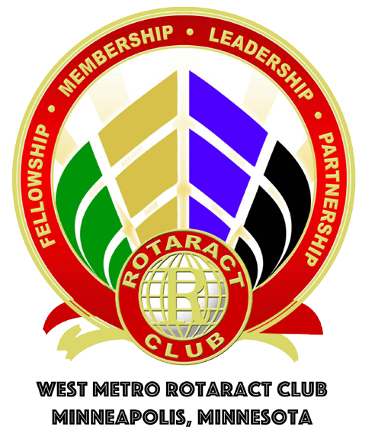

www.facebook.com/westmetrorotaractgroup
Westmetrorotaract@gmail.com
Tim Janssen, president: 952-917-9510

Thursday October 13, 2016 at 6PM
Boardroom – Room D (downstairs on right)
Colonnade Building: 5500 Wayzata Blvd, Golden Valley, MN 55416

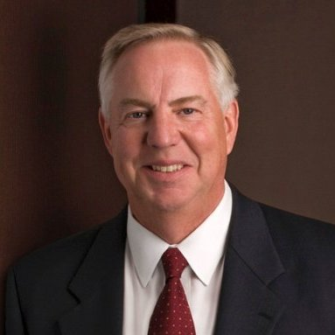

Richard Hemingway partners with his son Eric to use a multigenerational approach to help Hemingway Wealth Management clients meet their goals. Drawing upon his 30 years in the life insurance and securities brokerage industry, 15 years in the investment advisory business and vigorous on-going education gives Dick the foundation to help clients make smart financial decisions. Dick will focus on Financial Planning for Young Professionals including:
- Managing a budget/planning for the future as people are in early stages of their career including a focus on managing student loan debt.
- Advice on investing early. Young people have been solicited for paid financial planning services, life insurance, etc. There is often limited direction of what is wise now vs. what can wait.
- Navigating employer incentive programs (401k, health savings accounts, etc.)

