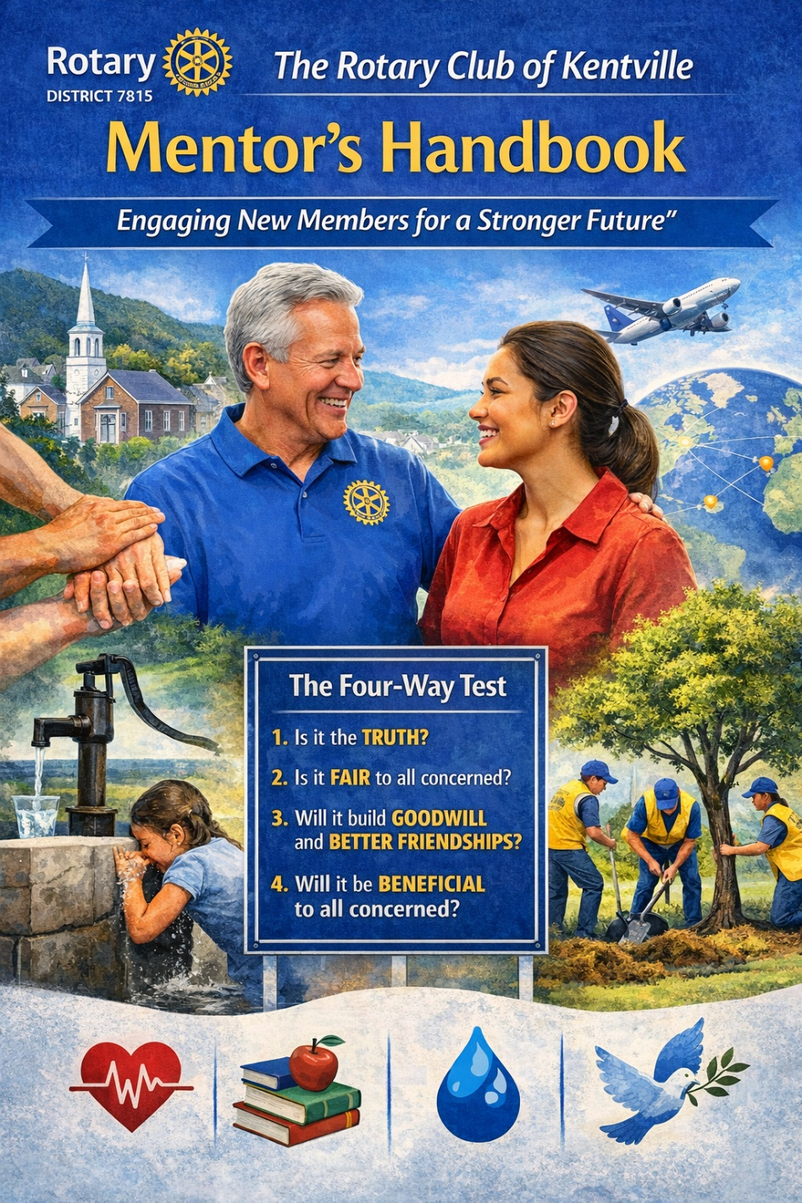

The Rotary Club of Kentville
Mentor’s Handbook
“Engaging New Members for a Stronger Future"
____________________________
Introduction
Welcome to The Mentor’s Handbook “Engaging New Members for a Stroner Future.” This guide is designed to provide mentors with essential tools and strategies for supporting new members of the Rotary Club of Kentville.
As a mentor, your role is vital in helping new Rotarians navigate their early experiences with the club, understand Rotary’s core values, and engage in activities that foster a sense of belonging.
This mentorship guide is a vital part of the Rotary Club of Kentville’s broader objective to engage and retain new members. It is a key initiative of the Membership Committee which plays an integral role in identifying potential members, onboarding new individuals, and ensuring their smooth integration into the club.
Mentors lead by example, embodying Rotary’s core value of Service Above Self and contribute directly to the growth and strength of our club and the communities we serve.

Important Mentorship Skills
- Active Listening: This means not only hearing what your mentee says but also understanding their needs, concerns, and aspirations. Active listening helps you build a stronger connection with your mentee and allows you to respond more thoughtfully.
- Adaptability: Every mentee is different, so being adaptable is key to providing personalized support. Some new members may need more guidance and structure, while others might prefer a more hands-off approach.
- Empathy: Be patient and understanding of your mentee’s challenges. Whether they’re adjusting to the club or dealing with personal concerns, offer a listening ear and reassurance.
- Patience: Mentoring is not a one-time conversation, but a continuous journey. Set realistic expectations for both you and your mentee. Understand that their learning curve may vary and that setbacks are a normal part of growth.
- Knowledgeable: A good mentor is knowledgeable about Rotary’s mission, values, programs, and processes. Your expertise allows you to answer questions, provide guidance, and clearly explain how Rotary works.
- Inspiring: Lead by example and be an inspiration. As a mentor, you participate in club projects, demonstrate commitment to service, and show enthusiasm for Rotary’s mission.
- Supportive: Being supportive means providing encouragement, guidance, and constructive feedback. Regularly check in with your mentee, not just about their tasks or involvement, but also about how they’re feeling within the club.
- Structure: Use the 15 Step New Member Activities Guide to help set clear goals with your mentee. It supports both mentors and mentees in tracking involvement—like attending meetings, joining committees, or taking part in service projects. Refer to it during check-ins to guide progress and encourage engagement. (attached)
- Rotary Resources: The Rotary Club offers many resources that can aid you in your mentorship role. This includes the club’s website, newsletters, training programs, and even global Rotary materials.
- Networking Opportunities: One of the greatest benefits of Rotary is the network of individuals who share similar values. Help your mentee build connections by introducing them to members, inviting them to club events, and encouraging them to join relevant committees or projects.
- The Importance of Engaging New Members: Members who feel engaged are more likely to stay with the club and become long-term contributors. Engagement helps members build meaningful relationships with other Rotarians, fostering a sense of camaraderie and belonging.
- Personal Fulfillment: Active participation in Rotary’s service projects and activities allows members to feel personally fulfilled by making a difference in their community and the world.
- Set Personal Goals: Work with your mentee to identify what aspects of Rotary interest them most. Help them set short-term goals for their engagement, whether it’s attending a meeting, volunteering for a project, or joining a committee.
- Celebrate Involvement: Recognize and celebrate new members’ participation in club activities, no matter how small. Public recognition can encourage continued engagement - whether through a simple thank you or during a meeting at Happy Dollars announcements.
- Encourage Attendance at Meetings: New members will serve a term as Greeter at regular club meetings, thus allowing them to become known and to recognize existing members. As a mentor, it’s your role to help them see the value in regular attendance and find ways to make it easier for them to attend, such as connecting to meetings on Zoom.
- Understand Your Mentee’s Passions and Interests: Suggest projects that align with these interests so they can make a meaningful contribution. Whether they are interested in community outreach, environmental conservation, or youth programs, matching their passions with a project makes volunteering more fulfilling.
- Encourage Social Interactions: Rotary membership often involves social gatherings. Encourage your mentee to attend these social events as they are an excellent opportunity for relationship-building in a more relaxed setting. These events provide a natural setting for members to bond over shared experiences and deepen their connections. Whether it’s a dinner, a coffee meetup, or a Rotary outing, these events go beyond the professional aspects of Rotary. Offer to attend with the new member if appropriate.

Why Rotary Matters:
Learning about Rotary’s history and mission helps new members feel that they are joining a global movement, not just a local club. Understanding its roots fosters pride and a deeper connection to Rotary’s values. Rotary’s values of Service, Fellowship, Diversity, Integrity, and Leadership are at the heart of everything the organization does. Understanding these values helps new members align their personal actions with Rotary’s goals.
Take time to tell the story of Rotary’s founding by Paul Harris and the early years of the organization. Explain the ethical principles embodied in The Four-Way Test and how it continues to guide the actions of Rotarians worldwide.

Of The Things We Think, Say or Do

- Is it the Truth?
- Is it Fair to all concerned?
- Will it build Goodwill and Better Friendships?
- Will it be Beneficial to all concerned?

As a global organization, Rotary works on large-scale initiatives that address some of the world’s most pressing issues, such as disease eradication, clean water access, education, and peace. Educating new members about Rotary’s global impact inspires them to contribute to these important causes.

Establishing a Supportive
Mentorship Schedule

- Establish Regular Check-ins: Work with your mentee to establish a regular check-in time, whether it’s weekly, biweekly, or monthly, depending on the needs of the new member. This will enable both the mentor and mentee to track the mentee’s progress toward the 15 Step New Member Activities Guide, which should be accomplished within one year of induction.
Addressing Challenges and Celebrating Successes
- Addressing Challenges
A vital part of the mentorship process is addressing challenges that may arise during a mentee’s journey, whether it’s navigating a difficult project, balancing time commitments, or feeling overwhelmed by new responsibilities. Offer specific advice based on your own experiences or direct them to a club member who might have additional expertise.

Key Takeaways:
Mentorship builds the foundation for leadership and long-term Rotary engagement.
Continuous support ensures new members stay active and involved.
Recognizing and celebrating growth strengthens commitment and morale.
Your guidance directly contributes to Rotary’s ongoing mission and global impact.

New Member Program Activities
Sequence New Member Activities

- Meet with your mentor **
- Receive the Objects of Rotary & the 4 Way Test at a Rotary Luncheon (Induction) **
- Attend Fireside Chat with Membership Committee **
- Attend Club Runner orientation session **
- Attend regular Rotary lunches **
- Upload a current photo to your Clubrunner profile **
- Join a committee and attend a committee meeting **
- Help greet people at regular meetings as assigned **
- Chair a regular meeting of the club.
- Attend Rotary Leadership Institute session and/or district conference
- Present a Classification talk to the Club **
- Attend a Rotary social event **
- Attend a community event where Rotary is participating **
- Invite a guest to a meeting
- 15 Propose a guest speaker to the Program Committee
- Secure a business advertiser for Valley Faces of Business **
- Follow/share content from Kentville Rotary social media

