PHILAKADE CARE HOME

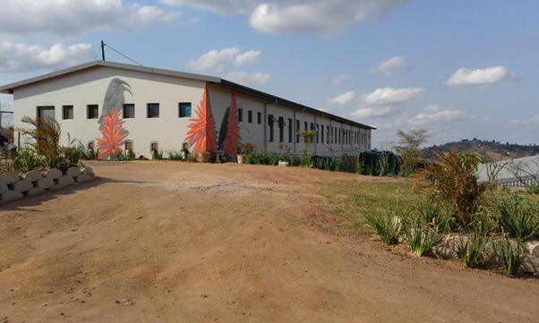
Philakade Care Home
Summary:

South Africa faces many societal and economic challenges, besides COVID19.
In recent years the AIDS epidemic, care of vulnerable and orphaned children, domestic violence and the growing epidemic of drug abuse have all attracted the attention of Government and a network of NGOs dealing with these important issues. However care of children and adults with disabilities, has to a large extent been ignored. The general assumption has been that African families will take care of their vulnerable members. However as the extended traditional African family structure changes, and economic hardship deepens, this is often not the case.

Government hospitals in the Durban area frequently have frail elderly or disabled patients being abandoned by their families. Community caregivers encounter disabled people being exploited for their grants or abandoned by family members.

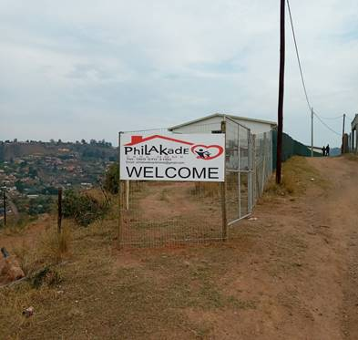

Very few step down or care facilities exist in Kwa-Zulu Natal for the poor; the few Government run old age homes and chronic care hospital wards have long waiting lists or are being shut down.

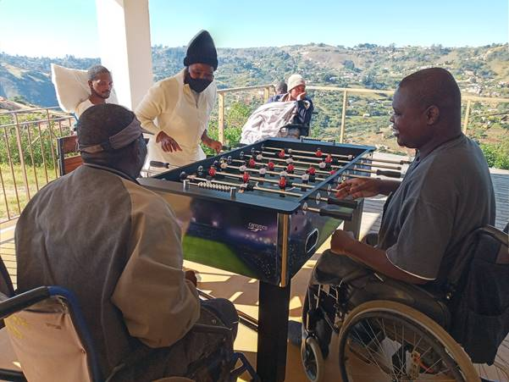

People fortunate enough to have a private medical aid or private wealth, have no difficulty accessing services when needing chronic physical care. However poor people needing chronic / frail care, who largely rely on State disability grants and pensions, are at the mercy of government institutions, NGOs or family members.
Elderly people and people with disabilities are often not cared for at home because there is no-one to care for them during the day, as family members work and can’t afford to pay for a care-giver or the carer themselves is in need of support / care.

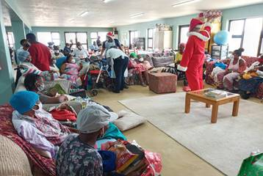 Christmas

The growing need for a residential home for people needing full time nursing care has reached a critical point. Many patients do not have family members able to offer full time nursing care.
For those patients left alone during the day because family members are at work, a day care center will be provided.

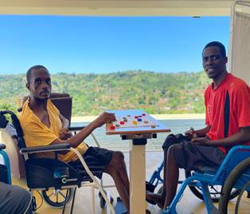

Land for the building of Philakade was provided by the Embo community church who have long been involved in community projects and have initiated a crèche for 128 children (initially for teenage mothers in order for them to return to school), a Primary Health Care Clinic, orphanage and home based care programme with feeding scheme.
Embo is next to Hillcrest in KZN. Nearest city is Durban.

Philakade Care Home is registered with The Department of Health as an extension to the already existing Primary Health Care Clinic run by the Embo Community Church.
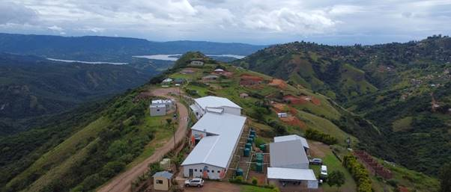

We believe the poorest of the poor in Kwa-Zulu Natal have a right to patient centred long term care. People who are wheelchair bound, bed ridden and needing 24 hour care deserve access to compassionate nursing care, especially people who are marginalised because they are homeless, destitute or abandoned.

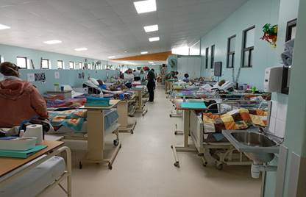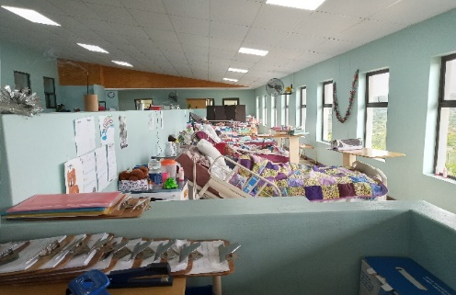

The Philakade Care Home is residential. Through this home, in which people of all faiths work side by side, we respond to the needs of the many people in need of care.

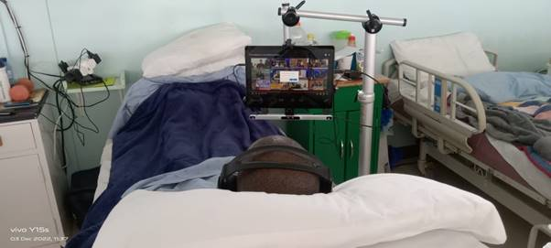
We were able to raise funds for an “eye gaze” computer for a young resident with ALS (the same
condition Steven Hawkins had). He was a fashion designer but is now quadriplegic. The “eye gaze”
enables him to type by using his eye movements alone. He is training students from Embo in fashion
design twice a week with one of his previous students who is his ‘hands’.

We provide a best practice nursing care model in a safe environment, with a daily activities programme, good nutrition and rehabilitation and support of families as well as patient and family centered ‘end of life’ care.
The care home is for people of all ages, religions, national origin, cultural backgrounds and gender.

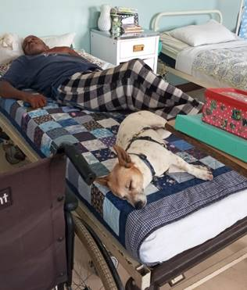 Lucy our 4-legged resident

Philakade Care Home opened its doors on 4th November 2019 to try and meet the enormous need for residential care of children and adults who are wheelchair / bed bound and have been abandoned or whose families are unable to care for them.
Many residents have heart-breaking stories about their lives before admission to Philakade – a paraplegic man who was living under a bridge; a man who is blind and deaf and had been abandoned at a local government hospital 4 years previously; a blind 5yr old girl with severe cerebral palsy abandoned in a hospital in northern KZN; a young hemiplegic man in his thirties shot in the head while studying law and whose parents are too frail to care for him. All our residents have stories of great hardship and suffering as well as great resilience, humour and strength.
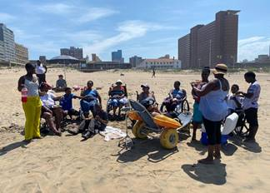 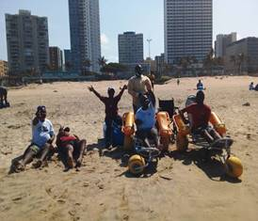 Beach day
Philakade has admitted 205 people since opening. Ages range between 1yrs and 95yrs. Some people who have a home were discharged having regained enough independence to manage on their own during the day when other family members are not around and some residents have died –we offer palliative care, for patients who are terminally ill on admission or whose condition deteriorates and for whom curative medicine is not indicated

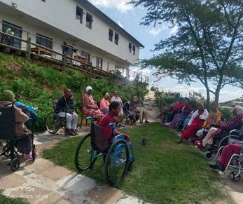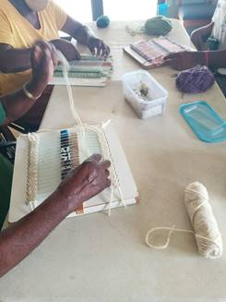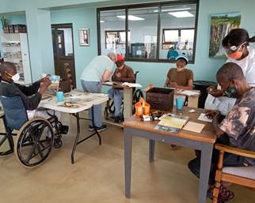
Art and Crafts and outdoor activity

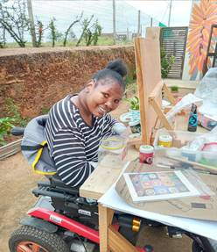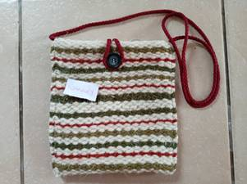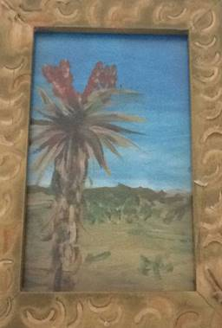

Impact

- 100 children / adults with disabilities receive optimal residential patient centred care and Philakade runs at 100% occupancy
- Publicity is drawn to the complete lack of facilities for people with disabilities needing 24-hour nursing care who do not have access to medical aid
- Rehabilitation of people who have not previously been able to access rehabilitation facilities
- The consolidation of and further development of a community outreach network to care for children and adults with disabilities who are destitute, abandoned or whose families are struggling to care for them
- Training of another 100 community carers. 99 carers have been trained to date.
- Advocacy at a municipal and regional level together with other organisations working to help people with disabilities.
- Income generation for residents

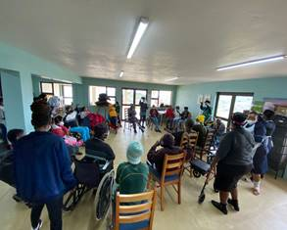 Music therapy group with Occupational Therapy Students
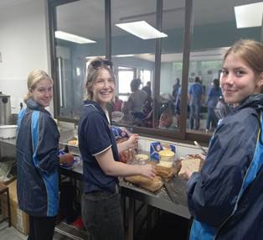 School pupils volunteering to help make sandwiches as part of their community outreach project

Staff training

106 carers have been trained to date from the Embo community. The training course focus is on patients needing special assistance, palliative care and care of the elderly. Students also have to be patients for 2 days and a night during their three month practical training.

All the carers working at Philakade are from Embo and have been trained in basic nursing care and caring for patients with special needs by a volunteer PHC registered nurse (with a palliative care background).

Currently 55 people are receiving stipends (cleaners, cooks, carers and driver).

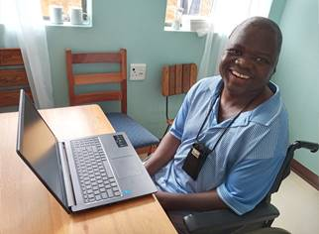
Computer course
ORGANISATIONAL PROFILE:
Name of NPO: Philakade T.L.C Health Post and Care Home
(Philakade Care Home is an extension of the services offered
through the clinic)

Physical address: No.90213 Nqotho Road, Embo Reserve, 3610

Chairperson: Leonard Gcabashe
Cell: 0827741687; email: goodnews@polka.co.za

Care Home Facilitator: Mary-Ann Carpenter
Cell: 073 681 7766; email: mscarpenter@lantic.net

Bank: Standard Bank
Name of Account: Philakade T.L.C Health Post and Care Home
Acc. Number: 10169482659
Account Type: Current
Branch: Hillcrest KZN, South Africa
Branch Code: 045726
Electronic Payments: 051001
Swift Code: SBZAZAJJ
REFERENCE: Name of depositor

Just Giving Site: https://www.justgiving.com/campaign/philakade

Facebook: Philakade Care Home

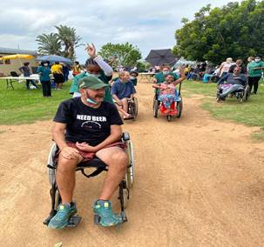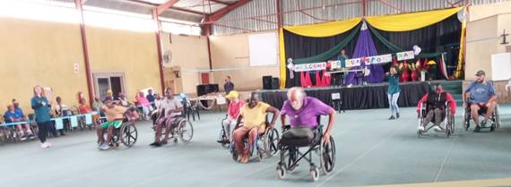
Olympics day

Committee Members
Name | Office bearer  title | Telephone | ID Number
Leonard  Gcabashe | Chairperson | 0827741687 | 5908195744080
Nhlanhla C. Ntobela | Vice-Chairperson | 0718001930 | 6911225641085
Sphindile Olga  Ngcobo | Treasurer | 0660383427 | 6606050880085
Nomusa F. Mazibuko | Secretary | 0724728954 | 7103270796084
Dumisani Hamilton Duma | Member | 07742341564 | 7401225740086
Thembisile Mthembu | Member | 0716284658 | 6512180277087
Andries  Kapara | Member | 0736259467 | 6106035900082
Nompumelelo Mtshali | Member | 0716284658 | 7512310948085
Dr Stephen Carpenter | Volunteer doctor | 0844265002 | 6306105123082
Mary-Ann Carpenter | Volunteer  Care Facilitator | 0736817766 | 5910280107082

Financial Management:

Karl Richards & Associates (Accountants), 481 Lillian Ngoyi Road, Morningside, Durban, KZN, 4001.

Financial matters:

Public Benefit Organisation: 930062527
Non-Profit Organisation: NPO 068-551
- Two signatories are required to sign off payment for a requisition / invoice.
- Funds received are immediately recorded and responded to. This process is monitored by the bookkeeper and chairperson and two members of the committee who keep strict records of all income and expenditure, to ensure that donor funds are spent correctly, with regular reporting to donors.
- An annual audit is conducted each year

Financial sustainability

- Most of our patients receive a government grant and this contributes towards their care.
- Continued fundraising – “sponsoring a bed”
- Medication is collected from our local government clinic for residents who have been collecting their treatment at a local government clinic.
- Cost effective (bulk buying etc.) administration and efficient maintenance
- Water tanks.
- Good security
- Happy, work satisfied staff (regular compassion-fatigue workshops)

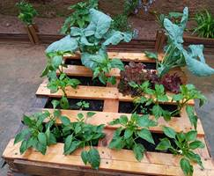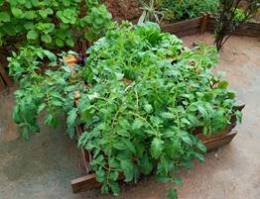
Resident’s gardens

Monitoring and evaluation:

Philakade Care home has a monitoring and quality control system, including:
- clear job descriptions
- time sheets
- patient records
- a patient ‘comments and suggestion box’
- regular meetings with staff to analyze patient centered care, updates and other important matters that may arise
- awareness meetings around work performance and attitudes and when issues need to be addressed
- donor visits to the project to monitor expenditure and achievements (during lock down – these visits have been placed on hold).

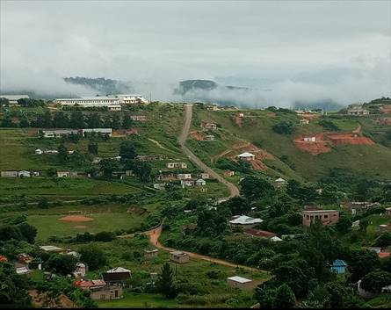
Philakade Care Home on the hill

Cost effectiveness:

- An ongoing cost analysis of expenditure
- Running costs are kept to a minimum - electricity, stationery, communication, water bill (we harvest rain water), equipment and transport
- 10 x 5000 litre Jo-jo tanks are in place to save on water costs.

Quality Control: (ensuring that all staff are able to offer an effective, caring patient centred service):

- The nursing sister supervising the training of carers, assesses their level of competence and knowledge, and evaluates the service being provided to maintain quality service to our patients
- Compassion Fatigue workshops for carers to help prevent “burn out”.
- A generator is reserved in case of power failures.

Screening criteria:

People needing 24 hour nursing care because they are bed or wheelchair bound - who are destitute or abandoned or whose families are finding it difficult to care for them.

New Income Generating Projects

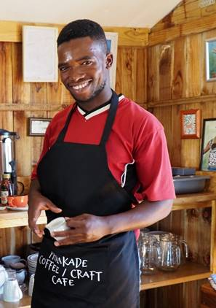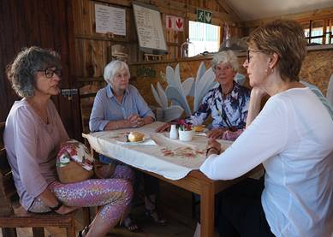
Coffee / Craft Café – we are hoping to attract tourist busses and tours. Two young men from the community have been trained as barista’s and we are selling craft and art from Philakade residents and donated books.

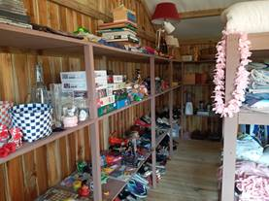

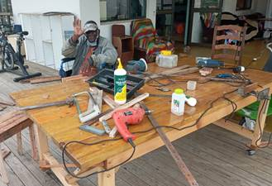 Carpentry

