5/30/2019 4:04 AM
Waiting to pick up the Vicky, tomorrow, and pretty well over jet lag, we became tourists for half a day. Visited Tiananmen Square where big leader Chairman Mao is buried and the young student faced off the tank about 16 years ago. Along the way, stumbled across a duck of Duck Dash fame.

On to the Forbidden City, building and grounds going back over 600 years. Very big and crowded with folks looking at their history. Again, not a speck of litter anywhere. Beautiful grounds and flowers; flags and Chairman Mao again on display. Everyone very well dressed, courteous and proud of their heritage. Our hired tour guide said Capitalism reigns, only the government officials are Party members and everyone appear to live a happy life, ignoring the politics but “staying in line” with all rules and regulations. Lots of police, military and guard presence, authorized to check identity cards at will, which everybody carries. That said, airport entry and customs inspections were a piece of cake and a non-event.

Lee
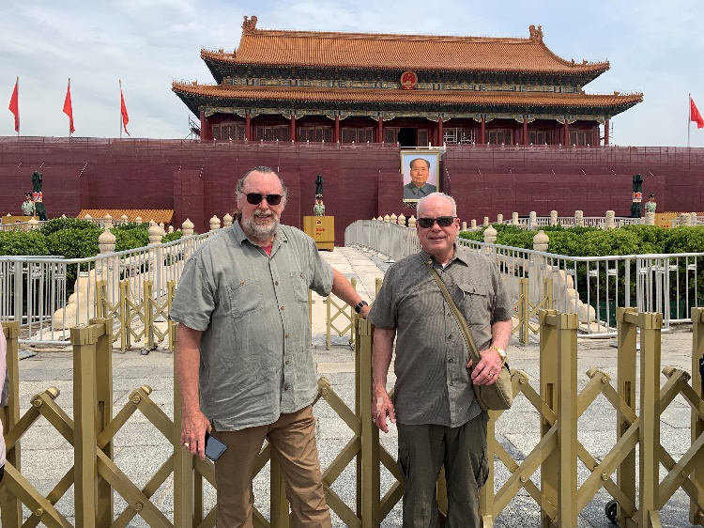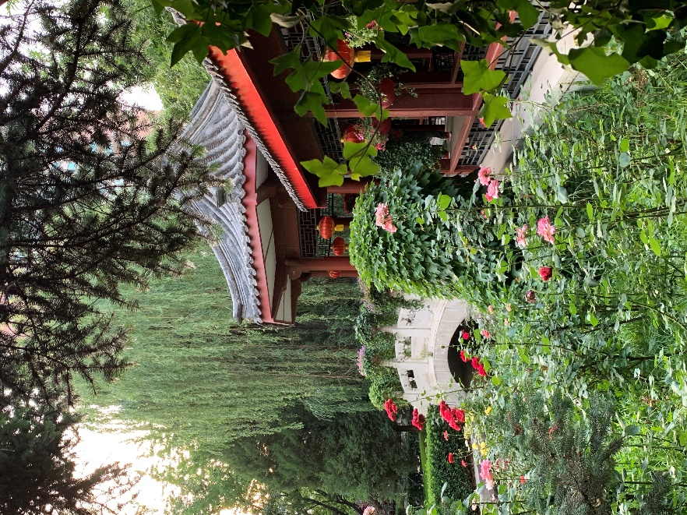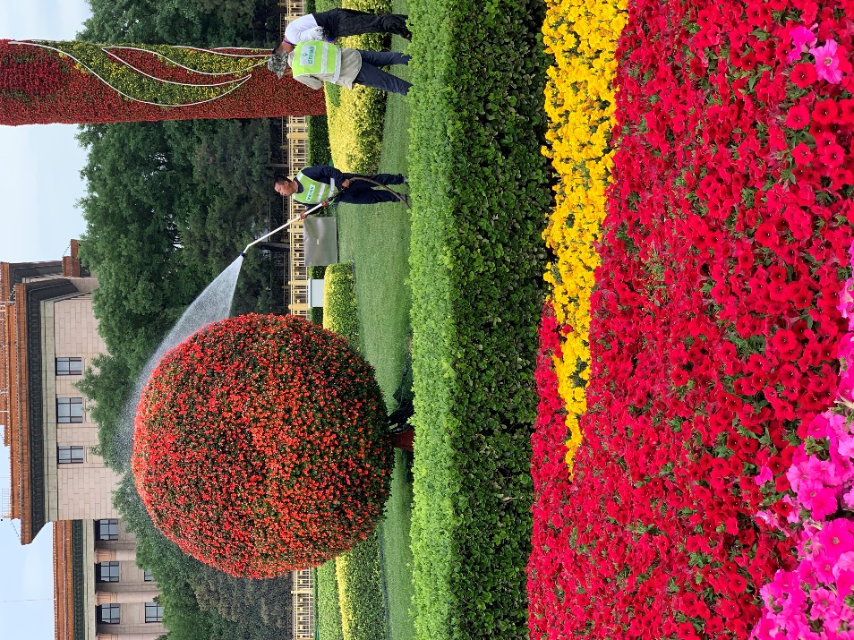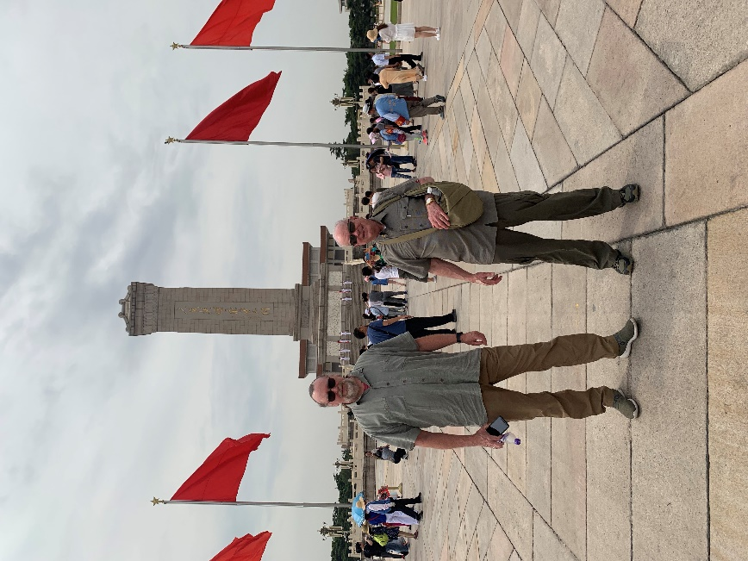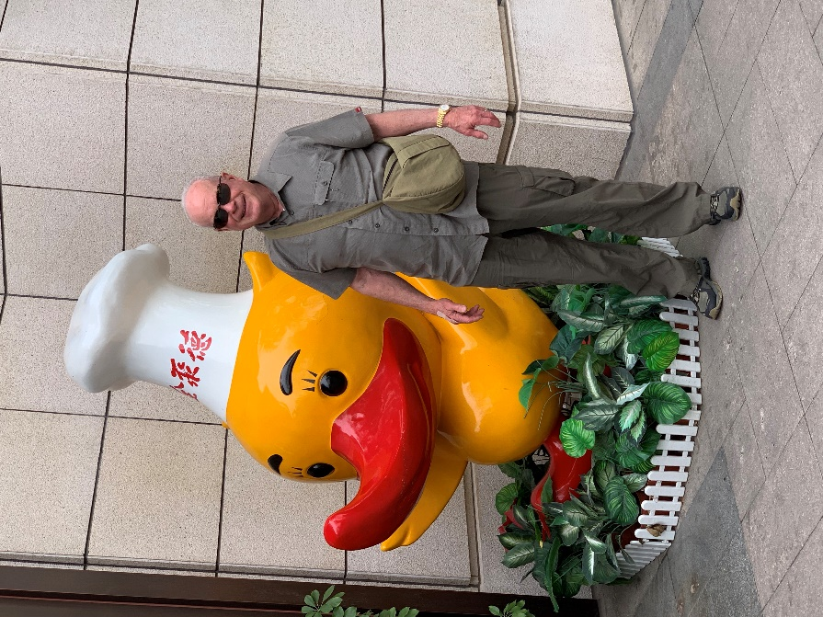
Stunningly beautiful city. Huge. Not a speck of debris on the streets anywhere. Clear beautiful sky with lots of sunshine. Cars and traffic galore.

Meeting fellow P2P-ers, mostly at hotel dinner. Interesting group. Those of us as first-timers all intimidated about what’s coming. Kind of like enjoying the calm before the storm. Our first trial will be fetching the Vicky from the port warehouse, about 50 miles south… then negotiating our way back to the hotel in the middle of Beijing. Hoping that the gps will simply guide us “left” then “right,” etc., since all the roadsigns are in Mandarin. Should be a very interesting ride!

Met R2D2 remote controlled policeman on the way to one of about a thousand Apple Stores to get the internet working. Turns out to be a combination of new VPN service that wouldn’t allow photos from iPhone-to iCloud-to MacBook. Also, hotel internet down intermittently for servicing and adding to the challenge. Bill captured in the modern spiral staircase of Mr. Apple Store.

Made it to “Silk Alley” for the obligatory exploration of “knock off” brand names…. Big box full of fake Rolexes.

Beautiful gardens at hotel.

5/31/2019 4:11 PM
Nuts, Bucky. Sorry you're having difficulty opening files.
can't tell you how frustrating this is. Should be better in the less developed countries, or so I'm told. I'll keep trying. Maybe you could forward to Dave Duskin to see if he can open it on a MAC? Sorry for the inconvenience.

Today is crunch day. The Vicky was perfectly packed three weeks before shipping when we received word that Chinese Customs required all items shipped in the car to be boxed and itemized. Sure enough, they didn't look at anything, the boxes and tie downs totally undisturbed. So today is re-pack for the trip, shop for WATER, car
"snacks" etc., and attend two mandatory driver's meetings. 5:00 a.m breakfast, tomorrow, and to the Wall by 0700 for a 0730 departure on the official, genuine first day of P2P.

Photos of last evening garden party, three-wheeled Caldon vehicle #1, the steam powered vehicle #2 and the most tricked out E-Type Jaguar ever seen. Amoung lots of amazing cars, the Vicky draws a fair amount of attention. A Rotarian, I think from a local club, says Rotary is doing something for all competitors sometime today.
Offererd, of course, my Vicky/PolioPlus talk, which he was enthused about. We'll see what happens; need to get the Vicky ready for tomorrow.

Oh, did I mention: the "test" run from the warehouse pick up back to the hotel using the "Tulip" guide sheets was mostly a disaster, at least to the half a dozen or so P2Pers I spoke with at the reception and dinner last night. Most used their phone navigation systems to get back...one team hired a taxi to follow (!). The town of
22 Million has not one but five (5) Ring Roads... We were on at least three of them but with only two "oh heck" U-turn arounds, one an out and back toll road. Oh my.

More later, Lee

6/12/2019 9:08 PM

Long day but beautiful when not fighting the treacherous roads. First water/ mud crossings were benign but photoed by others.
Wild Horse country with one group cooling themselves in a small lake.
A rather dicey bridge, maybe leftover from first P2P.
Vicky running great but body coming apart.
AC failed (as expected). Wearing masks for dust protection. Re-doubling efforts t stay hydrated.
June 20

Dear All:

Thanks to Rotarian and CPF (Close Personal Friend) Bucky Tart, I forward to you the best effort yet to chronicle P2P and the Miss Vicky saga. Bucky’s doing a great job of receiving and editing a travelogue of the adventure and can be reached at:
https://1drv.ms/b/s!Aul5Q9Fd01zjoFpz5TT_KwxfzbLW

The ERA has professionally edited rally footage and can be enjoyed at www.EnduroRally.com.

It has been quite a day, leaving Kazakistan and re-entering Russia. The greetings upon our arrival(s) have been marvelous and completely unexpected. Folks really get a kick out of
Miss Vicky, sporing an American Flag, no less. People are people, it appears and just want to get along.

Arriving Magnitogorsch, Russia, is a case in point. The city is quite large and is noted for power and production of all things mechanical. This meant armaments for “The Great War,” 1941-1945. Located athwart the Ural river, we received a grand arrival greeting and a certificate (suitable for framing) certifying that we had visited the city that separates Asia from Europe. Intrigued, I hiked down to a large monument overlooking the Ural, while Bill signed autographs (no kidding) at the Vicky. (It must be his innate rugged good looks or sixty’s pony tail, not sure which!). Anyway, overlooking the Ural and in clear sight of an old rusting but still functioning steel foundry, was a large Soviet era star housing an eternal flame. Further down and commanding the monument was a sculpture of two workers, holding a large sword. In the foreground were equally large marble pieces with thousands of names recorded. I was sure but confirmed that they represented the city’s fallen.
It was very moving and I hope a couple of photos confirm the mood with reverence.

We’re off to Ufa, Russia, tomorrow for a two night stay and a whole day for maintenance. Miss
Vicky continues to run according to plan and requires not much more than fluid changes, grease job, etc. A day at a time, we’re on our way to Paris.

Kind regards to all. Visit and enjoy Bucky’s fine work as noted above.

Lee and Bill
June 22, 2019 at 5:07:12 PM GMT+5

Oh dear, Oh dear:

Photos to follow but Miss Vicky has suffered a fractured axle keyway that powers the left main drive wheel.
A “bush” fix has been accomplished fashioning an axle “shim” out of a steel sheet cut from an extra piece left by another vehicle. The fix may or may not allow the Vicky to proceed. Will see tomorrow as we head out of the parking lot and on to our next overnight.

Just over half way to Paris, we’re going to give it our best try. Will know more tomorrow. Fingers are crossed.

Lee and Bill

Thinking JBWeld if brown gaffer tape fails
Sent from my iPhone

From: "R. Lee Harman, MD, FACS" <rleeharmanmd@gmail.com>
Subject: Hot Day Kazan, Russia
Date: June 24, 2019 at 7:14:13 AM GMT+3

From: "R. Lee Harman, MD, FACS" <rleeharmanmd@gmail.com>
Subject: Hot Day Kazan, Russia
Date: June 24, 2019 at 7:14:13 AM GMT+3

Dear All:

Vicky doing well with “bush” fix to drive axle. So far, so good. Gold Onion Orthodox churches are quite spectacular but I suppose will be easily eclipsed in St. Petersburg, three days out.

A warm day, the Vicky AC was quite nice and the envy of many of the “fast movers.” As you can see, some of the curves come quickly, as an 18 wheeler found out, spewing some sort of oil all over the road. Then came the race track “test.” Two laps of a genuine race course which was really fun until I missed the turn to make a second pass. Assuming I’d made two circuits, the timers were really impressed with the Vicky’s very quick time (!).

Pre-flight this early am found the water pump leaking; the head gasket leak has improved after the Stop Leak was added. May have to discontinue using the pressurized radiator cap, even at a measly 4 pounds.
Re-tightened the rear axle nuts and got almost a full turn on the repaired side, which is bothersome. Will re-check through the day.

The travels have been taxing, with “rest” days barely fulfilling the intention. Apparently, to make the event even more interesting, after St. Petersburg, we go 9 straight days directly to Paris. Supposed to separate the men from the boys, so to speak. From the looks of things, the cars and the participants will be fully tested, indeed.

More as events unfold,

Lee

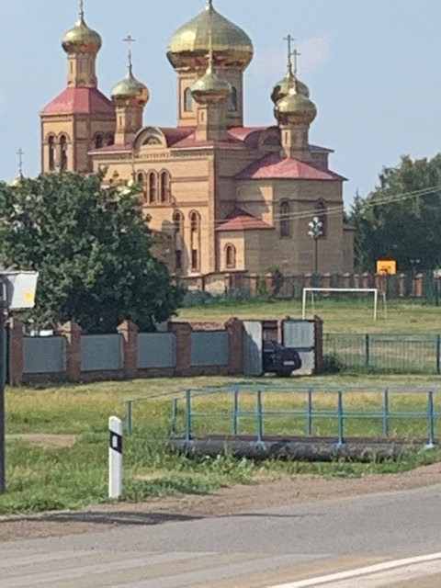
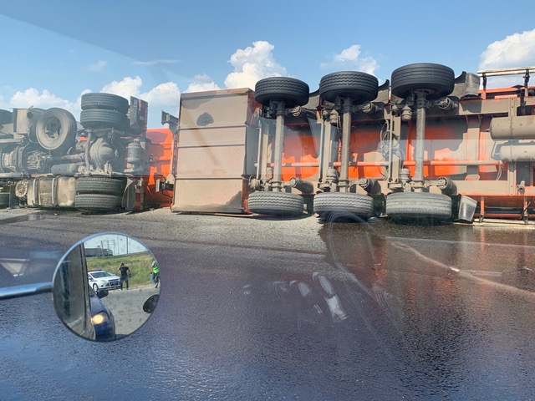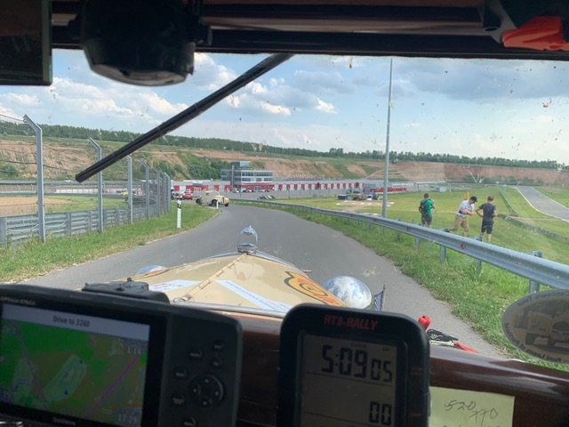

June 26th, Driving Day 25
R L Harman<rleeharmanmd@gmail.com>
6/25/2019 9:08 PM
To Ron Blair, Ron/Terri Love and 55 others

Greetings, all:
We’ve arrived at Mr. Putin’s equivalent of Camp David. The terrain has changed from Rocky Mountains in the extreme southeast to Plains of Kansas (Stepps) of Kazakstan and central Mother Russia to deciduous trees and lots of rivers/lakes as we near St. Petersburg, our goal for today. Still 12 hour drives covering maybe 350-400 miles. Lots of driving with plenty of challenges en route. People in the know say the show has only just begun hardship-wise, even with the roads of the EU in sight. I’ll have to experience it to believe that statement after Mongolian deserts and our current country roads.

The people everywhere have been most gracious and helpful. They love to pose with the cars, especially the Vicky.

The Russian roads are as predicted: patches on top of patches with stretches of beautiful tarmac ending abruptly back on tooth shattering non-roads. Lots of construction work but patched together here and there. As a large city approaches, dual carriageways appear, usually three lanes wide but the lines are merely suggestions and cars go everywhere. No malice in the drivers: if someone is a fender ahead of you and needs to change lanes, they do so and traffic gives way without apparent incident or aggravation. Just the way it is. Drove across a couple of pontoon bridges that looked like they may have been derived from WWII. Some, but not many, post-Soviet era signs/ hammers/ sickles, etc. In about 3500 miles of Russia, only a couple of billboards of Mr. Putin, who otherwise is prominent on the tv channels.

Miss Vicky has developed a head gasket leak and we’re too late in the game to order in another one. So, “bush” fixed it by carrying lots of water, eliminating coolant pressure and trying to stem the tide with silicon caulking… fairly novel, we think! We could only find the caulk in white, which unfortunately detracts from the heart of our “Ford with a soul,” as some have mentioned.

Looking forward to St. Petersburg where Bill and I hope too do at least a half day of touring if we can quickly accomplish our maintenance chores.

Kind regards to all,

Lee and Bill
