**The following steps are to be used to download, expand,**

**and view our Installation Booklet 2020-21.**

1. Open your browser and paste in the following link:

<https://app.box.com/s/8u5gqe8duizrnxi86qef9yiikuij6kfc>

1. This link will take you to the file location where you will download the file as shown below:

a. Make sure you see the file “Installation Booklet 2020-21.zip” on the left side

b. Next click Download

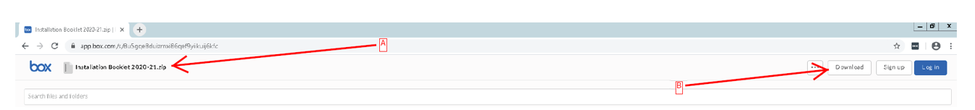

Machine generated alternative text:
Your Download is In progress 
In the loc in in 
Recent' 3 hare, the content VO_I 
Sign up 

3. You do not need to sign up or login in order to download the “Installation Booklet 2020-21.zip”. Simply ignore this message.

As you can see the “Installation Booklet 2020-21.zip” is located in the lower left.

4. Next, select Show in Folder. This will open up your Downloads folder. If you’re using another browser just navigate to your Downloads folder.

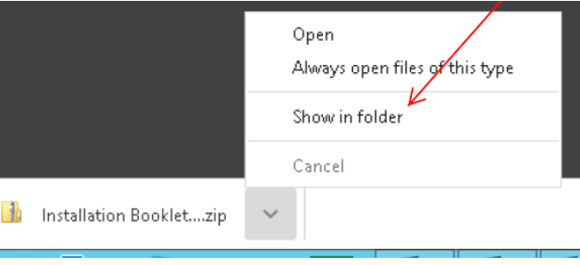

5. Next, right-click on “Installation Booklet 2020-21.zip” and select Extract All

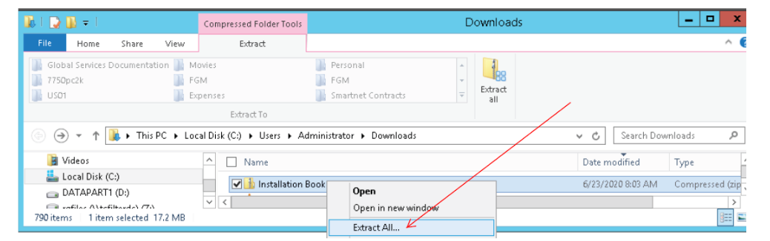

7. Now all you need to do is to double-click “Installation Booklet 2020-21.html” to view the flip-book

6. Next, leave the default settings and just click Extract

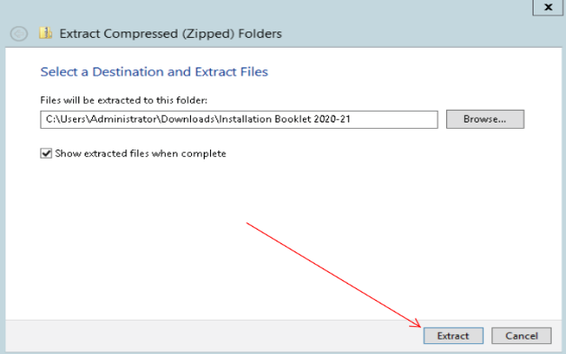 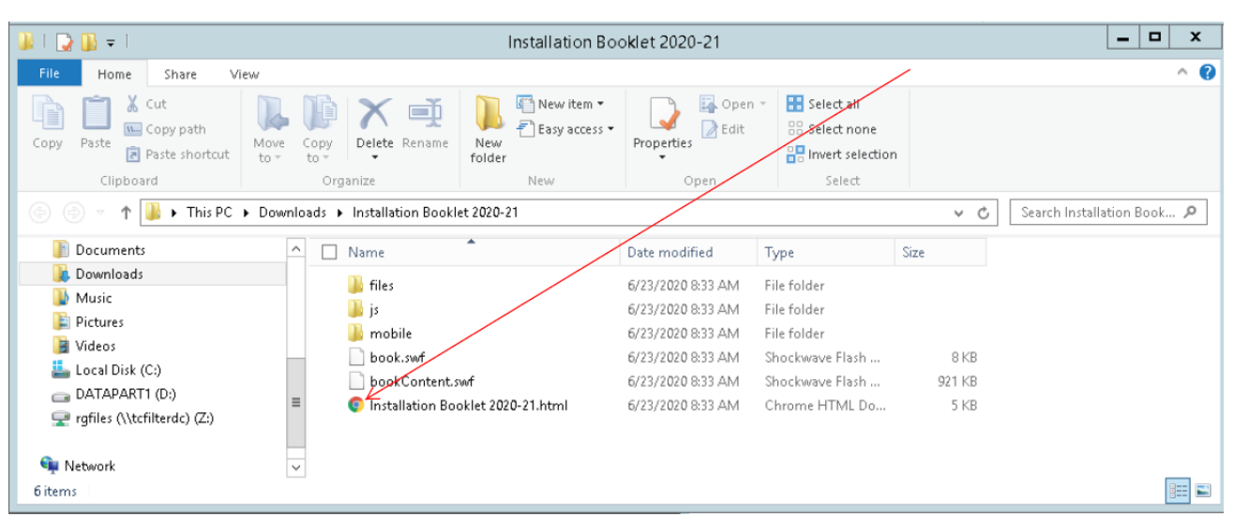

8.When viewing the flip-book just click on the arrow as show below to turn the pages.

