PRESIDENT DAVID'S DELIBERATIONS WEDNESDAY 23rd June
Meeting #2064
This week 14 of us ventured to the Hop Inn on Torquay rd. Great value meals, in fact some could not finish theirs.
Just a good night of Fellowship.
History was created for this event, in that 100% of our members actually replied to my emails. It’s amazing how easy it is to organize a night out when you get a yes x 1 or 2. But more importantly you get a no. At least that way you know everyone has received your email.
Well done Club.
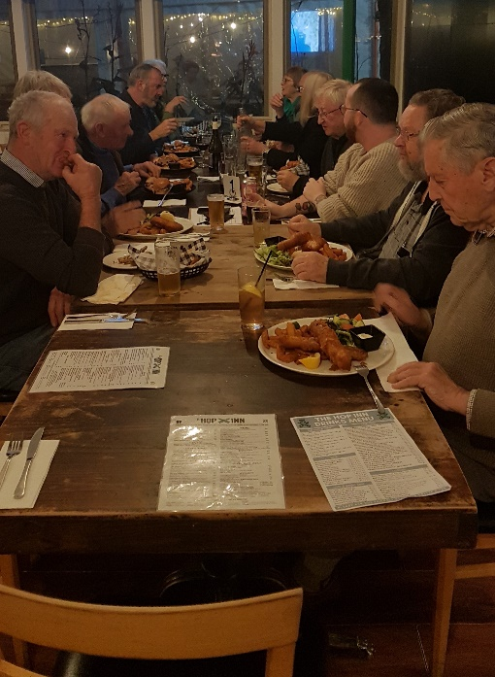

So out of the blue I get a message on Sunday :-
Haii david. How are you? It’s me Anti from Indonesia stayed at your place when I was an exchange student, ages ago.
As it turns out Anti was wondering how we were going with COVID. Found me on Facebook. That is how I keep in contact with all the exchange students.
Used properly Facebook is great.
She and her family are doing well. Son is 21 and Daughter 19.
1991-1992. Ed Pescott was President, John Mc Gibbon Secretary. I received The Rotarian of the Year Award.
I remember, I had only been in Rotary for 18 months. I went home one night and said we are having an Exchange Student, and they wanted a counsellor. Trish took one look at me and said, “so you said I’ll do it. Didn’t you”. The rest is history.
Anti ( A Muslim) use to pray several times a day. She would wash her hands and feet and disappear into her bedroom at night, where she would put a veil over her head and then pray. One night, not long after she went into her bedroom, we hear this laughter. We rushed down to her bedroom. To find out our 6 year daughter had hidden under her bed , to see what she did.

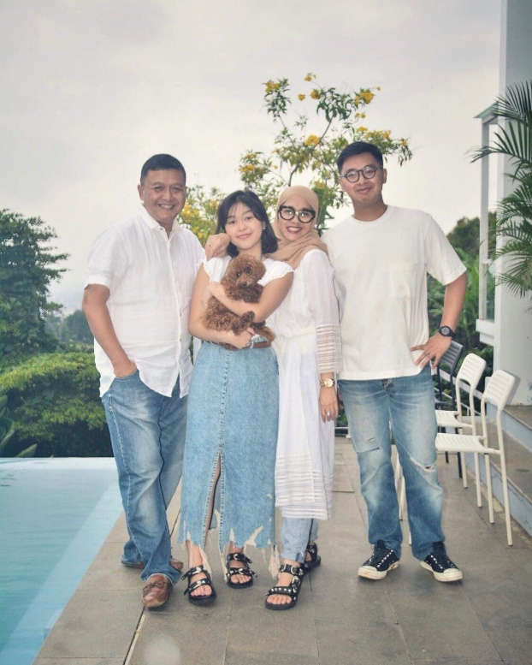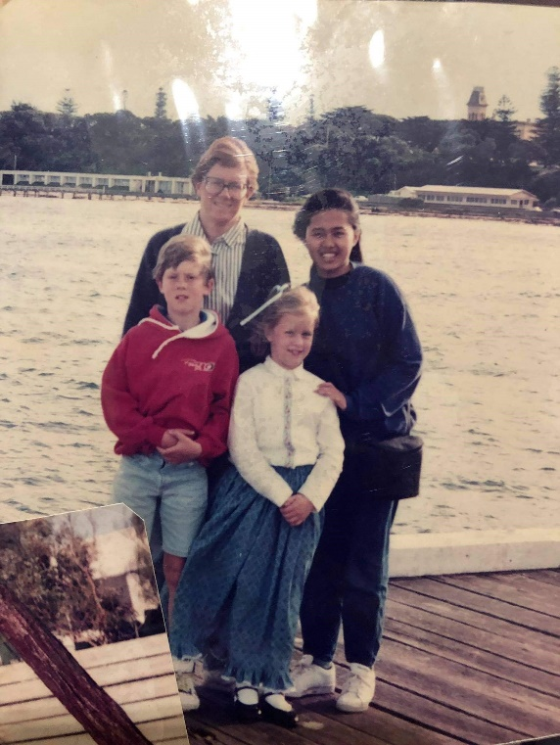

MEETINGS CALENDAR

June 30th No Meeting. An Executive decision made by me and seconded by Don.

JULY 7th Change Over Dinner .
This will be at a new venue. Thanks to Don’s ground work.
Jordan, Trish and I hope to finalise this on Monday.
The price will remain the same.
I will confirm the time.
I will contact ALL guests and members. So please have your Yes (and how many) or No ready.

President David

.

