PRESIDENT DAVID'S DELIBERATIONS
Wednesday 28th April
Meeting #2060

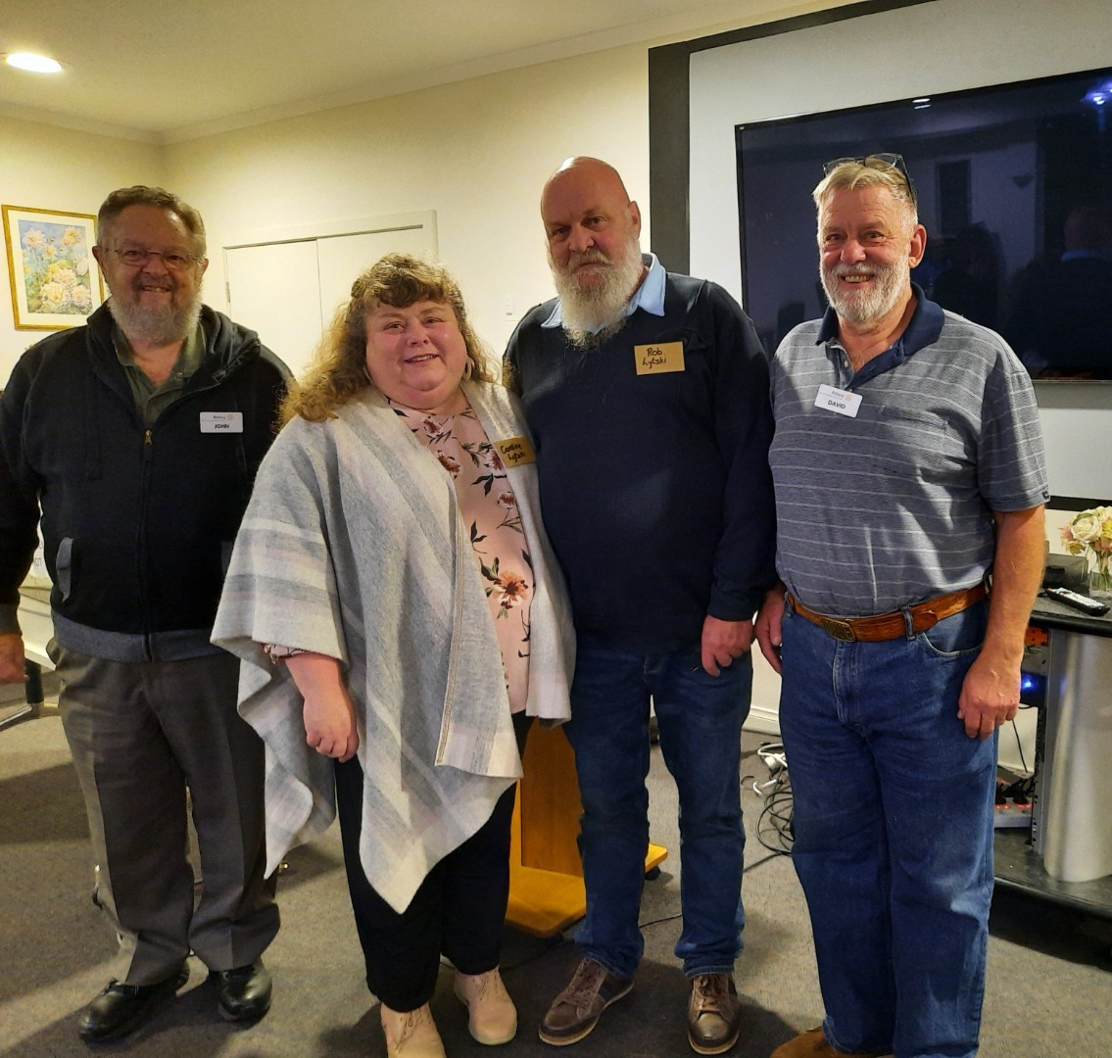
John McGibbon P.P Caroline and Rob Lytzki (Foundation 61) David Carlyle Pres.
Rob
Spoke with pride when he told us how far they have come. From people sleeping on couches to a 15 bed facility. Hopefully after year of battling Bureaucracy, the 8 bed female facility should be under way soon .
https://www.foundation61.org.au/
On the good news front (as I reported last week) Thurs BBQs at Bunnings are back on the agenda. Gary is already working on the roster. We also have the opportunity to do a Trade day BBQ at Barwon Timber. This will be Thursday 6th May 6.30am to 10.30 am. Contact Gary.

MEETINGS CALENDAR * Note Changes for Committees

MAY 5th Committee Meetings Rice Village. BBQ night. Numbers to Jan by Sunday 2nd please on 0419341112
May 12th At this stage it is likely to be a movie and meal night. Jan is in the throws of finalizing details.
19th Joint Board Meeting on zoom
26th Dinner Meeting at Rice Village. Partner's and guest’s night. Speaker is Mary McPherson. "Living in the Middle of the Desert ". Numbers to Jan please by Sunday 23rd on 0419341112
JULY 7th Change Over Dinner at Rice Village. Numbers to Jan by Sunday 4th please on 0419341112.

You need to book in , we need to have fairly accurate numbers for the kitchen.
We are not doing this very well. Please call or text Jan. Unless you do this we assume you are NOT coming.
I realise we may have people turn up on the night, and others who have something pop up which means that they cannot attend. Such is life.

President David

.

