PRESIDENT DAVID'S DELIBERATIONS
Wednesday 10th February 2021
Meeting #2053

We had a fun night at the Leopold Sportsman’s Club. Barefoot bowls was the order of the night. However, everyone seems to have footwear ?????

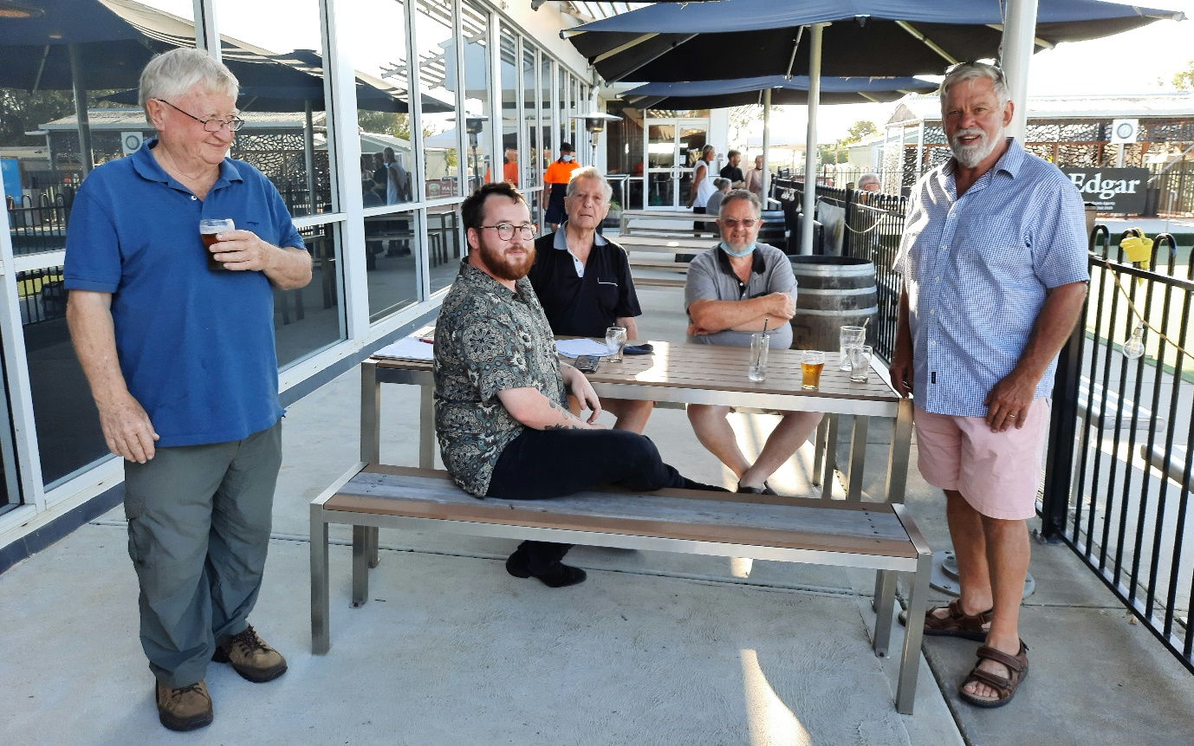
The Match Committee consisting of the better players, who stood aside to allow others a chance to enjoy the night.
This is an Elite group. L-R P.P. Bill, incoming Pres Jordan, P.P. Ray, Immediate P.P. John, and myself.

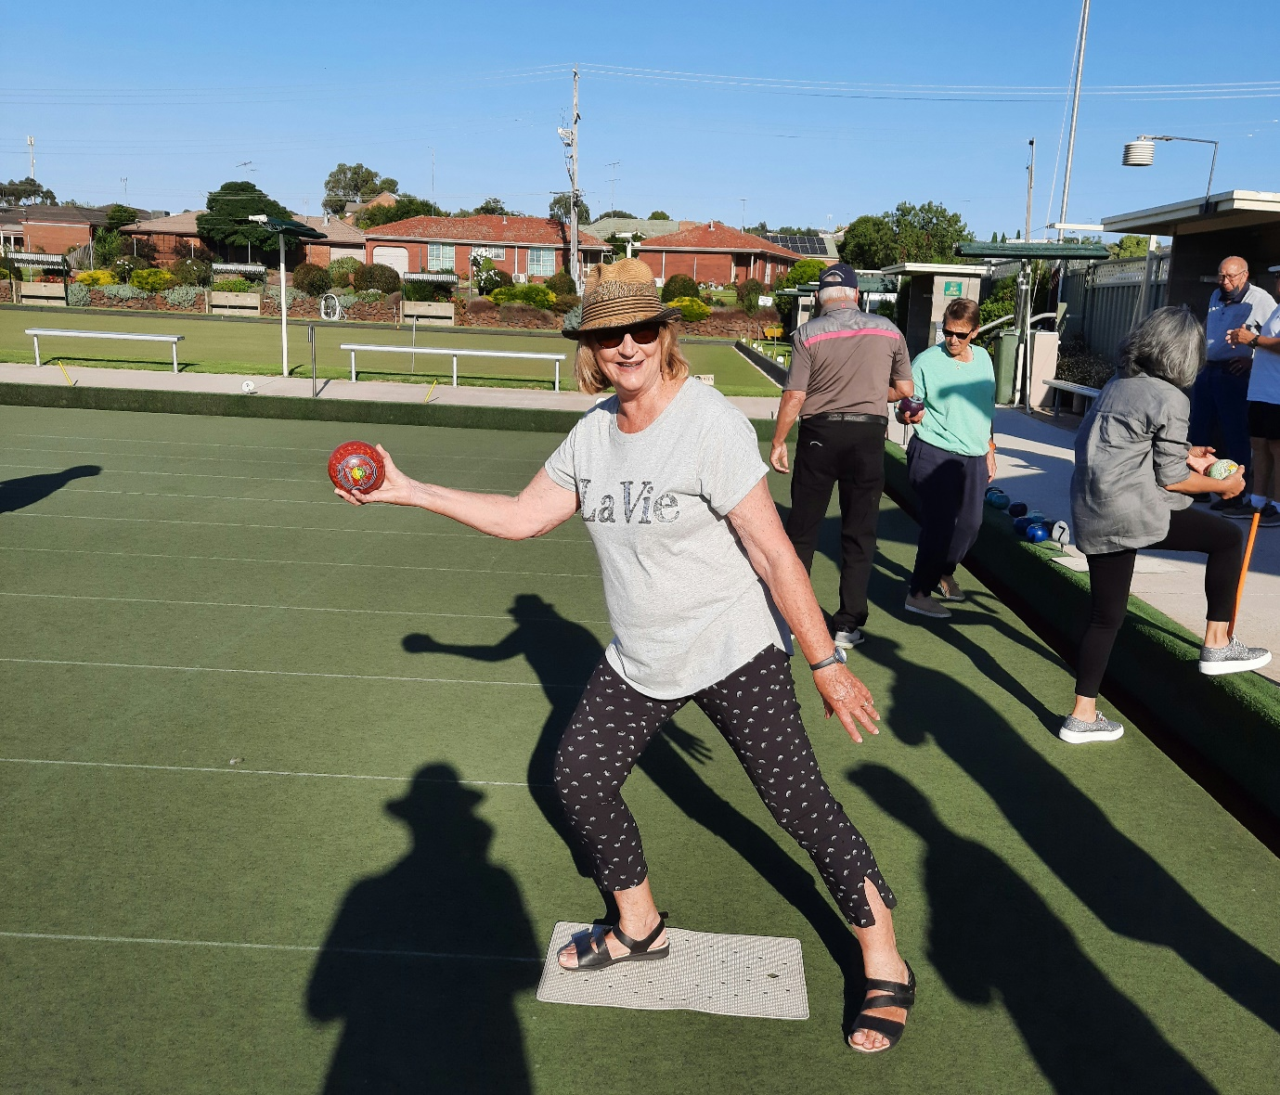
Someone forgot to tell Jan you bend down and roll it on the grass. I think she was aiming for a good length Bowl, to win the End.

Joint Meeting with Torquay 24th February Rice Village 6.00 for 6.30 pm
Just a reminder that we are hosting our annual joint meeting with Torquay at Rice Village. It will be a sit down dinner with two courses at $25. Please invite your partners and friends as it will be a great night. Our special speaker is Michael Murphy who has worked internationally in the aluminium industry. Let’s make this a special get together for our two clubs. For catering purposes I need numbers no later than Sunday 21st February. Please call or text me on 0419341112, if you didn’t let me know at the bowls night.
Thanks Jan Gillett

Club Calendar
17th February: Board Meeting via zoom. All members welcome.
Starts at 7.30pm
Meeting ID: 771 008 4602
Passcode: 47Wb15
24th February: Joint Meeting at Rice Village with R. C. Torquay. The speaker will be Michael Murphy former international executive with Alcoa.
Normal Meeting time 6.15pm for 6.30pm.
Cost $25/h
Numbers limited to 60.
Numbers (not set in place, just indicative) to Jan by this Monday so that Barb can plan her meal. Final and Firm Numbers by Monday 22nd Feb
28th February: BUNNING’S BBQ
3rd March: Committee Meetings. Times and venues to be advised.
10th March: Gary’s Fun Quiz night at Rice Village.
17th March: Board Meeting via zoom.

Joe got in Early. I have received a lot of good feedback on the meal.

Heather enjoyed the Chilies in her meal. Gary’s T/Bone was huge , The seafood pasta looked great.
History was made, in that I could not finish my Parmi. Yep you have read this correctly. It must have been the 2 chips I had off Joe’s plate.

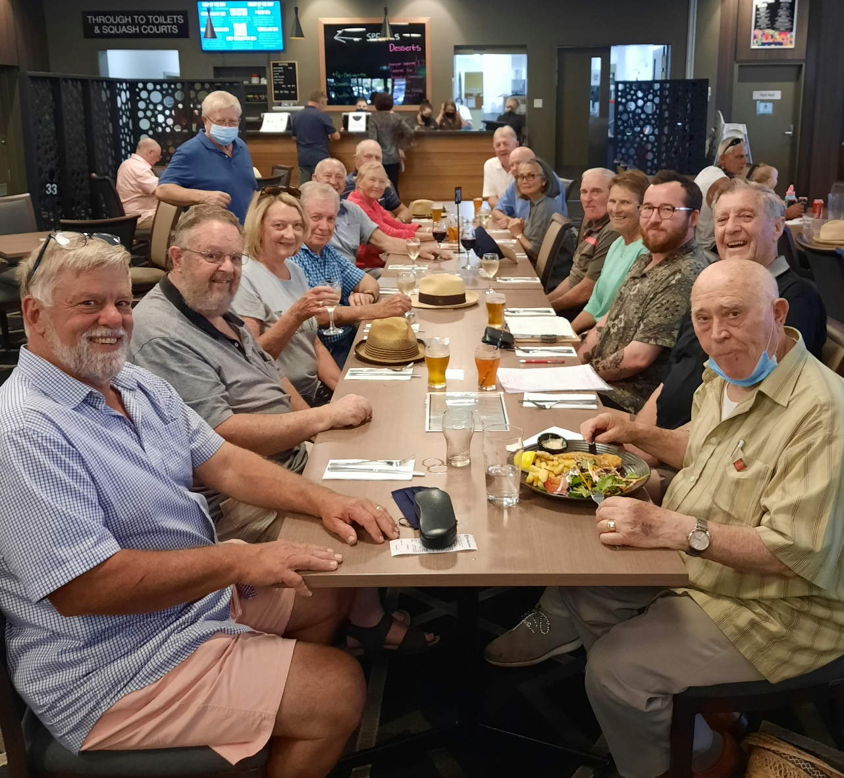
Lock Down Again. But it does seem to work.

Just as well the Board meeting is via Zoom.

Wear a Mask , Stay Safe.

President

David

