PRESIDENT DAVID'S DELIBERATIONS
Wednesday 24th March 2021
Meeting #2056
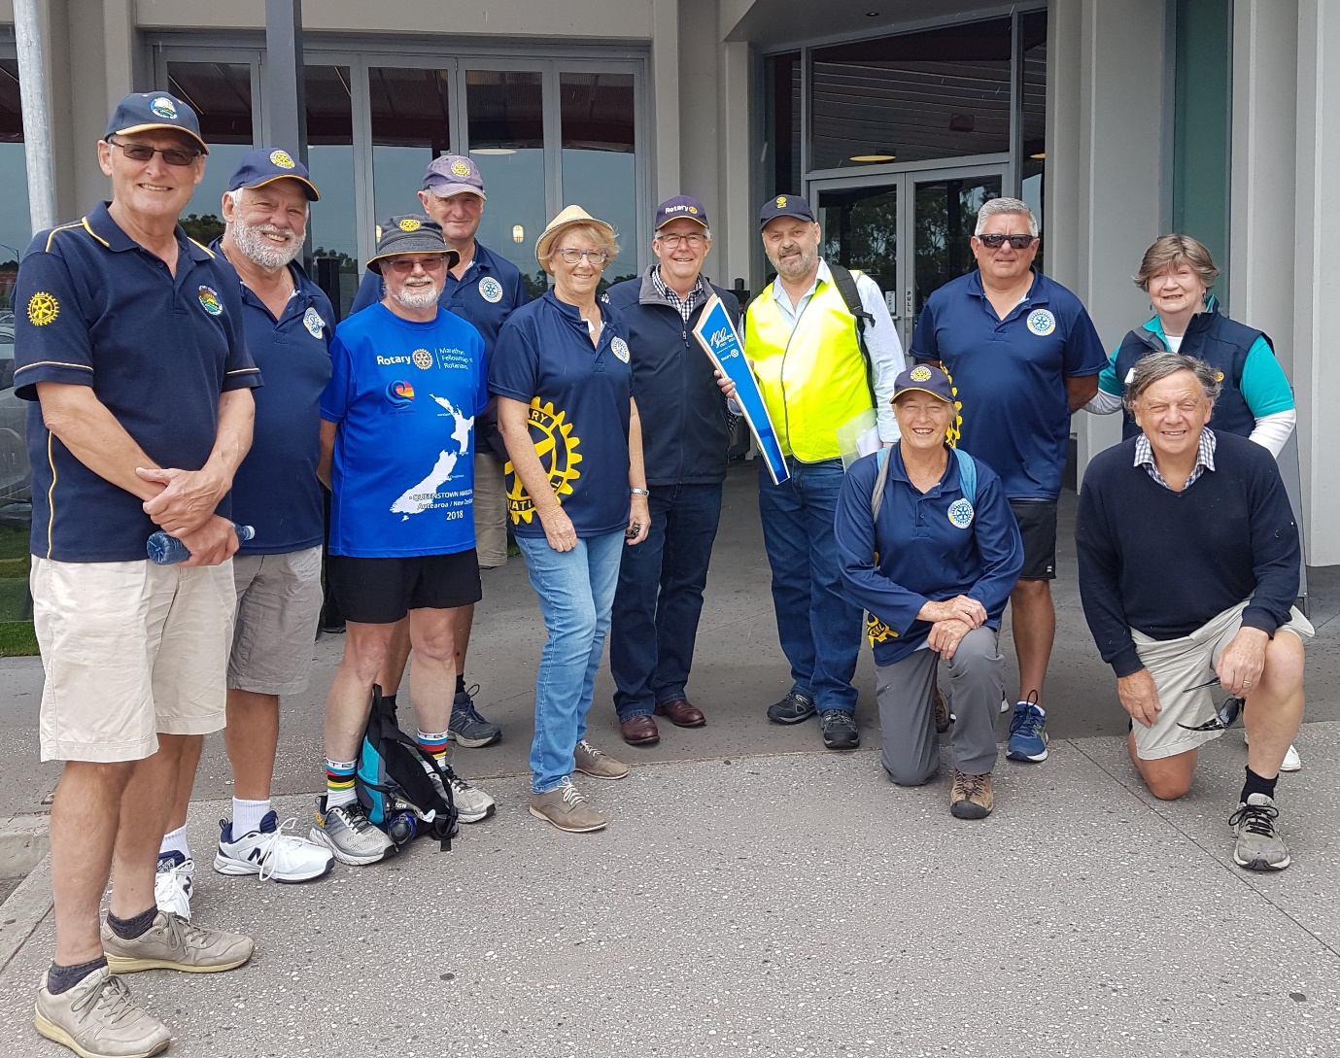

I forgot to put this in the newsletter last week. This is the group (a couple came after the photo) that did the whole 8.6 km walk. Waurn Ponds Shopping Centre to Christ Church.
We were well represented by myself, Don Lester Trish(my dear wife ),Lesley and Phil.
Trish who did it in the car provided the very valuable service of driving our members back to their cars.
Phil and Judy were there for appearances only. Don’t think I’m wrong in saying they probably did more than enough during the day.

OBERON SOUTH PRIMARY SCHOOL Community BBQ Friday 26 March 2021

Oberon South Primary School now exists on Kidman Avenue in the grounds of the previous Oberon High. All the old school has been demolished, including the garden and playground.
At the moment there are 37 pupils. Acting Principal is Stephen King and Bec Rees is in the Office.
The new buildings are terrific and include a great canteen.
Stephen indicated that they are keen to see the Breakfast Program restarted next term if possible. Noel Lunnie is the coordinator from Belmont. There may also be an opportunity to join with Belmont to assist with reestablishing the vege garden and chook shed. Kevin Stuart has a part to play in this project.
There was a photo and article in the Geelong Advertiser on the new school showing the 3 new preps who started this year.. (Saturday 27 March)
I asked about a tour of the school by the Club as per a suggestion last Wednesday at our Committee meeting and this was welcomed. Details to be finalised early next term.
It seems that there will be many opportunities for GWP Rotary to help the school community if there are volunteers available.
John McGibbon

Thank you John for his report on Oberon South who are keen to get the breakfast program. I will chase this up with Belmont.
Also thanks to John in Chairing the Committee Meeting night.

As Usual Keep Safe.

REVISED MEETINGS CALENDAR * Note Changes for Committees
MARCH 31ST No meeting
APRIL 7th Social Night at Rice Village. Partners and guests night. Numbers to Jan by Monday 5th on 0419341112.
Frank Nott will talk about his life.
14th Dinner Meeting at Rice Village. Joint Meeting with RC Ocean Grove and partner's night. Speaker is P.D.G. Stephen Lamont, RI Convention Melbourne 2023. Numbers to Jan by Sunday 11th on 0419341112
21st R 100 Birthday celebrations. Details to follow.
28th Dinner Meeting at Rice Village. Speaker from Foundation 61. Numbers to Jan please by Sunday 25th on 0419341112

MAY 5th Committee Meetings Rice Village. BBQ night. Numbers to Jan by Sunday 2nd please on 0419341112
May 12th TBA
19th Joint Board Meeting on zoom
26th Dinner Meeting at Rice Village. Partner's and guest’s night. Speaker is Mary McPherson. "Living in the Middle of the Desert ". Numbers to Jan please by Sunday 23rd on 0419341112

JULY 7th Change Over Dinner at Rice Village. Numbers to Jan by Sunday 4th please on 0419341112.

You need to book in , we need to have fairly accurate numbers for the kitchen. As they are working with less volunteers and staff.
I realise we may have people turn up on the night, and others who have something pop up which means that they cannot attend. Such is life.

President David

