Tonga Dental Health Project project 2022

Rotary Club of Ballarat West RAWCS Project 144/2005-06; District 9780
Project Overview; Aims and Objectives 2a
Purchasing and shipping a 40ft container to ship requested donations of Dental and Medical Equipment
  - Equipment to install new dental clinics in three secondary schools.
    - Queen Salote College (all Girls),
    - Apifo’ou College, (Catholic) and
    - Tupou College (all Boys)
  - Equipping First Aid rooms in these schools- including a 16-bed Health Clinic at Toloa
  - New School Libraries for the Queen Salote College (Junior and Senior)
  - Donations of Medical equipment and supplies for the Vaiola National Hospital
  - Converting the container into a permanent maintenance and repair facility at the Vaiola Hospital
  - Providing emergency Aid supplies for the Tonga Volcano and Tsunami disaster recovery

This is registered as RAWCS Rotary Club of Ballarat West Project 144/2005-05.
Our volunteer dental projects in Tonga have continued since 1996 and established many friendships and close contacts. Without this established medical, dental, and engineering support, it would have been extremely difficult to successfully implement such a varied project in just two weeks and during an active Covid epidemic.
We are grateful and deeply honoured for the staunch support we received throughout our stay, including from;
- Her Majesty Queen Nanasipau’u of Tonga
- the Prime Minister, Hon. Siaosi ‘Ofakivahafolau Sovaleni
- the Australian High Commissioner Ms. Rachel Moore,
- the CEO of the Ministry of Health Dr Siale Akau’ola
- the Minister of Health Hon. Dr. Saia Piukala
- Lord Tangi
- the Rotary Club of Nuku’alofa
- Dental Department CEO Dr ‘Amanaki Fakakovikaetau FICD, DR. Sisilia Fusi Fifita FICD, Dr. Susitina Piukalu and the dental staff at Vaiola Hospital
- Past and present students of the three schools, and countless others.

This Rotary project was greatly assisted by the strong backing of past students from the years Safaia (Dr Sisilia Fusi,), Amatakiloa ‘O Kaimelie ‘Api Ko Petani (Dr. Tule Akau’ola-Misa, Seini Manu) of Queen Salote College, and Longoteki ‘ae Uma (Dr. ‘Amanaki Fakakovikaetau, and Lopeti Lanivia) for Tupou College. Past students have pledged ongoing support of supplies, staffing, and finances together with the Tonga MOH which ensures the long-term viability of these clinics

Rotary clubs and Districts such as Keilor, Ballarat East, Balwyn, Cranbourne and Koo-We-Rup, the International College of Dentists (ICD), the Rotary Foundation, RAWCS, and others supported the project financially.
RC Ballarat East members loaded three DIK truckloads of donations from Ballarat, driven from Melbourne by David Dippie such as 25 TVs, books, and 276 banks of library shelving.

Two 40-foot high-cube shipping containers filled with donations working from the Wish Lists supplied from Tonga were shipped from the DIK West Footscray Store in Melbourne in April and May to the Vaiola Hospital, Nuku’alofa. These containers included all the equipment and supplies needed for the above projects

Central to this project’s success has been utilizing the management, accountability, and resources of Rotary Australia World Community Service (RAWCS) and Rotary Donations-In-Kind (DIK), plus the added value of Rotary Clubs networking together. Such a large undertaking as this, involving three Rotary Districts, several individual projects, and multiple Rotary Clubs, simply would not happen within Rotary without this RAWCS support.

Also crucial locally, was the organisation, commitment and ongoing work by Mr. Sioeli Manu, the chief dental engineer for Tonga. There was regular, sometimes daily, communication between the project managers Dr. David Goldsmith in Australia and Mr. Sioeli Manu in Tonga over many months.

A new Library for Queen Salote College. Tonga
Key supporters were ‘
- Rotary Club of Ballarat East
- RCBW supporter Selina Knight at Ballarat and Clarendon College
- Ballarat City Library.
Their donations of 276 bookshelves, three pallets of quality books, plus chairs, stools, tables, and filing cabinets enabled us to furnish both the Senior and Junior Libraries with books, shelves, photocopier and computers
The Guest of Honour at the televised opening ceremony was Queen Nanasipau’u of Tonga.
This project at Queen Salote College came from Queen Nanasipau’u personal request to Rotary with the support of past students from the years Safaia and Amatakiloa ‘O Kaimelie ‘Api Ko Petani (1980s students)

Ballarat East Rotary donated 25 flat-screen TVs, which have been allocated to hospital waiting rooms in Tonga.

Thanks to team member Marie Knight, 300 “Days For Girls” hand-made kits were distributed from the Horsham Rotary branch to Queen Salote College. It is hoped this will initiate a new DFG chapter in Tonga by the school

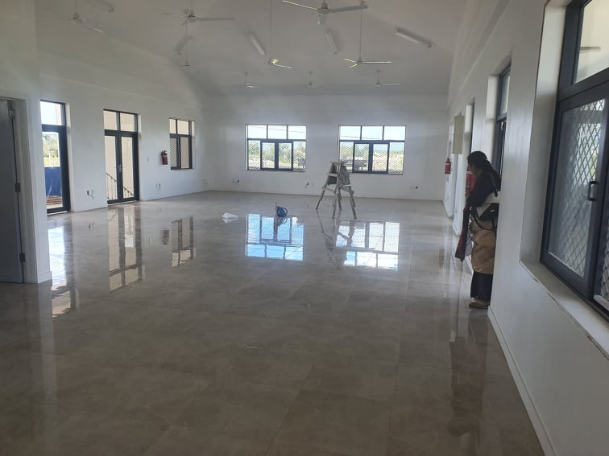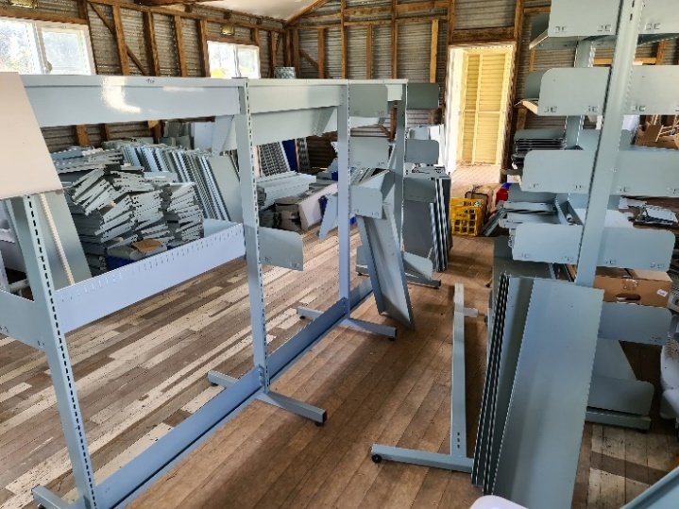
New Library room at Queen Salote College Tonga May 2022 the Rotary Club of Ballarat East donated 276 sets of Bookshelves
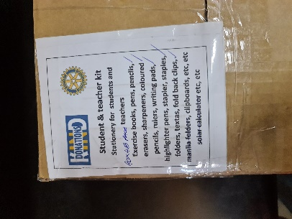
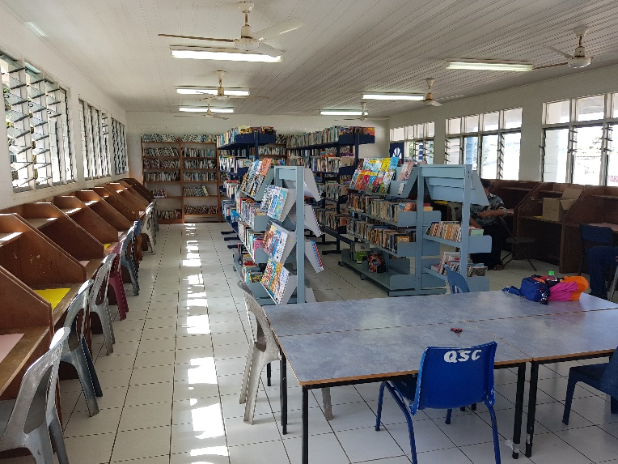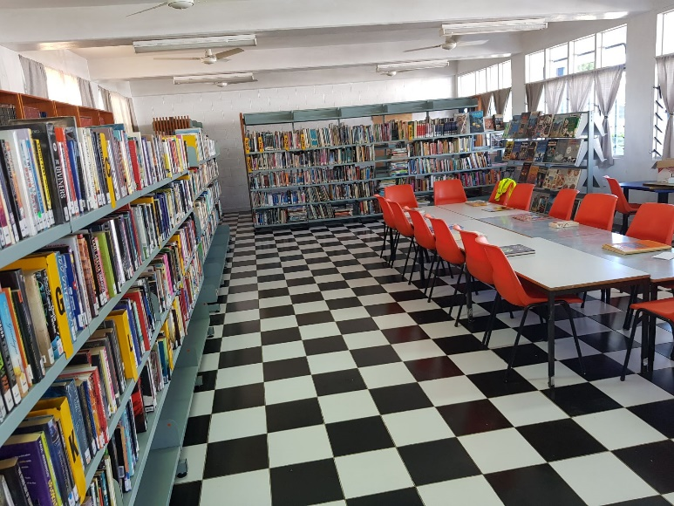
Upstairs Junior Library Ground floor Senior Library

Her Majesty Queen Nanaispau’u of Tonga unveils the new Senior Library at Queen Salote College
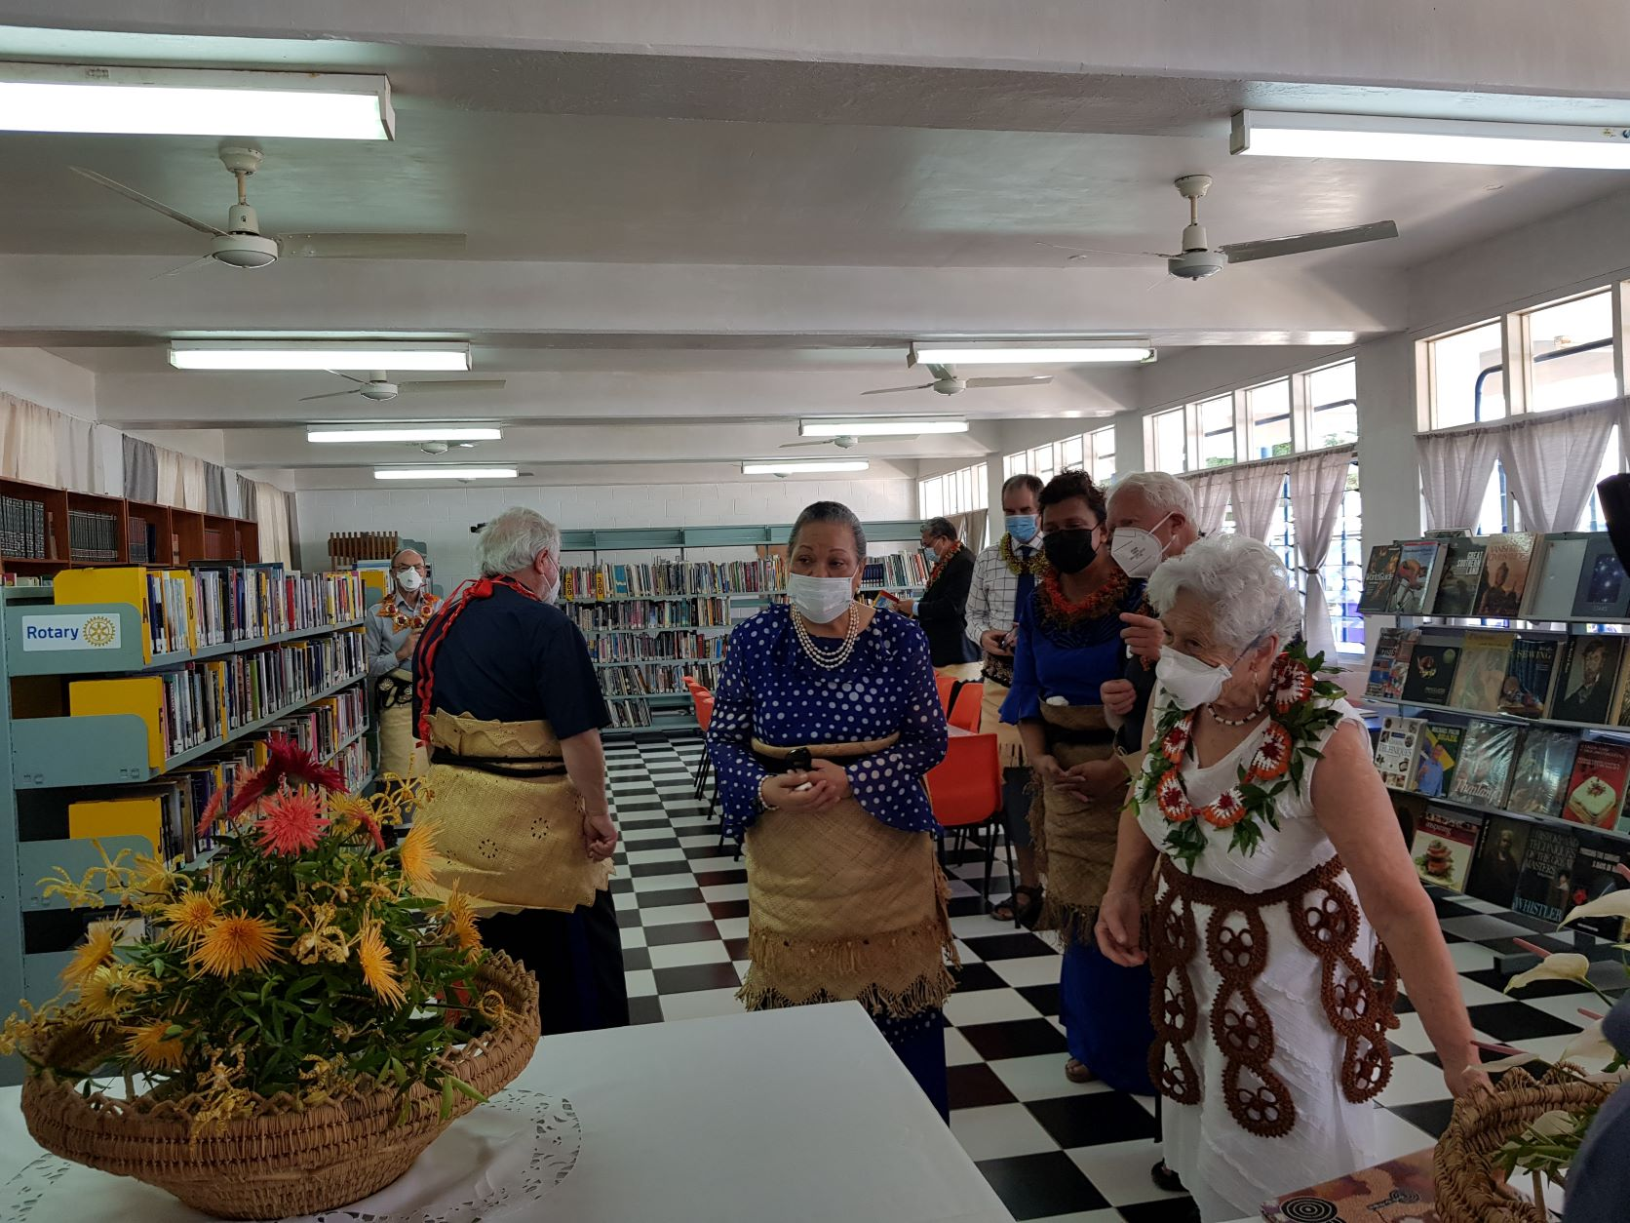
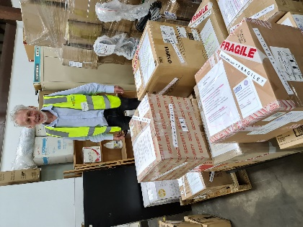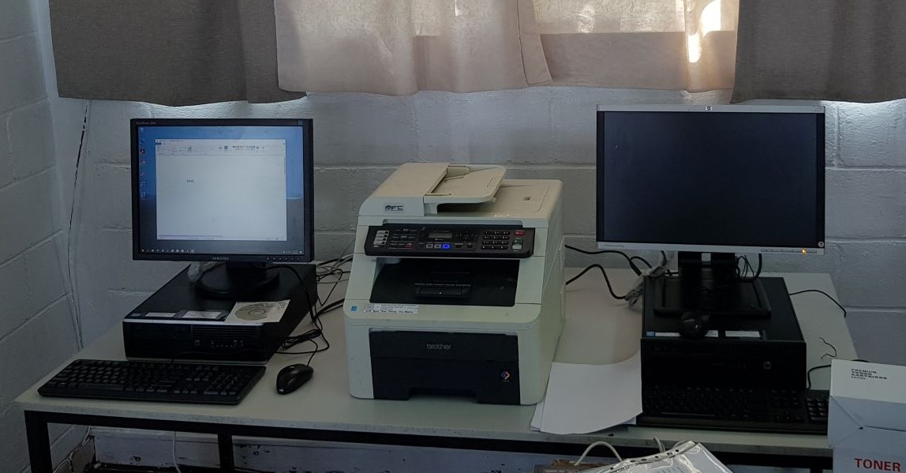
Computer and photocopier and IT equipment donated by Peter Holdenson and the Rotary Club of HOC

First Aid rooms for three schools
Rotary Donations-in-Kind donated the hospital beds, equipment, furnishings, linen and medical supplies for the Sick Bay Clinics in the three schools; Queen Salote, Apifo’ou and Tupou College.
The schools made new rooms available to house these medical facilities.
The facility at the Tupou College Toloa campus will be a 16-bed Health Clinic.
Rotary DIK has packed supplies and equipment to furnish this and the other First Aid rooms with the following items;
- Hospital Beds (34), Bedside medical cabinet, bed linen, over-bed tables,
- Crutches, Wheelchair, bandages, and a comprehensive range of sterile dressings
- thermometer, sphygmomanometer, BP monitor, trolley, IV stands
- gloves, masks, rubbish bin/bags, table, chair, hand sanitizer, disinfectant
- Large range of professionally selected wound care packs, eye-wash, etc.
Computers
The Rotary Clubs of Oakleigh, Huntingdale and Clayton, Peter Holdenson and Nucleus Computers made generous donations of commercial computers, colour laser printers, laptops and photocopiers, together with spare cartridges and paper. They will be allocated between the QSC Library, the Vaiola Hospital dental department, and the three secondary schools.
Dental Clinics.
Dental Equipment sent in two DIK containers has equipped three new school clinics. Spare parts in the new Rotary Dental Workshop will be used to maintain the dental equipment throughout the Kingdom.

This project will allow Tonga to extend its junior and kinder preventive dental programs (Mali-Mali) into three main secondary schools, including one with over 1000 full-time boarders. This gives these schools the considerable advantage of students having their clinical and preventive dental treatment performed on-site in familiar surroundings, without them having to leave the campus to visit the hospital and losing a day’s education.
The Dental department has agreed to staff the clinics. Alumni Dentists from these same schools together with the MOH and past student bodies will sustain them with supplies.
The Royal Melbourne Dental Hospital has donated 6 dental chairs of models(A-dec) ideally suited to Tongan conditions and come with spare parts available. Three more Adec chairs were also donated by dentists.
Five robust older style autoclaves have been donated and factory validated to Australian standards by Siltex Australia in Melbourne, and they also came with spare parts. Autoclaves are vital pieces of medical equipment. These sturdy models withstand the large voltage fluctuations experienced in the smaller Outer Islands much better than many newer models.
Also, Tongan Biomedical engineers and dental staff have experience in working, maintaining, and repairing them.

The aim of this RC Ballarat West project is to make Tonga self-sufficient in dental equipment and maintenance
We decommissioned three dental practices in Melbourne and their entire contents were donated to the project. Other dental donations include $30,000 sets of new denture teeth and $25,000 of orthodontic supplies (bands, braces, NiTi arch wires etc.), sets of surgical and conservative (fillings) dental instruments for all the new clinics, and the purchase of new items from our funding resources such as a hand-held X-ray machine (a Tonga first), new water distillers, an Intra-Oral camera,(a Tonga first) an Apex locator and endodontic handpiece, and X-ray developers.
RC Ballarat West progressively accumulated donations over the past 12 months from an extensive Tonga Wishlist, which were shipped in two 40-foot-high cube containers in May and June. The containers were packed and sorted so that the items inside to be unloaded progressively as needed and the contents were unloaded and at their respective venues when the Rotary team arrived in Tonga. Many of these donations included medical supplies from Melbourne Donations-in-Kind and books and shelving from RC of Ballarat East.

The total value of the donations provided would run into many hundreds of thousands of dollars

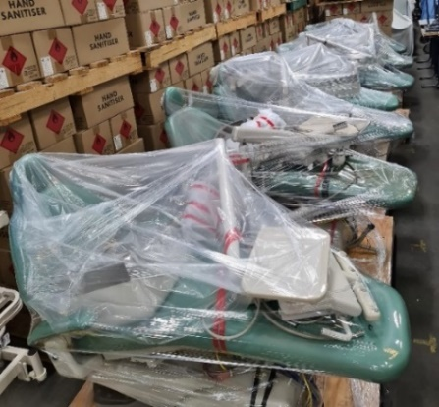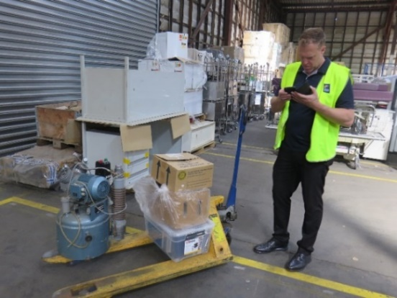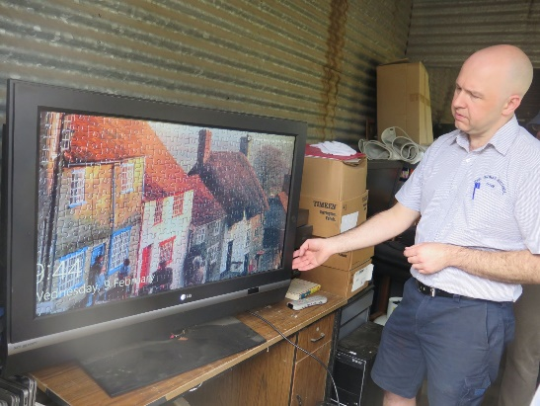
Dental chairs from DHSV / Engineer Cale Ziola checks suitability of the dental equipment/ 25 TVs for waiting rooms
Dental Repair and Storage Workshop at Vaiola Hospital
One of our shipping containers has been converted into a much-needed Dental Equipment repair and storage workshop.
In Tonga the hospital staff had painted the outside and put on a roof to protect it from the climate, and had already installed the shelving, workbench, and two air conditioners when we arrived. Almost all of the spare parts and tools in the workshop have been sent progressively over the years from the Rotary Club of Ballarat West.
Mr .Sioeli Manu has provided a detailed workshop inventory. This is a very well-organised storage workshop

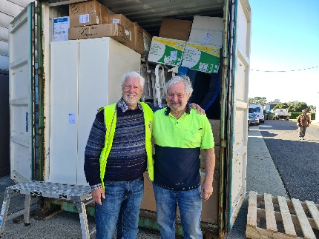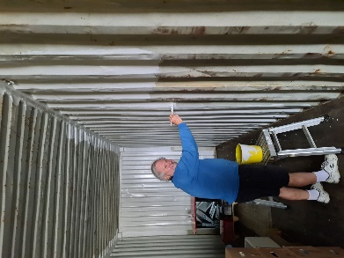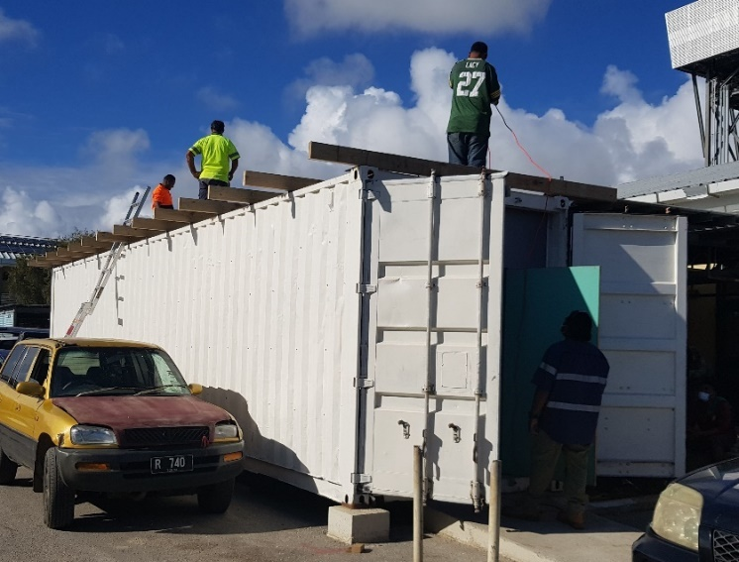
Preparing the container in Melbourne Roofing over the workshop at Vaiola Hospital

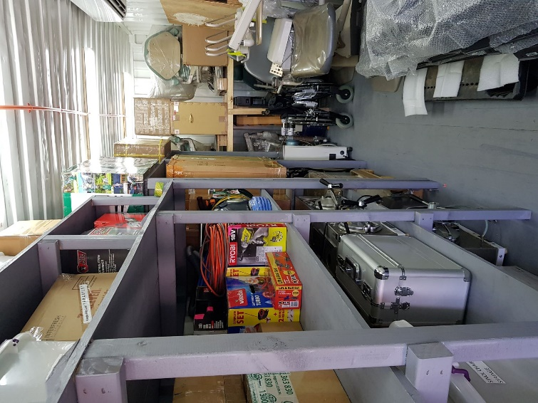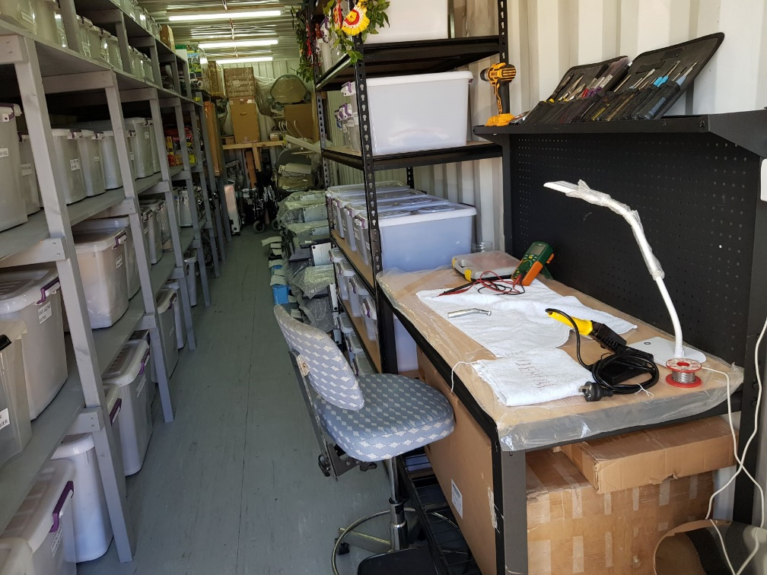
Inside the Hospital Dental Workshop. The Spare parts and dental equipment all came from RC Ballarat West

Financials
Major donors were the Rotary Clubs of Keilor and Ballarat West.
We also received financial support from Rotary Donations-in-Kind, the Rotary Clubs of Cranbourne, RC Koo-Wee-Rup, Balwyn, D9820, the Rotary Foundation, the International College of Dentists (ICD), RAWCS, Melbourne Fofo’anga Club and some private donors.

The Rotary Australia Disaster Fund donated $18,000 to the project towards container purchases and shipping costs.

Education and Training
Specialist Orthodontist Dr Deborah Sykes and Dr Susistina Piukala developed a special relationship, originally forged in Ballarat, Australia in 2016,which has developed to provide an Orthodontic service in Tonga. This includes the provision of specialist supplies and clinical diagnosis. Dr. Pikuala is the only dentist providing fixed appliance orthodontic treatment in Tonga, and this visit by Dr. Deborah Sykes has further strengthened their relationship.

Dental Equipment Engineer, Mr Peter Copp, also joined by his partner Mary Copp have been installing dental equipment in Tonga and other Pacific Islands (Solomon Is. Vanuatu, Cook Islands) since 1996. Central to Peter’s work has been the training of local dental staff and tradesmen to do installations, repairs and maintenance themselves. This has resulted in Tonga now being largely self-sufficient in dental equipment maintenance under the leadership of Mr. Sioeli Manu.
Tonga now has its own custom-designed and fully stocked repair and storage workshop at Vaiola Hospital.
Mr. Manu (Uho), and Mr.Peter Copp are seen below training dental apprentice engineers Messi and Fred. These two men did much of the installation work at all three schools this year themselves, whilst under the close watchful eyes and supervision of Peter and Mr. Sioeli Manu. A great practical hands-on learning experience!

RAWCS Team member, and past student of Tupou College, Mr. Lopeti Lanivia has generously awarded a scholarship for a chosen student to be educated at a school on Queensland’s Gold Coast for years 10,11 and 12 with the expectation of a further degree education course to be provided at Griffith University.

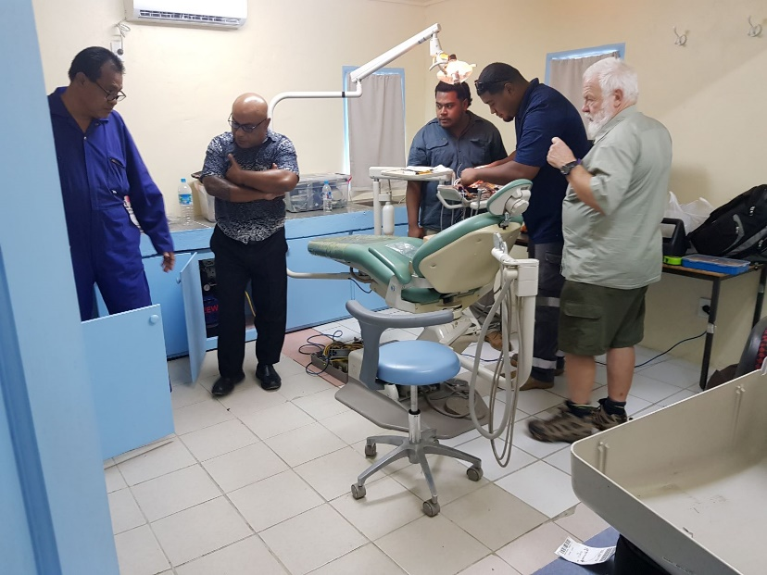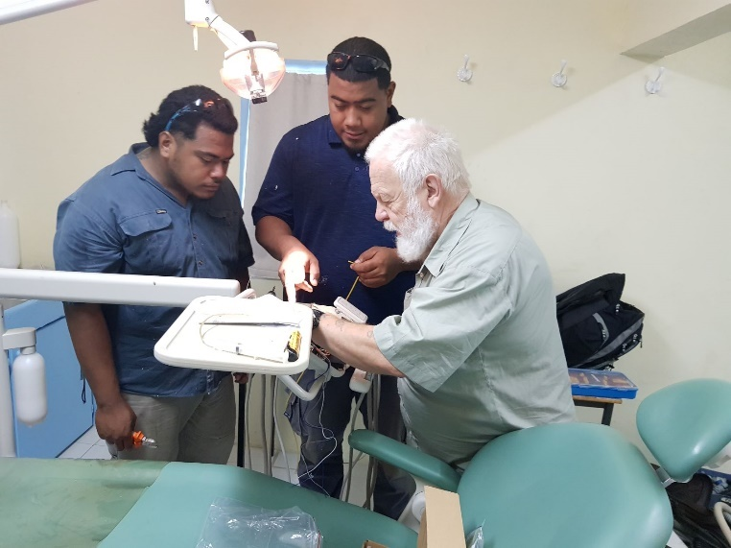
Dental Equipment Training

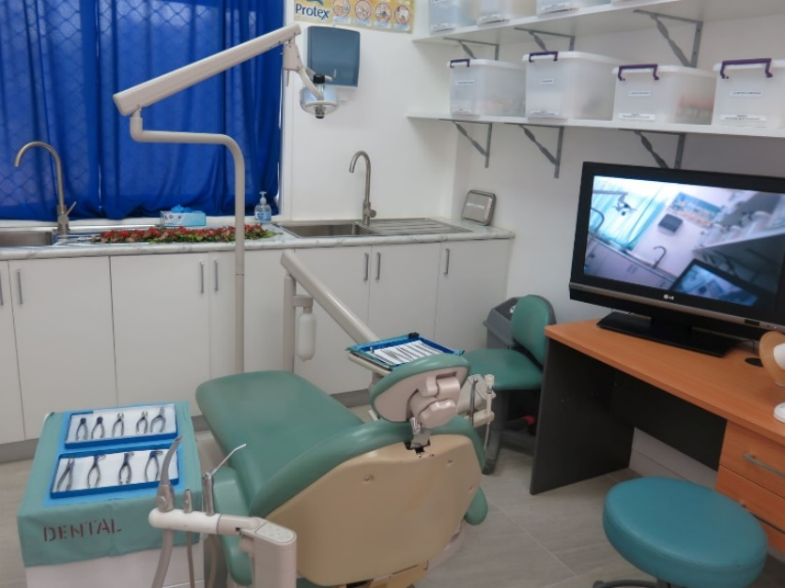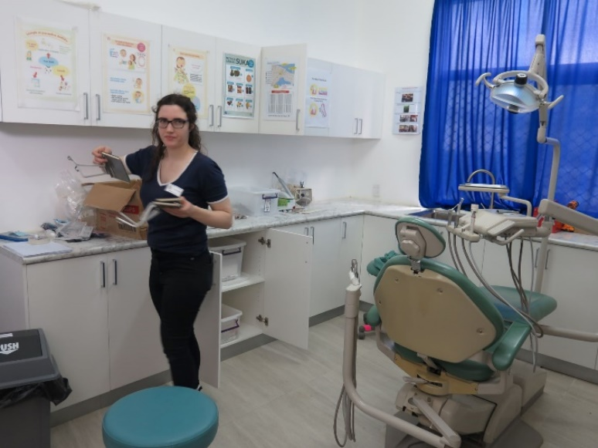
Queen Salote Dental Clinic – seen here with volunteer dental Nurse Ms. Claire Tannahill

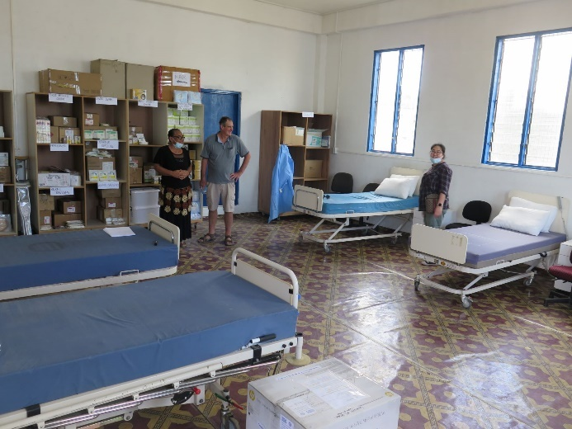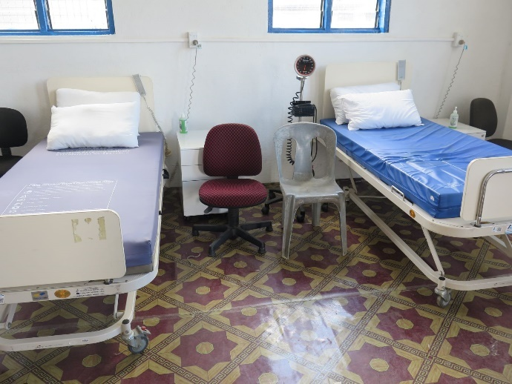
Queen Salote Sick Bay

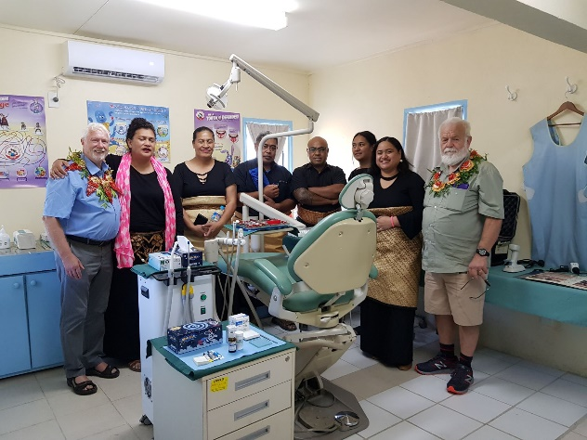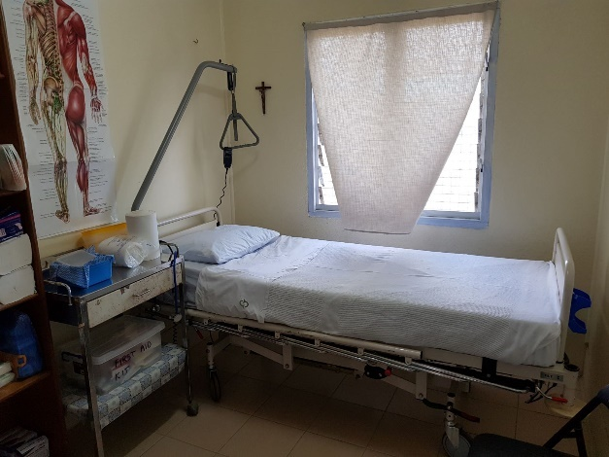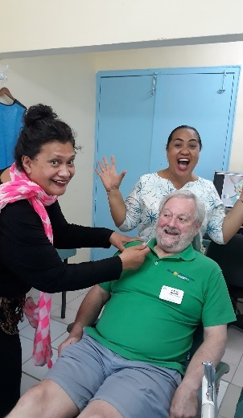

Apifo’ou Dental Clinic and Sick Bay- first patient Rotarian David Dippie!

Tupou College Fire

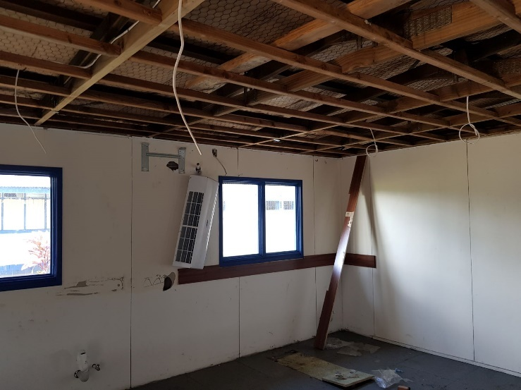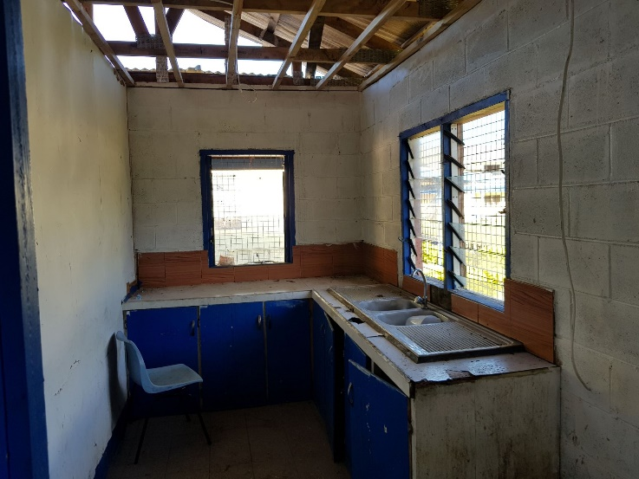

Tragedy struck just a few days before our arrival with a major fire in the building in which we were to install our Dental and Medical equipment. Fortunately, the 10 students sleeping in the building, which was being used as a dormitory, heroically pulled out our dental chairs, equipment, cabinetry and medical supplies from the building to safety before the Fire Brigade arrived. Without this prompt action, we could have lost everything.

Then the Tupou College past students in the form of Puloka Constructions came to the rescue to totally refurbish the building in record time. In just 10 days the Hon. Tēvita Fatafehi Puloka and his company had a new roof, ceiling, tiling, rewiring, painting and plumbing completed and authotised for use in time for us to install the Dental Clinic and Hospital. It was quite an amazing feat to have everything installed and working in time for the opening ceremony.

It is a tribute to the Longomaile Brotherhood, past students of Tupou College, and its leader in this project Dr. ‘Amanaki Fakakovikaetau F.I.C.D., that the building was finished to enable the dental chairs, compressors, suction motors, sterilizing room etc. be installed and working in the Dental Clinic, plus the 16 hospital beds, furnishings, medical supplies and equipment to be ready for the Hospital opening ceremony

Both the Dental Clinic and Hospital looked superb!

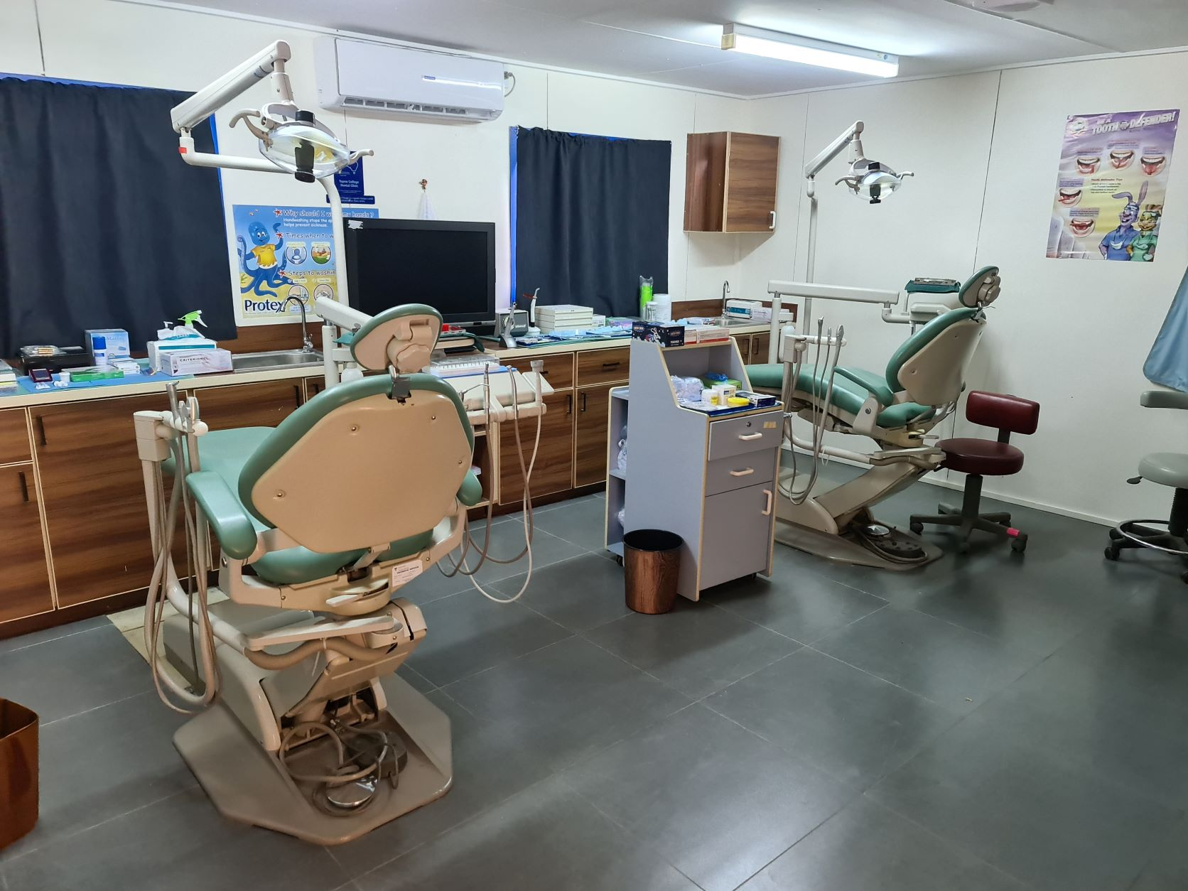

The new dental clinic provided by the Rotary Club of Ballarat West at Tupou College, Toloa
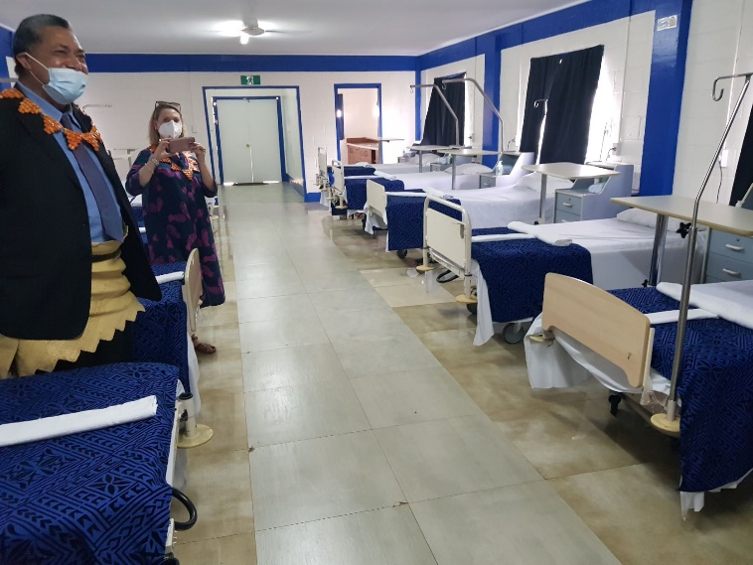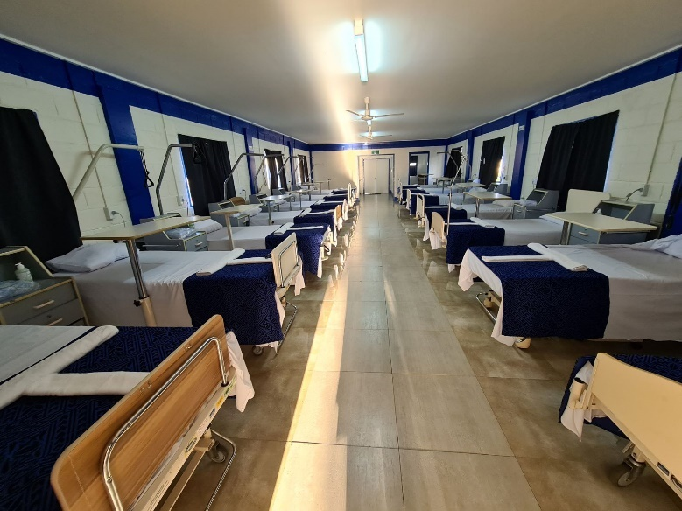
The new Hospital inspection with Australian High Commissioner Rachel Moore and Prince Kalaniuvalu Fotofili.

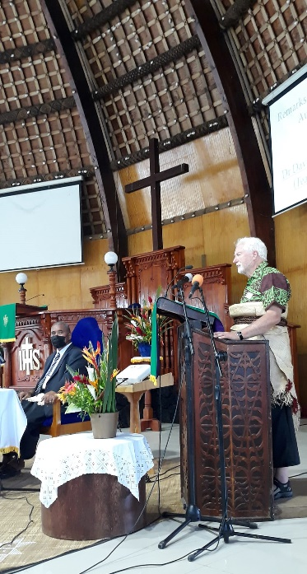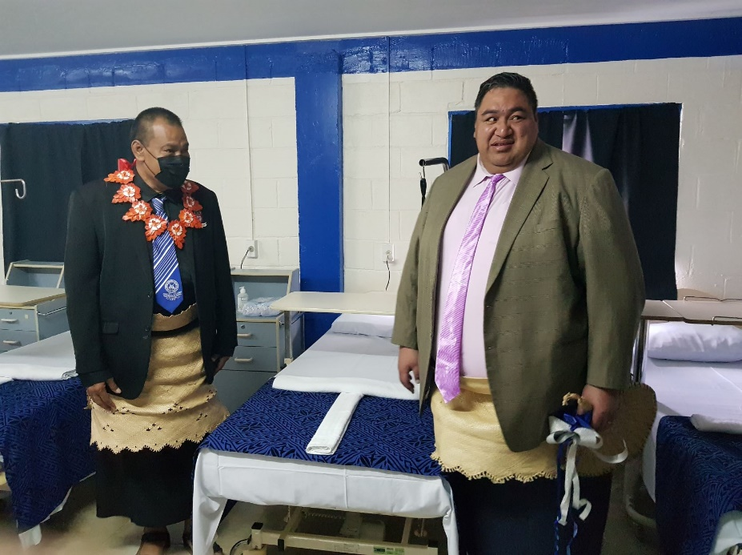
Presentation at the Moulton Chapel / Ribbon cutting was by His Serene Highness Prince Kalaniuvalu Fotofili.

The formal opening ceremony was held in the impressive Moulton Chapel, the largest traditional Tongan Fale in the world. After the Dental Clinic and Hospital ribbon-cutting ceremony, performed by the guest of honour and past student His Serene Highness Prince Kalaniuvalu Fotofili, there was an inspection of the new facilities. This was followed by speeches and votes of thanks. Entertainment was provided by singers and an outdoor jazz session by some of Tonga’s finest musicians for the Rotary team, assembled distinguished guests, politicians, clergy, teaching staff, and students past and present.

Thank you to these RAWCS volunteers who made this Rotary project possible
David Goldsmith Team leader/Dentist Rotary Club of Ballarat West PHF
John MacDonald IT Nurse with 25 years of Tonga experience PHF
David Dippie Rotary Donations-in-Kind. PHF. Rotary Club of Keilor East
Peter Copp Specialist Dental Equipment engineer. PHF
Mary Copp Dental equipment installations
Phil Roberts Head Teacher /Education.. Rotary Club of Ballarat West PHF
Jack Knight Head Teacher / tradesman/ Farmer. Rotary Club of Horsham
Marie Knight Education, Horsham Days for Girls
Damien Knight Optometrist
Claire Tannahill Dental Nurse
Deborah Sykes Specialist Orthodontist
Lopeti Lanivia Past Student Longamaile Brotherhood of Tupou College
Ross Stewart Dentist Carindale Rotary Club Queensland
Kim Schilling Travelling Dentist Los Vegas Sunrise Rotary club USA

A special mention for the key support received from Dr ‘Amanaki Fakakovikaetau, Dr Sisilia Fusi Fifita, and Mr. Sioeli Manu in the dental department, and the Rotary Clubs of Ballarat West, Australia and Nuku’alofa, Tonga

Full TV coverage of the opening ceremonies for the new facilities provided by Rotary at both Queen Salote College and Tupou College are available for viewing on Facebook and on U-Tube

Queen Salote College https://www.facebook.com/broadcasting.broadcomfm/videos/494565735342284/

Tupou College U-tube https://www.youtube.com/watch?v=7f9LfKqQZrQ

We had a team of 14 volunteers but two deserve special recognition for their work over many years: Mr Peter Copp for his multiple Dental Clinic installations, and Emergency Care nurse John Macdonald for his role in Vaiola Hospital projects.
Between them, they have made more than 60 visits to Tonga, and are to be highly commended for their commitment and the huge contributions they have both made to health care delivery in Tonga.

Finally, I could write an equally long article as this one in praise of the tremendous generosity and hospitality lavished on all 14 volunteer team members throughout our stay. This has been an unforgettable experience for everyone on this Rotary team. Every aspect of the visit greatly exceeded our expectations. The Friendly Islands people so thoroughly deserve their reputation
Malo ‘aupito, Tonga!

Dr. David Goldsmith. Project Manager
Rotary Club of Ballarat West
Email dgold@netconnect.com.au Mobile 0488 688 700
Phil Roberts proberts@ncable.net.au
David Dippie solatube@bigpond.com

Meet Fiona!
This is our next project which we hope to complete in 2022
A mobile dental clinic with facilities for handicapped patient access is awaiting shipping to Tonga
This is the number one priority for the dental department of Tonga
Funding is still needed for shipping and rewiring

