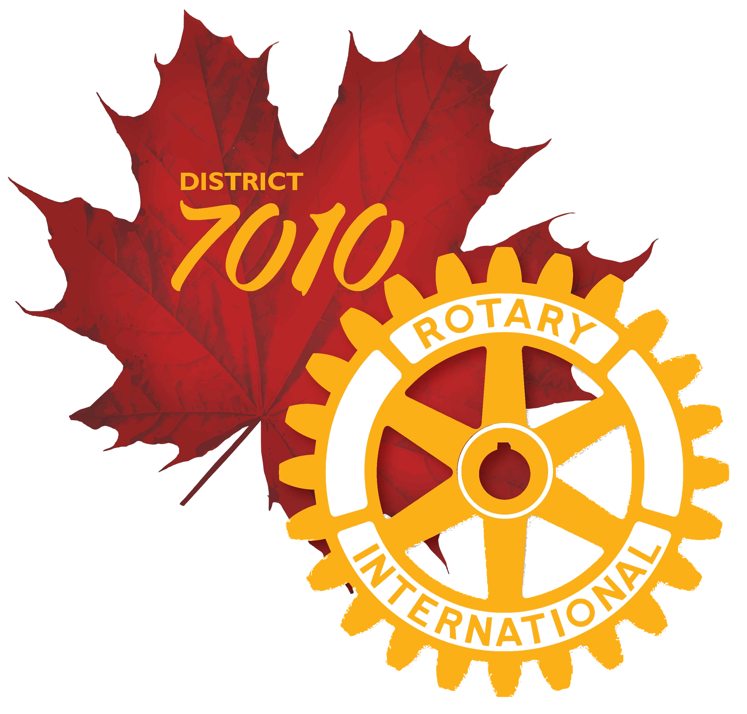
District 7010
PolioPlus Society
Membership Form

As a Rotarian and supporter of Polio Eradication, Rotary #1 priority, I wish to participate in this humanitarian endeavor as a member of the PolioPlus Society.

Therefore, I hereby commit to making an annual donation to the PolioPlus program of The Rotary Foundation until the W.H.O. certifies Polio to be eradicated. The minimum donation is $100.00 CDN per year. Please select one of the following:

- $100.00 CDN annually

- $25.00 CDN quarterly

- $10.00 CDM monthly

- A contribution of $____________ per year (more than $100.00 CDN)

Society members will be inducted into the Society at club meeting, and will receive a Certificate and membership pin. You will receive Paul Harris recognition points for your donation. Make your donation on-line at www.rotary.org/donate and select the Polio Fund or make it through your Foundation Chair at your club. If made on line you can set it up as a recurring donation.

Name: : Phyllis Winnington-Ingram
Please return this form to dktisch@rogers.com, or mail to:

Dr. David Tisch
20 Layton Cresc.
Barrie, ON
L4N 6G3
Signature:_________________________________

Date: 31 October 2023

Club Name: Impact Rotary Club District 7010

Phone #: (705) 645-0754

Email: phyllis@winnington-ingram.com

Your pledge to contribute at least $100.00 each year until the World Health Organization certifies that Polio has been fully eradicated and the world is polio-free. You do this because:
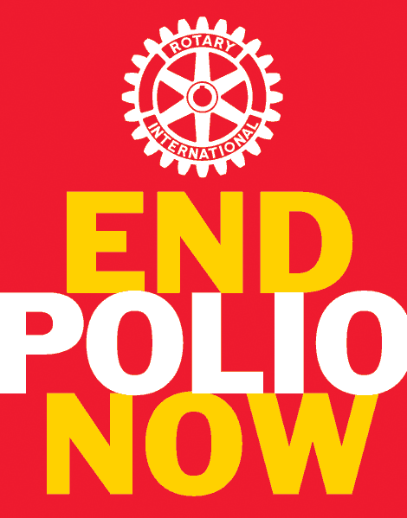
“UNTIL THE LAST CHILD IS IMMUNIZED AND
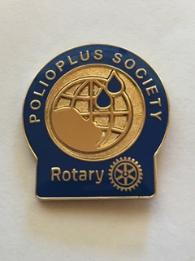
THE WORLD IS CERTIFIED POLIO-FREE, EVERY
CHILD IS AT RISK.”

