NEWS RELEASE
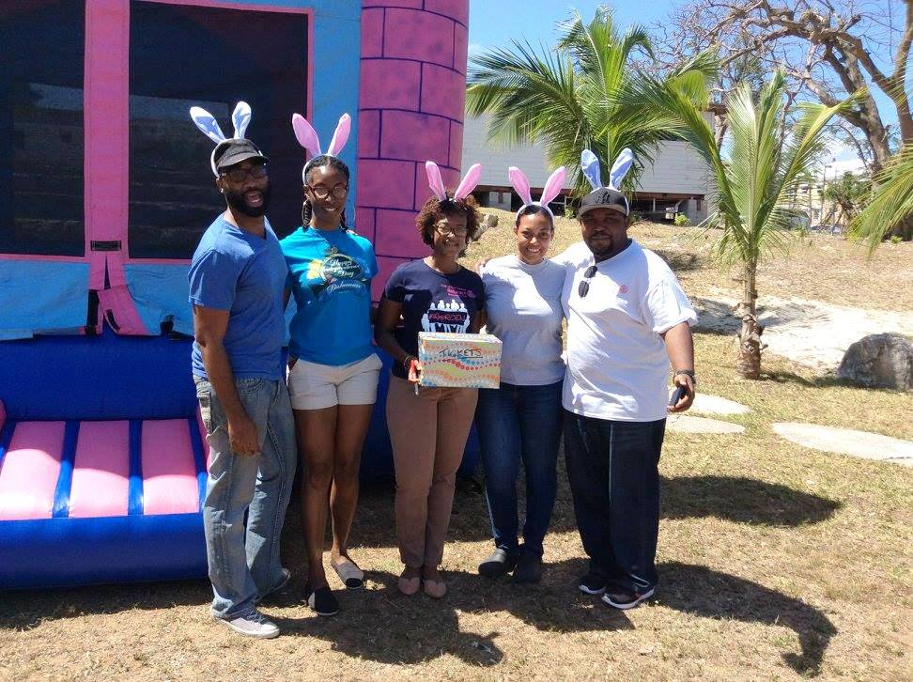
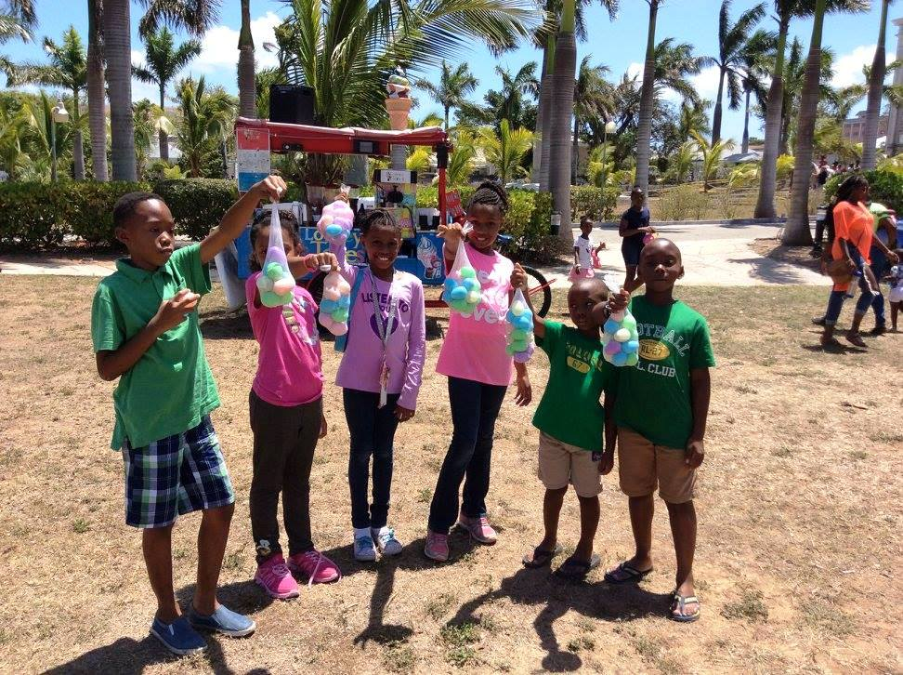
Easter egg hunt to celebrate The Rotary Foundation centennial
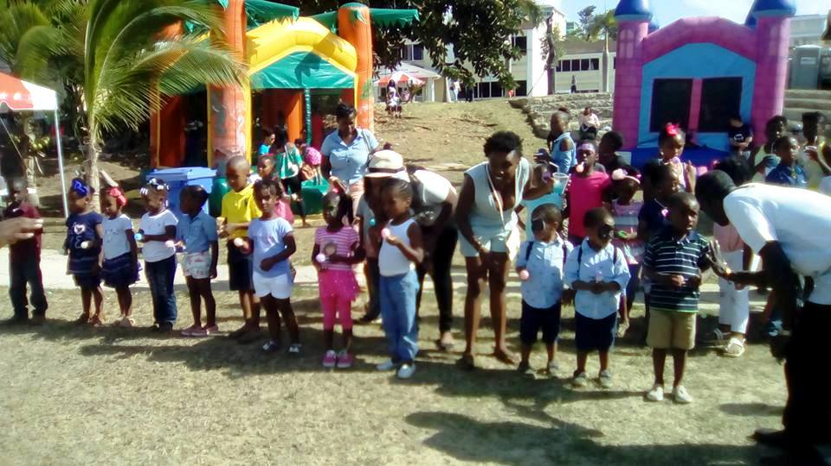
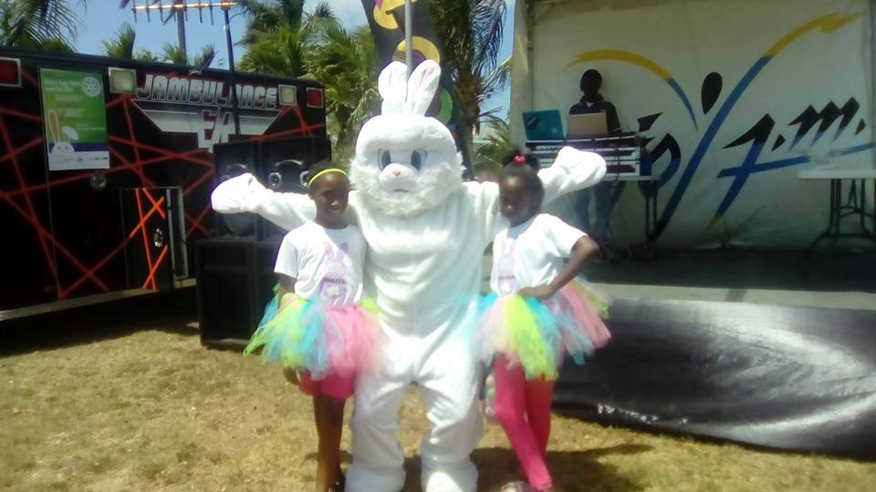

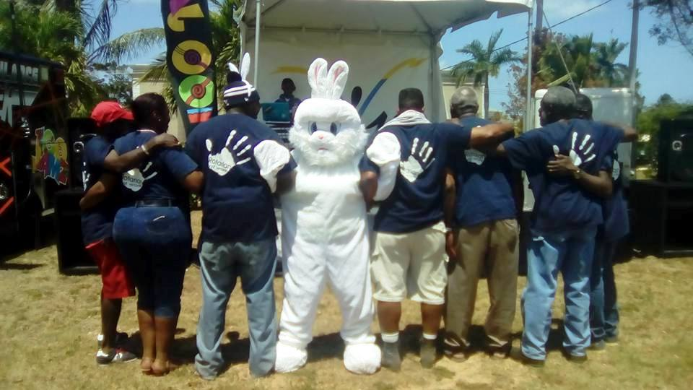
Clockwise:
- Happy children after the egg hunt
- Members from the East Nassau Rotaract Club manning the bouncy castles.
- "Hoppy" the bunny with members of The Rotary Club of New Providence
- Children lined up for the egg on a spoon race.
- Hoppy the bunny with some fans.

[NASSAU, THE BAHAMAS, APRIL 21, 2017]— The historic Collins House grounds were speckled with colourful eggs Easter weekend as hundreds of children searched for prizes during six egg hunts throughout the day. The Rotary Clubs of East Nassau, Nassau, and New Providence, in partnership with JoyFM and 100Jamz, hosted an Easter Egg Hunt and Fun Day on April 15 to celebrate the centennial of The Rotary Foundation. Proceeds from the fun day will be donated to The Rotary Foundation to do good in our community and the world.

Live radio remotes from JoyFm and 100Jamz carried the festive atmosphere throughout the day. After an appearance from the Easter Bunny, the entertainment peaked with a live performance by Faddah Fred, Bahamian Tre, Spicy Dee, and Lil Peewee brought to us by the Exile Media Group.

Exile Media Group is a music production company with a focus on connecting Bahamian Culture, and music to the youth. It was formed by Charlie Brown and radio personality Handel "Reality" Sands.
[INSERT QUOTE FROM REALITY]

The Foundation is the $1 billion charitable arm of Rotary International. To mark the centennial, Rotary aims to raise $300 million by July 2017 for its campaign to eradicate polio and for service in communities around the world. Two notable benefits to The Bahamas because of The Rotary Foundation is the Bloodmobile and the Grand Bahama Emergency Water Relief Plant.

The Rotary Clubs of the Bahamas Bloodmobile was a generous donation to The Bahamas provided by the Rotary Clubs of The Bahamas, Rotary Districts 7020, 6980, 6900, and The Rotary Foundation which was funded by a matching grant from Rotary International. It is in you to give and the Rotary Bloodmobile can come to your event, making it easier and more convenient for people to get involved and save lives.

The Grand Bahama Emergency Water Relief Plant came to life in 2004 after hurricanes Frances and Jeanne. Rotary, and it's partners, wanted to respond proactively rather than reactively to assist Grand Bahama, which was suffering severe water shortage after the storms cut off the local supply. The Rotary Water Plant is hurricane proof, built 10 feet above grade level with its equipment raised two feet above the floor level. The plant makes 7,500 gallons of top quality, pure drinkable water per day. It also stores 5,500 gallons of water drawing from its own well, which has six fill stations and the reverse osmosis system has no proprietary parts. The Water Plant again proved to be a vital component of the Grand Bahama Hurricane Recovery Plan in the aftermath of Hurricane Matthew. The team was able to pre-position emergency water in shelters, as well as provide immediate relief after the storm, until the island’s water supply was re-established. Working with NEMA, and with the help of other partners, the water plant provided over 100,000 gallons of emergency potable water to citizens in Grand Bahama after Hurricane Matthew.
Established in 1917 with a donation of $26.50, The Rotary Foundation is dedicated to advancing world understanding, goodwill, and peace. Through grants and other resources, Rotary members develop sustainable projects that promote peace, fight disease, provide clean water, support education, save mothers and children, and grow local economies.

Rotary’s top priority is the global eradication of polio. Rotary launched its polio immunization program, PolioPlus, in 1985 and in 1988 became a leading partner in the Global Polio Eradication Initiative along with the World Health Organization (WHO), the United Nations Children’s Fund (UNICEF), the U.S. Centers for Disease Control and Prevention (CDC) and more recently, the Bill & Melinda Gates Foundation.

Rotary has contributed more than $1.5 billion and countless volunteer hours to eradicate polio. Through 2018, every dollar Rotary commits to polio eradication will be matched 2-to-1 by the Bill & Melinda Gates Foundation, up to $35 million a year. Since the initiative began, the incidence of polio has plummeted by more than 99.9 percent, from about 350,000 cases a year to less than 71 confirmed in 2015.

Diane de Cardenas, President of The Rotary Club of East Nassau, said "Rotary Bahamas is a long time supporter of The Rotary Foundation. When monies from around the world can be combined and smartly invested, then come back to our community through grants it is easy decision to support. Working with The Rotary Foundation requirements forces us to be focused and deliberate giving our projects more relevance."

About Rotary
Rotary brings together a global network of volunteer leaders dedicated to tackling the world’s most pressing humanitarian challenges. Rotary connects 1.2 million members of more than 34,000 Rotary clubs in 200 countries and geographical areas. Their work improves lives at both the local and international levels, from helping families in need in their own communities to working toward a polio-free world. For more information, visit Rotary.org.To access broadcast quality video footage and still photos, go to The Newsmarket.

CONTACT:
Jipcho Johnson, Event Chairman (376-8073/Jipcho.Johnson@yahoo.com)
Diane de Cardenas, Committee Member (445-6655/DianedeCardenas@gmail.com)

