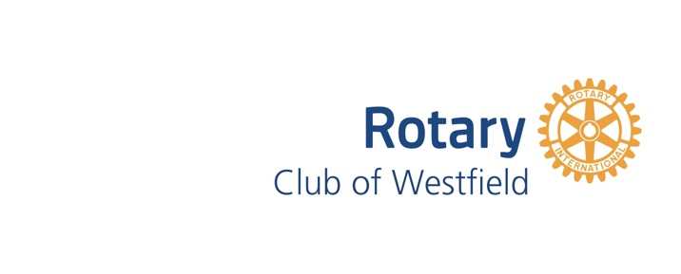
COMMUNITY GRANT APPLICATION
The annual deadline for submitting a Rotary Club of Westfield Community Grant application is October 15th for the Fall cycle. To be considered for a grant, please complete the following questionnaire and email to address at bottom of the form. No grant will be awarded for the funding of general operations and expenses. By way of example, general operations and expenses are deemed to include items like overhead, salary, administrative expenses, not the costs and expenses involved in the charitable program or services rendered. An organization may only receive one grant per calendar year. (This application may be reformatted on your own computer. Please print or type.)

Please confirm how the check should be made out and mailing address to send check if different from below:

Name of Organization

Address__________________________________________________________________________________

Phone ________________________Fax _______________________E-mail ___________________________

Non-profit status Yes No Does your organization receive United Way funding? Yes No
501 (c) (3) or other _____________

Applicant's name (Contact Person) ______ Phone __________________________

Signature ______________________________________________________ Date _____________________

Description of Project: _____________________________________________________________________

Total number of people to be served: _________ Total cost: __________ Amount requested: ___________

Please be brief, include the following information on a single sheet, and attach to this application:
your most recent Form 990, 990-EZ or 990-N (or a written explanation if none of these forms have been filed), project summary and objective, background and general goals, details of implementation, budget and equipment costs, estimated useful life of project, number of individuals impacted and how they will benefit from this project. Please do not include additional promotional materials or brochures.
Direct questions about your proposal to Marta Alexandre, Rotary Community Grants Committee Chair
EMail the completed grant request application before April 15th or October 15th to:
Rotary Club Community Grants Committee Chair
Marta Alexandre
malexandre@spencersavings.com
Please include in email subject: Rotary Grants Application
Or mail
Rotary Club Community Grants Committee Chair
Marta Alexandre
c/o Spencer Savings Bank
240 North Ave W
Westfield, NJ 07090

