Geraldton – St Tropez! I went on this trip with my boss Teresa Italiano- we flew from Geraldton to Nice, and we stayed in Nice for 4 days before travelling to St Tropez.
DAY 1: I arrived in St. Tropez on Friday, and went straight to the hotel to meet the other junior hairdressers. I met my roommate and she was so nice, she was from Germany and barely spoke English, so I had to use the translate app on my phone to talk to her most of the time. I also met the other Aussie girl, Emily, from Tasmania. After settling in, we went to the Kissing Party, and I met so many people from all around the world- Japan, China, Germany, Belgium, Sweden, America, and Switzerland.
DAY 2: On Saturday I went to a hair cutting seminar. The two hosts were from Brazil, and I found it very interesting to see their different hairdressing techniques. The hosts showed us 2 different hairstyles, explaining everything about how they achieved the looks while they were working. We then got given our own mannequins and got to try out the different techniques we learned, getting help and feedback from the hosts. We spent the whole day in this seminar, and then went back to our hotel to get changed for the evening beach party! We then went down to the beach, where we listened to a DJ, ate amazing food, and spent a lot of time mingling and getting to know everyone better.
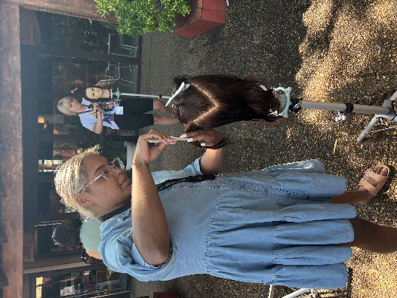
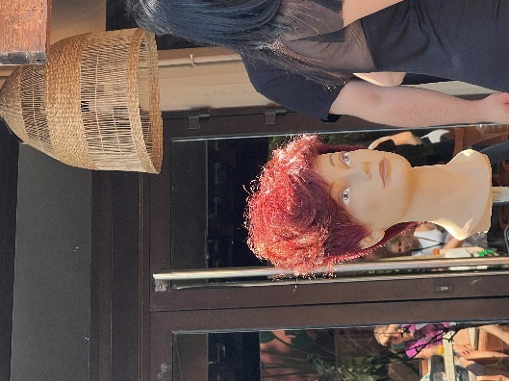
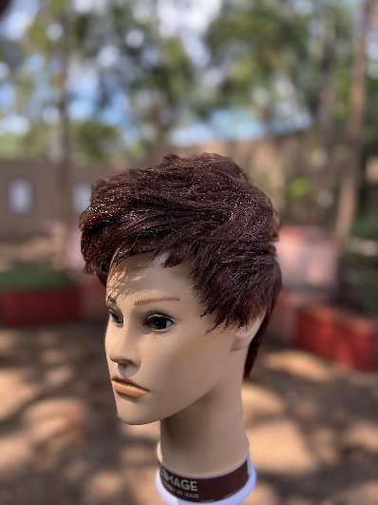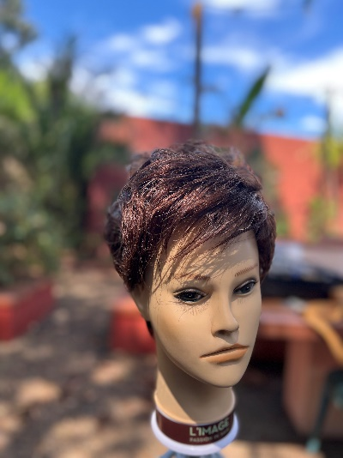
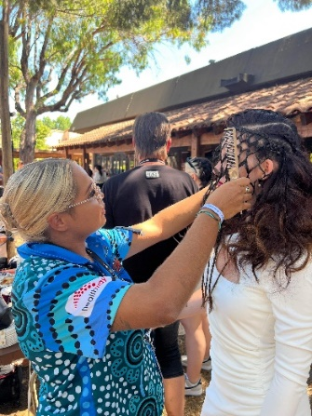
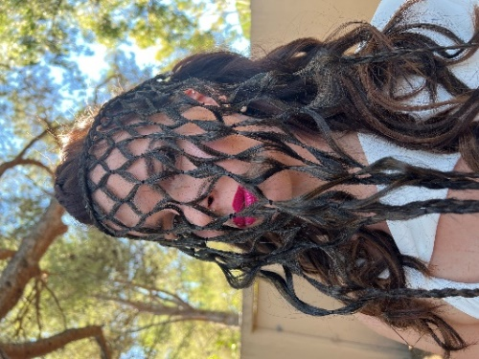
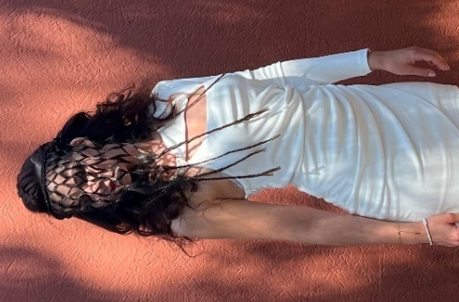
DAY 3: Sunday was the Guillaume hair show, and I was so nervous! The weather was super nice, not windy which was a bonus because we were all working outside (as you can see in the photos). We all got split up into groups and teams of two, and my partner was Emily from Australia. We got told that we would be given a model and that we needed to work together to create an amazing hairstyle without cutting or colouring. Emily and I came together and spoke about our strengths and spent ages brainstorming and coming up with ideas. We were given some inspo photos and all the looks were so different, they had Marilyn Monroe old Hollywood style curls, heaps of mohawk looks, cage braiding, and many more unique braids such as Dutch, French braids, waterfall braids and many more. I have a lot of experience in braiding, it was one of the first things that got me interested in hairdressing, so I was really hoping to be able to do a braided style. We met our model and she had dark long hair, so we decided it would work perfectly for cage braiding, as the colour of her hair was a huge contrast from her skin tone and would show off the braiding really well. We had to create three different looks. For the first one Emily and I made 2 small Dutch braids on either side of the hair, to the top of the ear, and 1 large braid on top which we pulled out to make it look bigger than the side braids. We left the rest of the hair out and lightly curled it, and then placed the cage extension over the model’s face to create some mystique.

For the 2nd look we kept the Dutch braids in, and we teased the back section and put it into a large bun. We decided to place the cage extensions on the neck for this one to really highlight the cage braiding while the rest of her hair was all up off her shoulders. After each style was created, our model went and had professional photos taken.
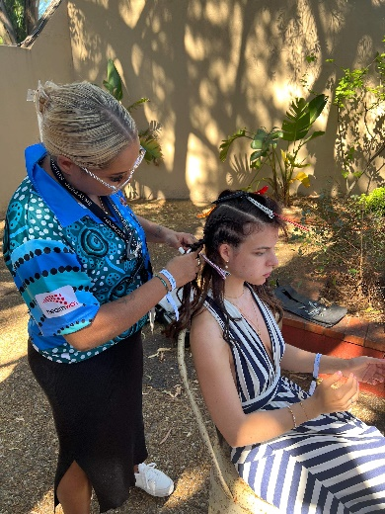
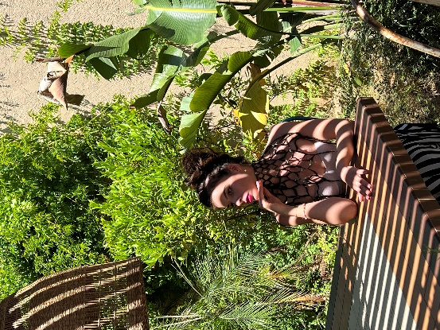

For our third style, which we presented on stage, we took a horseshoe section on top. With the underneath, we brushed all the hair back into a high ponytail close to the crown, and pinned all of the length into a loose bun. For the fringe section, we used an extension to create a wave shape in the style of a fascinator, which we attached to the front of the hair, decorating with pearl beads. We added some padding to the crown to emulate a vintage roll. We chose to leave the cage braid around the model’s neck for this look, and added pearl beads to create even more visual effect.
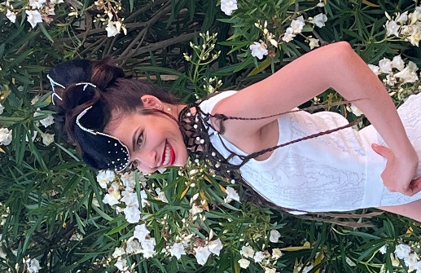
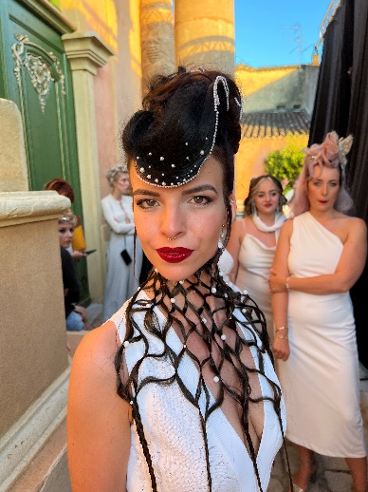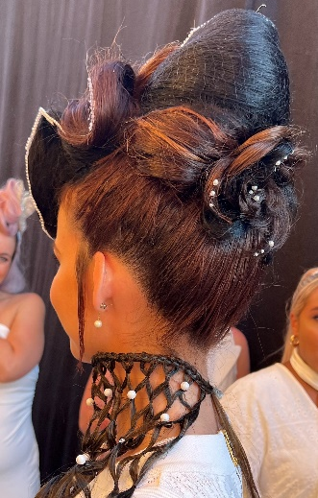
Then the big night came… it was time for the show! All the juniors would go up on stage with our models and show everyone our final style. Emily and I were the second presenters to go on stage. While we were waiting, we made sure our model looked absolutely perfect. Then it was our turn! We went on stage one by one and I spoke first, I was so nervous but it was so exciting! Everyone had their own little speech while showing the look on stage. It was AWESOME!! After we got off stage, we got to stay back and watch the rest of the show.
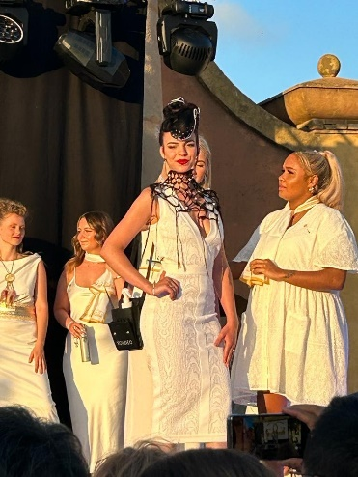
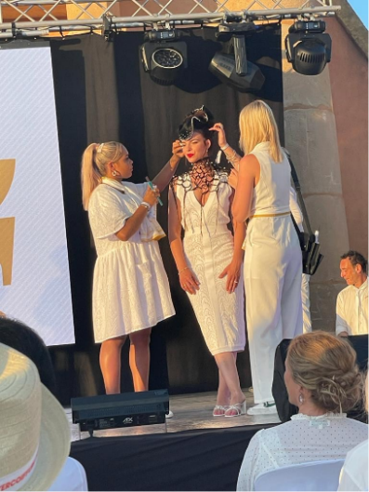

Day 4: Monday was the last day. It was quite sad as we were saying goodbye to our new friends. We all got given a certificate to commemorate the event, it was super special, and I plan to frame the certificate as a reminder of this huge achievement. My highlight for this trip was meeting new friends from all over the world, and getting to see what they do in their country and salons. I loved that even though most of them didn’t speak English, I could really see their passion for hair and we were able to bond over that. The Guillaume show was my favourite event, the whole experience was so special to me. Thank you for giving me the opportunity to go on this trip, I am so grateful.
Kaylee Woodley
