Minutes of Directors Meeting
Rotary Club of Taieri

Held at Weavers Restaurant
Mosgiel,
4 March 2020

Apologies
Peter Williams
Moved apologies be accepted Jill Thomas, seconded Ian Spencer, Passed

Minutes from previous meeting:
Uploaded to Club Runner 20 February 2020 and attached to this document.

Matters Arising:
Nil
Moved that the minutes be accepted Gill Brown, seconded Eric Johnson, Passed

Correspondence - (Motion that Outwards endorsed, inwards accepted) – then discuss.
OUT –
John Stevenson - letter of thanks for use of log splitter
Margaret van Zyl – letter of support for “Mosgiel Memorial Wall”

IN –
New Zealand Post
Changes to Private Box Network rental fee –increase by $10 effective 31 March 2020
PO Box renewal invoice - $195, and Changes to Invoicing – earlier invoicing to align with terms and conditions that require payment in advance of renewal date, notice that cheques are no longer an acceptable method of payment

Rotary Down Under
Invoice for 35 magazine subscriptions January to June 2020 - $700

Rotary Email correspondence:
Joan Kiernan, District Grants, 6 February - wanting to ensure grant money is spent this year. This includes our Samoan Foot Clinic project. International Committee.
Shaun Harris queried how this will affect the $1000 held for the Samoan Foot Clinic Project if it is not spent, Colin Ferguson replied that as long as it can be reasonably justified as committed but for “extra ordinary” reasons cannot be used yet for the intended purpose in grant reporting the situation shouldn’t cause any issue.

Rotary International 23 February - Club Dues payment reminder $1,487.36 (I think Neil has dealt with this)

Dylan Murray, District Governor Visit - sorting club visits and requested 15 July 2020 to visit Taieri, we have responded stating that date is fine with us. Include in Bulletin.

Gary Williams, Rotary Youth Exchange, 24 February
seeking host clubs for 8 European Students arriving in our district in July.
Seeking applications from NZ students to travel overseas. Youth Committee.

Tania Lowery, District Conference 17-19 April, Balclutha, 24 February – Call for Registrations

Tania Lowery, District Conference 17-19 April, Balclutha, 26 February, required by 31 March
Memorial on 19 April – call for names and photos of passed members
Recognition of new members - call for names and photos of newly inducted members. Membership Committee. Noted that Tracy de Pra and Paul Urquhart qualify for the latter category.

Moved that Outwards correspondence be endorsed and inwards correspondence accepted Colin Ferguson, seconded Ian Spencer, Passed

Leave of Absence:
Ross Bathgate 8 April to 22 April inclusive
Denis Aitkin 14 March to 7 April

General Business:

Two families that would benefit from a gift of firewood have been identified, 2m³ will be delivered to each.

Gill Brown made a plea for items suitable for the Bulletin, members have been remiss in offering up such and this makes compiling an interesting Bulletin difficult.
Gill Brown also spoke about using social media formats, Rotary outlets, local press and the DCC website ParNui(?) to promote the club’s profile and activities.

Reports:
Treasurers Report
Presented.
Treasurer to present a list of invoices to Directors at future meetings to approve, (retrospectively if required) for payment, this to ensure that club procedures are are kept consistent with standard operating practices.
Moved that the report be accepted Neil Hodgkin, seconded Chris Rudd, Passed

Trust Report
Presented.
Moved that the report be accepted Shaun Harris, seconded Jill Thomas, Passed

To be generated during Committee meetings on Club Night
Club Administration
Attached
Membership / Fellowship
Attached
International/Foundation
Attached
Youth and Vocation
Attached
Community Service
Attached
Public Relations
Attached

Other Business
“Awesome Award” – the cup relating to this extremely prestigious and coveted award is missing. Eric is working on procuring a replacement.

The Spencer Pink Ribbon Brunch – this will take place on 10 May 2020. Forty people will be catered for, cost is $30 pp. Ian will select and shoulder tap personable, and presentable, male Rotarians capable of preforming general waitering duties for the event.

Meeting closed

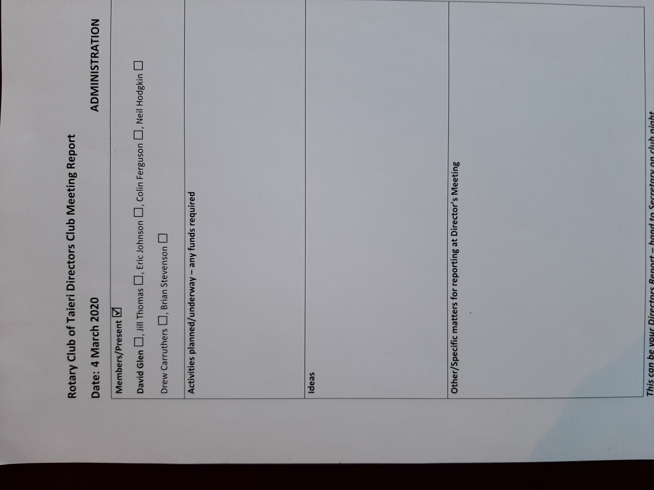
President Elect, Richard Sipthorp, has replaced David Glen on the Administration Committee.

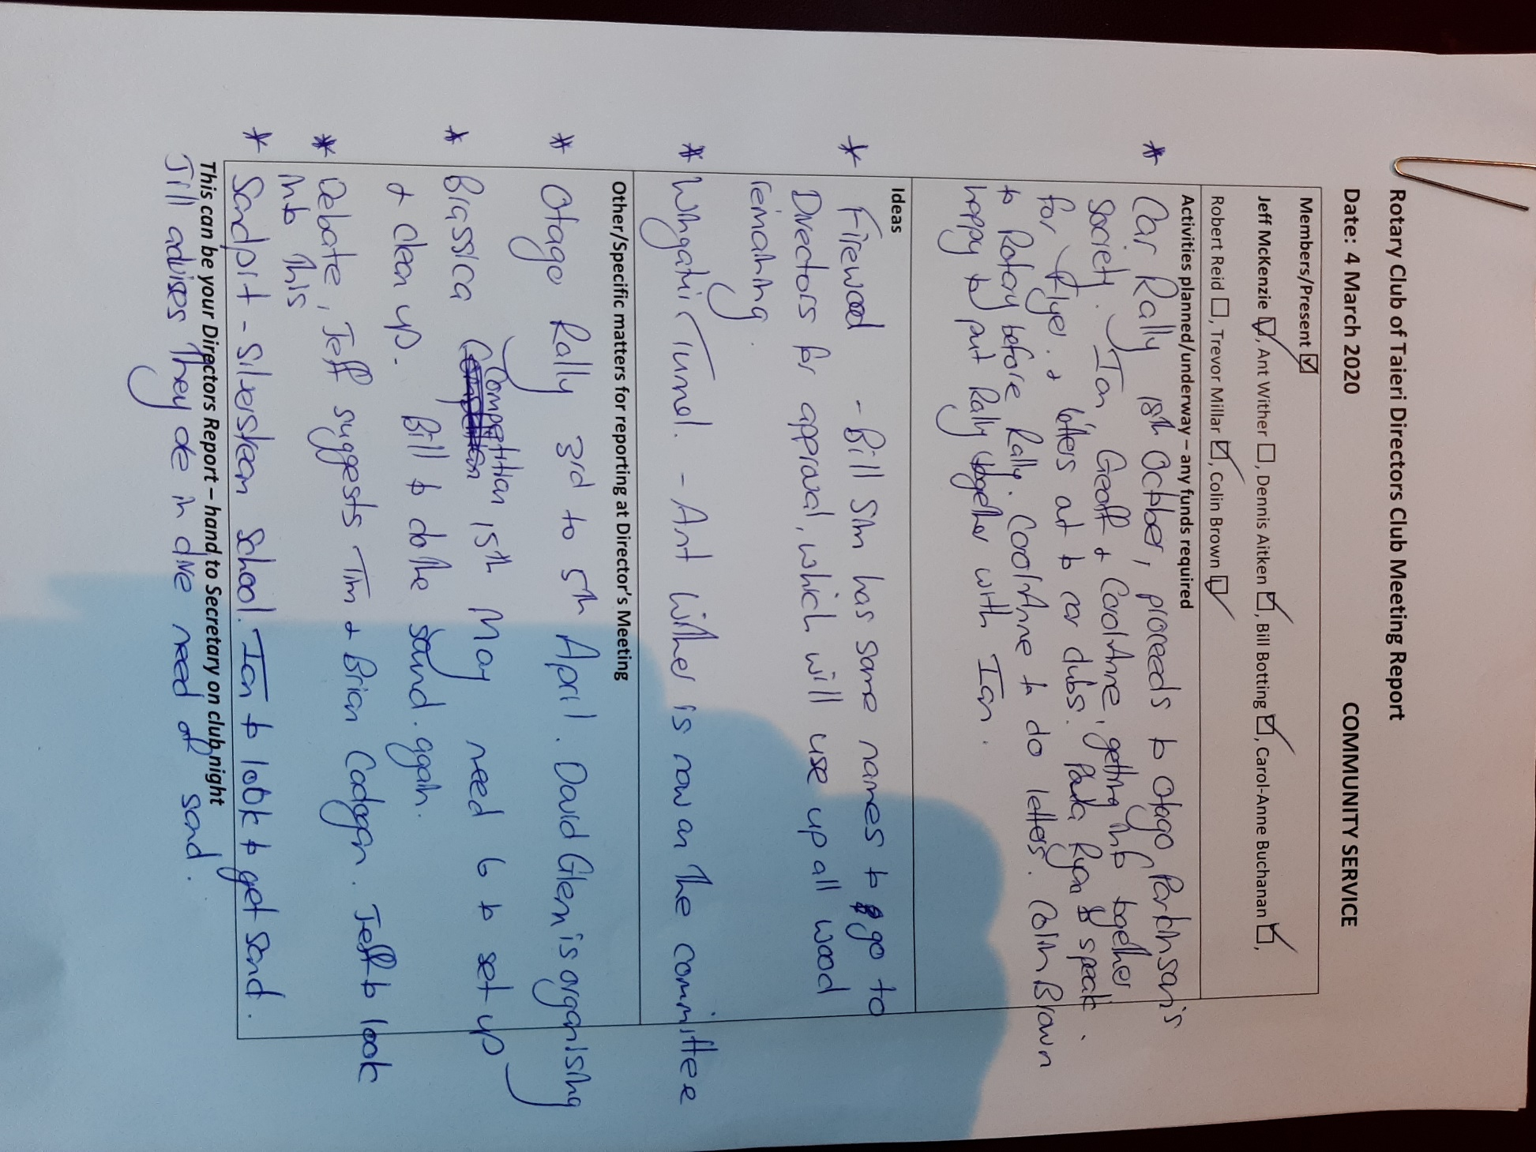

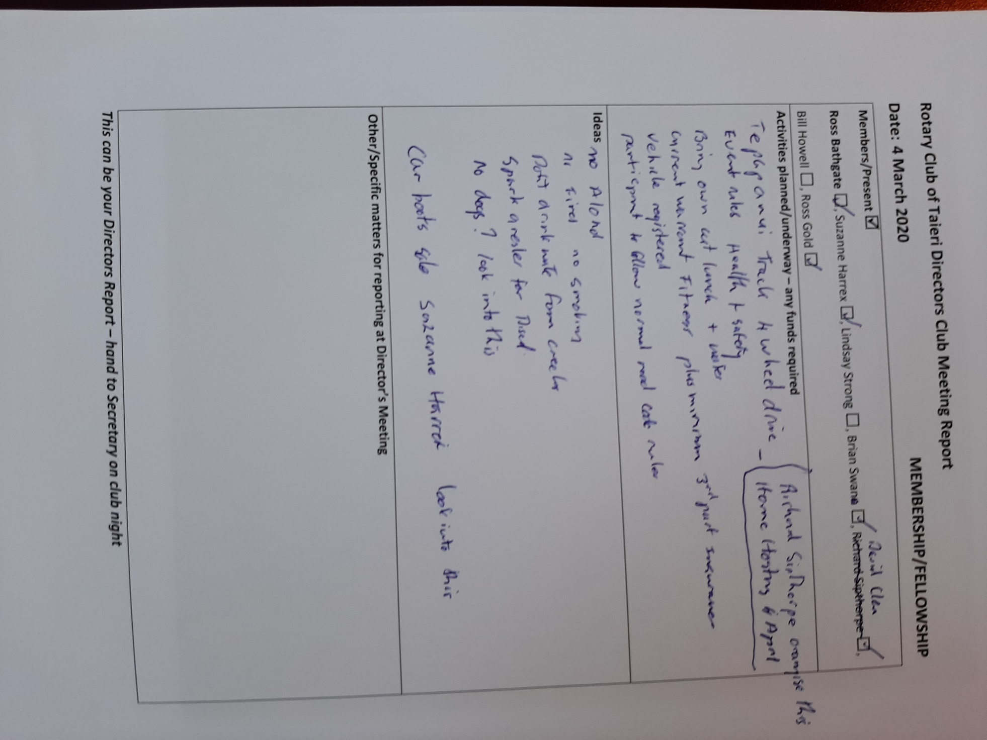

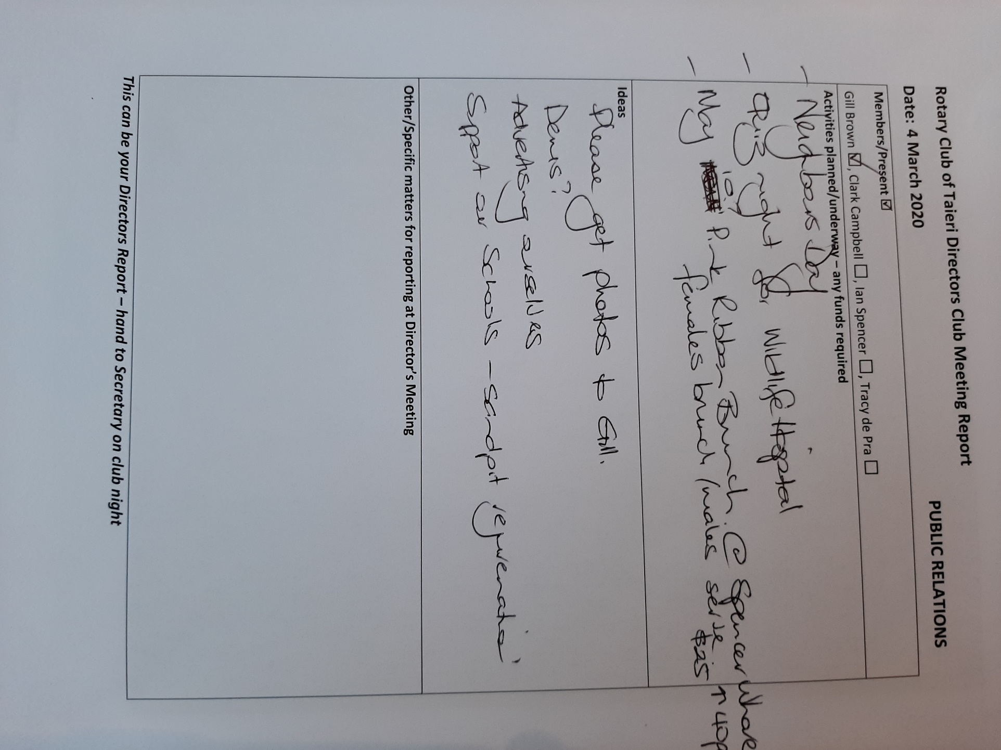

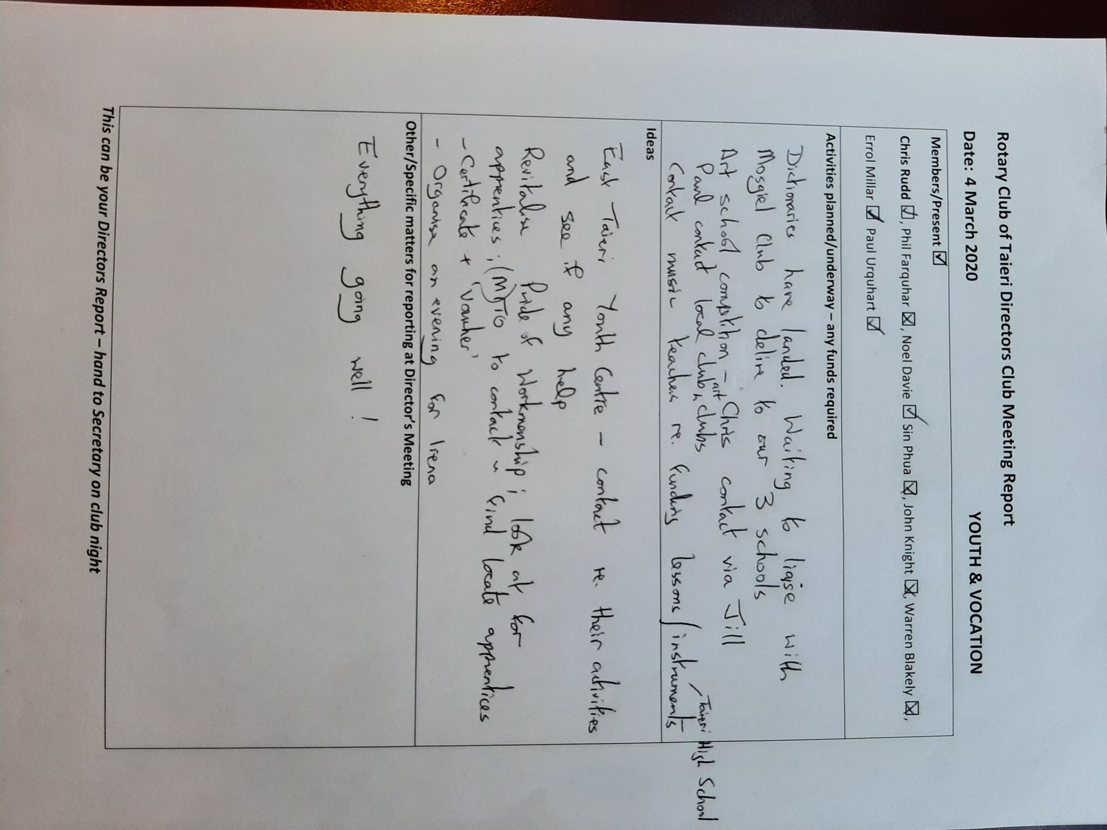

Rotary Club of Taieri Directors Club Meeting Report
Date: 4 March 2020 INTERNATIONAL/FOUNDATION
Members/Present
Peter Williams □, Hartley Meder □, Shaun Harris □, Gail Williams □, Neil Simpson □, Bill Sim □, Murray Pridham □, Susan Wyngaarden-Low □
Activities planned/underway – any funds required
Samoa Foot clinic
24 Feb 2020: Latest in a regular email drop to Samoa by Christine checking on progress:
Talofa and greetings to you all, May I respectfully ask on behalf of our Rotary colleagues and health specialists for a progress update on the Foot Health Clinic application? With kind regards
Christine
Last email from Authorities in Samoa______________________________________
From: Poutasi Seuseu <poutasi.seuseu@health.gov.ws>
Sent: Thursday, 14 November 2019 2:47 PM
Subject: Apia Hospital diabetic foot health clinic: formal application and supply of hospital beds
Lau Afioga Lesa Fuatai, Dr Sarah Brown and Tevaga Dr Ponifasio
I humbly wish to forward email below from Christine Hurley as Dr Robert Thomsen is currently away on duty travel to Nairobi Kenya for your perusal and decision on way forward. Christine Hurley has confirmed from her email below that the Rotary colleagues in Otago are preparing to transport four hospital beds and associated items to Apia for the expanded Diabetic Foot Clinic. In addition, fundraising has begun for new equipment and supplies for the clinic, in collaboration with the University of Otago. I know it is a great initiative and appreciative of this donation to help support Diabetic Foot Clinic which is currently led by Dr & Nurses at APCC and would require the Proposal (draft) to finalize and submit for endorsement from the Diabetic Foot Clinic team under the leadership of the APCC & PublicHealth nurses. Your advice and continuing communication to the Local and NZ Rotary Team is very much appreciative. Sincere thanks Poutasi K.Seuseu

PFW: Suggested to Christine that it’s about time Taieri arrange a visit to Samoa. Christines reply: I suggest you give plenty of notice, and work through Poutasi & the Apia Rotarians copied in on my last message to fix a time. Aim to meet with the CEO and Dr Thomsen, but don't be surprised if they or others are unavailable at the last minute and someone else is teed up to see you.
Hartley and Peter are prepared to subsidise a trip if funds put aside ($1000 from Wanaka, + $1000 from district Grant) do not cover flights, accommodation etc. Timing dependant on some response from Apia club, but also cessation of virus outbreak.
Club meeting recommendation:

Rotary Give Every Child a Future
Request from Christine: is your District aware of our Centenary project, Rotary Give Every Child a Future - see attached Flyer? As I may have told you, I'm the Wellington rep on the Aus/NZ steering committee. We really need to give the fundraising a big push. $45 per child will cover vaccines, nursing training, cold chain equipment etc. Do you think your club's members could be persuaded to set the example of each person sponsoring a child's costs?
PFW: I have forwarded a copy of the Rotary flyer for your perusal – can our group discuss/promote ???
Suggestions:

Rotary Friendship Exchange
PFW: FRE summary. 12 visitors from 7850. 4 Nights Dunedin. Day 1. Peninsular drive & lookouts, Monarch trip, Albatross info centre, Portobello, evening get-together @P&P with BBQ, presentations, meet with DG Tania. Day 2. Milburn Quarry fossils, Nugget Point, Purakanui falls, some evening sightseeing. Day 3 @ 4. Varied with hosts and drivers: Seasider train trip, Toitu, Museum, BaldwinSt, University, Cricket match, Speights etc etc Day 5 Dn to Wanaka, transfer at Roxb. Lunch @ Cerrick vineyards, wine tasting Wooing tree, evening BBQ by celebrity chef at Georges place, all hosts and guests. Day 6. Ridgeline 4WD Tour by George – sheep shearing, dog handling and fantastic views. PFW took one visitor to Wanaka outpatients with suspected broken wrist, had to be plastered in Queenstown Hospital. Back for club meeting and presentations in new water-sports centre at lakefront. Day 7. Puzzle world whisky distillery and lunch at Cardrona pub. Some chilled out – P&P walked with some visitors on waterfront – pie and cakes from the bakery – yum met the team at Cardrona. Got one visitor to Queenstown for Xrays and changed flight. Day 8. Some travellers to Queenstown for homeward bound flight. P&P + 6 visitors start Tekapo extension in P&P car and Francois rental. Early supermarket visit for two days bkfast/lunch/dinner supplies. Clear Lindis pass lookout and walk, shops/morning tea Omarama, sushi at salmon farm and two salmon for next days dinner. Clearing sky as approaching Mt Cook. Walk over Hooker bridge and climber’s monument with perfect scenes of Aoraki. Cut lunch on the lawns by the park hut with great views. Lots to see at the visitor centre followed by coffee in the main lounge taking in the view. Pariya’s substantial dinner on the deck of our accommodation looking over lake & Mt St John. Evening walk to the dog and Church and over to town on the new bridge. More wines there and at home. Day 9. Early breakfast and prep for walk. Pariya Francois and Danny walked to end of Hooker valley, then to Tasman Glacier lookout. I took the more leisurely to just the Tasman Glacier lookout. Fantastic views over the glacier lake but glacier a long way away. Special place to have our cut lunch. Another brief look at the information centre and a last coffee, but top of Aoraki in the cloud – the cloud piercer. Back to Tekapo – a brief pass of Mt St John, too cloudy to see the sky, but Pukaki very Turquoise. Long and relaxing dip in the hot pools. Pariya roasted the two salmon for our last meal on the deck. (about $300mfor breakfasts, lunches, dinners, snacks for 8 people 3 days with some leftover for the boys to take on their trip). Day 10. Left Tekapo for Tarras, Francois and Danny continuing their trip up the west coast, Dave from Wanaka kindly met us at Tarras and took two to Qt airport for midday flight. P&P took other two to Queenstown for over-night stay for next days flight. Visited Old Cromwell town, Bungi, Arrowtown, Chinese settlement, Lake Hayes, Qt waterfront. Left for Mosgiel back early evening

Ideas
RFE requests
RFE request from New Orleans; 2021 Feb - March
RFE request from Hamilton NZ; 2021 Autumn colours
RFE request from 9790 Victoria Aus; 2021 Summer or spring
I need persons willing to help organise

Other/Specific matters for reporting at Director’s Meeting:

Making previously allocated funds available to progress Global Grant process
Help requested to find organisers for future RFE visits
Help requested by PFW for AG duties
This can be your Directors Report – hand to Secretary on club night

Treasurers Report

