Rotary-St. James Public School Partnership
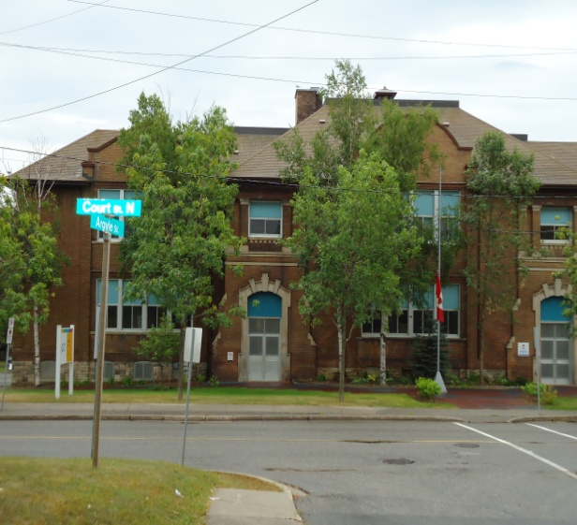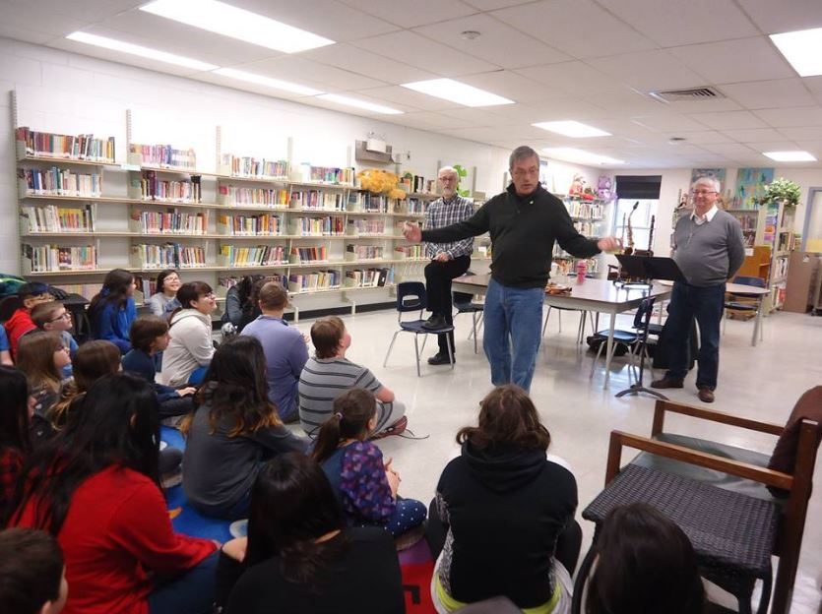

Background
The Rotary-St. James Public School Partnership was initiated during the 2013-14 school year with the official signing of the agreement in January 2014.
St. James Public School has been identified as a high needs elementary school within the Lakehead Public Schools. St. James is a JK-Grade 8 with approximately 200 students. There has been approximately a 50% turnover of students each year during the life of the Partnership.
The school population has a large transitional population as well as frequently receiving children of immigrant families.
Commitment
The Rotary Club of Thunder Bay (Port Arthur) will maintain a Club-School Partnership Committee throughout the duration of the Partnership.
The Club will provide financial support to Partnership activities through its annual budgeting process.
The Club-School Partnership Committee will encourage the participation of club members in school program activities requiring additional community support.
In particular the Club-School Partnership Committee will encourage member support of the school literacy, music and leadership initiatives.

Activities
Over the five years of the Partnership activities have included the provision of adult Readers who listen to, assist, and read with children in the primary grades. Up to a dozen Rotarians and their partners or friends have participated in the Reading program each year. A Reading Helpers Handbook has been developed to assist with new Reader orientation. Leadership development has also been fostered by certain programming offered by Port Arthur Rotary. A Music program is also an integral part of the relationship while a sports program has periodically been offered by Rotarians who have skills in certain areas.

