Field of Greens

Partnership between Port Arthur Rotary Club and the Salvation Army Thunder Bay
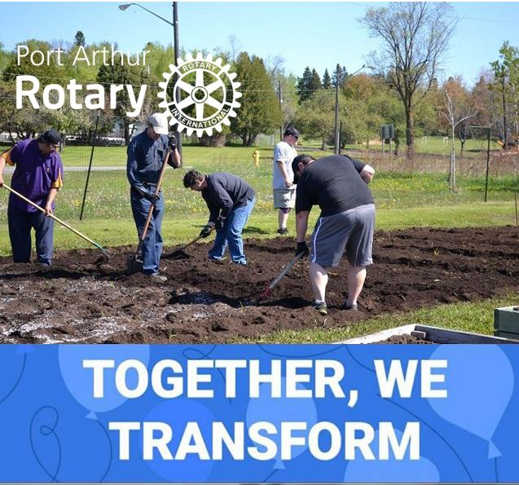
Project Concept: Develop a combination Vegetable Garden-Recreational Area on vacant north side lot of the Salvation Army Men’s Hostel, North Cumberland Street. Rotarians are partnering with the administration and residents of the Salvation Army, community organizations such as the Food Security Research Network, and many local businesses to achieve this goal. As the garden develops, the residents will take over ongoing care and nurturing.
Goals: The veggie garden will supply a large percentage of fresh vegetables for the resident’s immediate use (full service cafeteria and kitchen on site) as well as their own Food Bank. The recreational area (basketball court et al) will provide important exercise opportunities, not otherwise met, for long term residents.
An Opportunity for the Community: We are inviting interested businesses to contribute to the start-up of this project. This can be in the way of in kind donations, services/merchandise at cost, or even human resources. All contributions will be suitably acknowledged.

