Youth Exchange
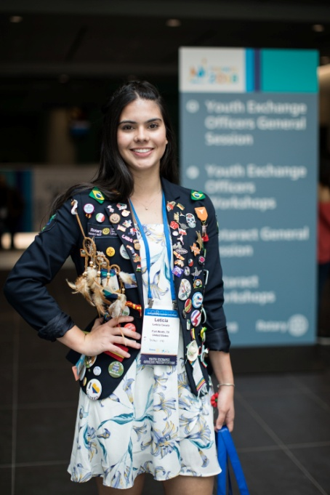
Rotary Youth Exchange is for high school aged students who are interested in living and studying abroad for one year. Its goal is to promote the advancement of international understanding, goodwill and peace at the person to person level. It is an opportunity to learn a new culture and language, to be an ambassador, and to make friends for a lifetime. It's a year of adventure. Our returned students call it "The best year of my life."
It is not a vacation...instead it's a cultural and academic exchange that lasts a full school year (11-12 months.) While in your host country you will attend school, be hosted by families (normally 3-4 ) and be supported in your country by your local Rotary club and Rotary counselor (as well as Rotarians here in Canada.) We exchange with over 40 countries. When applying, you indicate which countries interest you the most--and we attempt to place you in one of them. Unfortunately, due to the nature of our program we cannot guarantee that you will be placed in a specific country.
Rotary Youth Exchange is one of the largest, oldest and most respected Youth Exchange Programs. Key reasons to consider Rotary include:
- Orientation/training process before you leave
- Hosted by a Rotary Club and Host Families
- Activities with Rotary/Rotarians
- Low Cost / Everyone is a volunteer
Our club, through our Rotary District 5580, is a member of the Central States Rotary Youth Exchange (CSRYE) multi-district. We are a group of 17 Rotary Districts, located across North Dakota, Minnesota, Ontario, Wisconsin, Michigan, Illinois and Tennessee. Each year, we are home about 300 Inbound students from around the globe, with the same number Outbound students living abroad. Our club usually sponsors one Outbound student, and receives one Inbound student.

Key Qualifications:
Must be a good student (top half of class)
Between 16 and 18 1/2 years old at the time of departure
Other Important Attributes:
A willingness to learn the language and culture of the country that your are assigned to.
The initiative to get involved in activities in you host country.
Applicants should have pleasant personality and must:
-be able to adjust to a new and different culture/country
-be willing live apart from their families for the year
-be open to new and different experiences.
A member of your family does not need to belong to Rotary for you to be eligible.

How much does it cost?
It varies:
- Airfare depends on country (and is higher than you might expect because of specific ticket requirements)
- Insurance / orientation / blazer
- possibly language school/extra insurance in your host country
- passport and visa
- pins, presents, photos
- spending money / extra trips in your host country/ souvenirs
For most students the cost of the year is between $5,000 - $7,000 CAD although this is very much dependent on your spending habits while on exchange.
This does not include what your parents save while you are gone (food, car insurance, etc.)
Rotary provides:
- host families and school
- monthly allowance
- and often lots of extras...

How do I Apply?
Our Thunder Bay clubs together promote the programme in the local schools during May and June. However, at any time you can find out about Youth Exchange by contacting our Rotary Club's Youth Exchange Officer, TBD visit http://www.csrye.org/. You apply through your local Rotary Club. Application forms are available through that link as well, but check with TBD to ensure that you have downloaded the current one.

Applying
You submit the initial section of the information form by the summer of the year previous to the year you would go (e.g July 2019 for Sept. 2020). Next there is a preliminary interview/orientation process by September. At that point you are, - hopefully! – approved by our club to enter the district application process. At that point you will need to fill out the full application form, which is quite extensive, and have an interview with the district selection committee. (This takes place in the fall, usually in Minnesota.) The interview is not a test or measure of how great a person you are--instead it is meant to ensure that you are an appropriate student for Rotary Youth Exchange--and that Rotary Youth Exchange is an appropriate program for you. A year abroad is a significant commitment and a major challenge--so it very important that both YOU and ROTARY benefit from the experience.

and then what happens...?
After being told you are approved, you wait....Sometime in January you will be informed on your country assignment. After that, you have six or seven months to get yourself ready for the experience!

Being a Host Family:
After successfully completing an application/screening process with the Youth Exchange Officer, as a host family, you agree to accept the exchange student as a new member of your family. The student will be governed not only by the rules of the programme but also by the rules of your household. You are responsible for the safety of the exchange student the same as for your own children. Although you might have a bit more of the soccer mom or dad for normal everyday activities, it is not your responsibility to act as a taxi service of a tour guide. Rotarians for the hosting club will be helping in these areas. Please note: while the Inbound student receives a monthly stipend from the club, the host family does not.

How long would I host a student?
If you volunteer to be a hosting family you can expect a student to live with you for about 3 months, but it varies depending on how many families are involved, when the move date is convenient for the families and the student, holidays, vacations, etc.
Again, for more information, or to talk with former Outbound students, current Inbounders and/or Host Families, contact our Rotary Club's Youth Exchange Officer, TBA We're waiting to hear from you!

