Rotary Highway Cleanup
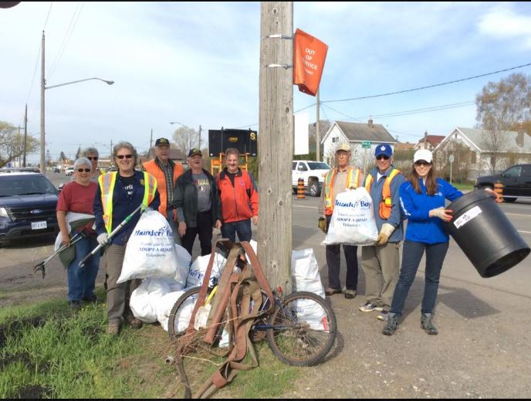
The highway clean-up was started in 1991 and our task was to clean the road right-of way from the intersection of Red River Road to Hodder Avenue. Later we cut the project in half by ending the project at the Balsam Street intersection. This meant the we were still responsible for four kilometres of right-of-way.
Since 2015 we have a new clean-up area. For Thunder Bay Adopt a road we tend to the right-of-way on Cumberland Street from Gibson Avenue to Granville Avenue. We are partners with the Salvation Army in this adventure. Our goal is to do the clean-up twice a year in the spring and fall.

