Bridge
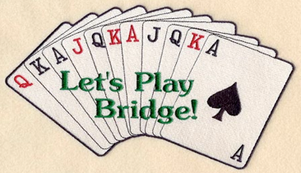
The term “Bridge” has always held a special place in the hearts of Thunder Bay Rotarians. In 1917 it referred to “The Outlaw Bridge of Pigeon River”. A unique bridge joining the United States and Canada in a bond of friendship that continues to this day.
However, today Rotary Bridge in our club refers to a group of Rotarians and spouses who meet on a bi-weekly basis, from October to May, to indulge in the best known card game in North America. The group is open to all Rotarians and/or spouses. This is a contract bridge group who get together for fellowship and, of course, to play their favourite game. Supporting them is a group of 6-8 spares who ensure that the games continue despite holidays and family events.
The Christmas season and year end are special occasions when the whole group gets together at one home for fellowship, food and fun. Of course, year-end means the distribution of prizes for top scores and high scores and bragging rights for the coming year.
For more information contact Joanne Tulloch at 767-3862 or lptulloch@shaw.ca.

