Rotary Shelter House
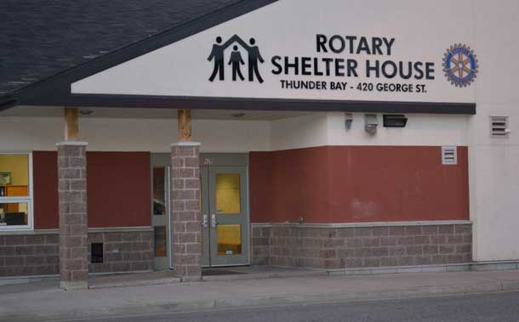
In 2003, Rotary Clubs around the world were putting their minds to an appropriate legacy-style project that would properly mark Rotary International’s one hundredth birthday. Port Arthur Rotary President Seppo Paivalainen surmised that each club standing alone would not be able to deliver lasting legacy projects. He believed that together, Rotarians were capable of creating lasting, meaningful change. He asked that we take a look at the Shelter House as a worthy project.
In a landmark demonstration of unity, the three clubs settled on a $225,000, multi-year capital gift to the city’s shelter house. Port Arthur led the way with the donations to the fund pro-rated against the number of members in each club: Port Arthur, Fort William and Lakehead. Due to the size of the commitment, it led to a very rare instance of funding a project over a multiple year timeframe. Every member of the clubs was afforded the opportunity to voice their concerns and support. The project has grown to be not only a financial commitment of the clubs but is also a focus of ongoing Rotary volunteer activity.
Located in the Fort William or south ward of our community, the new shelter for destitute and homeless individuals offers levels of dignity and safety that would not have been possible in the former derelict building which had housed the service. It is now seen as a positive influence in its downtown home.
Rotary Shelter House Manager, at the time, Cal Rankin gave Rotary a high compliment. He noted that there is always considerable controversy in the building and locating of such facilities. He was delighted to see Rotary play a leading financial role but said it was the credibility and integrity of Rotary that proved so valuable in the development and lobbying required for the new building.

