ShelterBox Canada
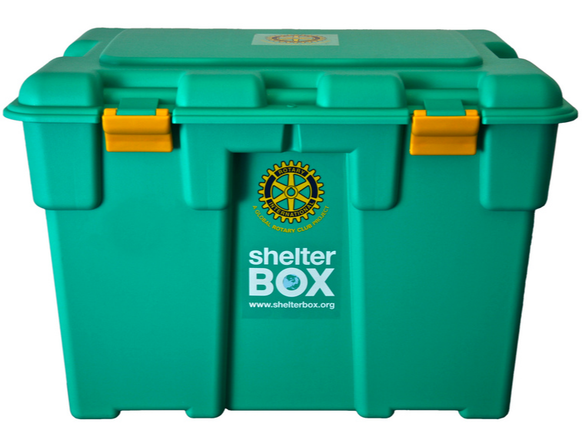
ShelterBox is an international disaster relief charity that delivers emergency shelter, warmth and dignity to victims of disaster worldwide. It was started by Rotarian Tom Henderson of the Helston, Cornwall Rotary club in the UK in 2000 as a millennium club project. There are now 9 international affiliates worldwide including Canada and the USA.
Every $1000 CAD collected provides a tent and shelter for a group of 10 people for up to 6 months. Donations of any size are accepted and can be made online. The website for ShelterBox Canada is: www.shelterboxcanada.org
For more information on ShelterBox, how to get involved with a local fundraiser or if you would like to schedule a presentation to your group please contact our Thunder Bay area ambassadors listed below:
Maria Hudolin 345-3800 nuevo@tbaytel.net
Jackie Dojack 344-3840 jdojack@tbaytel.net

