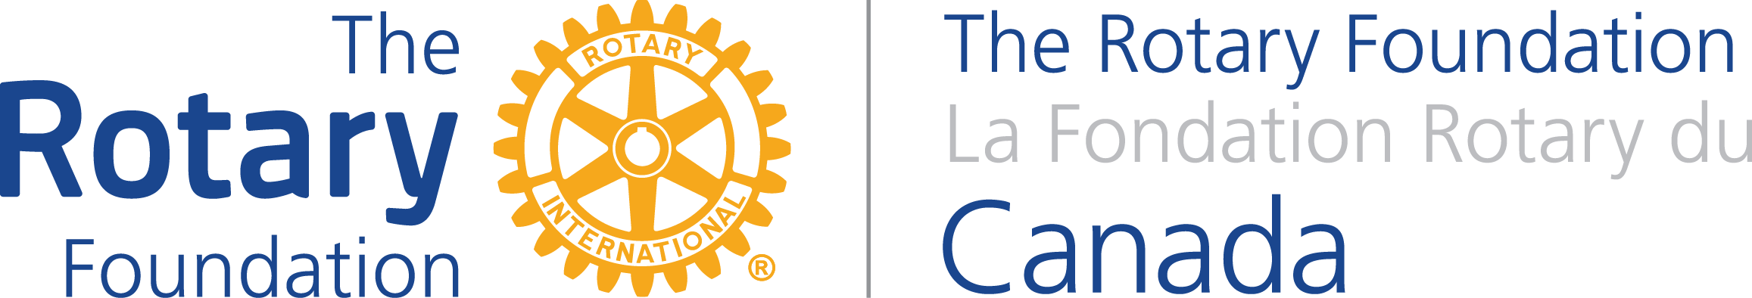

PARTNERSHIP FOR COMMUNITY DEVELOPMENT

INTRODUCTION TO GRANT REQUEST CALCULATOR

To assist Rotary Clubs prepare their pre-qualification application, TRFC has created a handy calculator to help you determine your ask of TRFC and subsequently TRF.

Just plug into the calculator the club funds that will be directed towards the project and the anticipated request for DDF. The calculator will automatically determine the potential grant from the TRFC – Government of Canada (GoC) and the World Fund. It will give you a grand total of the funds potentially available for the project.

The calculator will also determine the amount of the “additional contribution” the Rotary Club would need to forward to TRF relative to the club’s cash contribution. Please note this amount is not included in the grant total of funds available for the project. Also note that TRFC will handle the related “additional contribution” to the eventual GOC funding, so clubs do not need to take that into consideration.

Should you wish to run a different calculation – just change the amount of the club’s and DDF request as appropriate and the calculator will re-calculate the other amounts.

