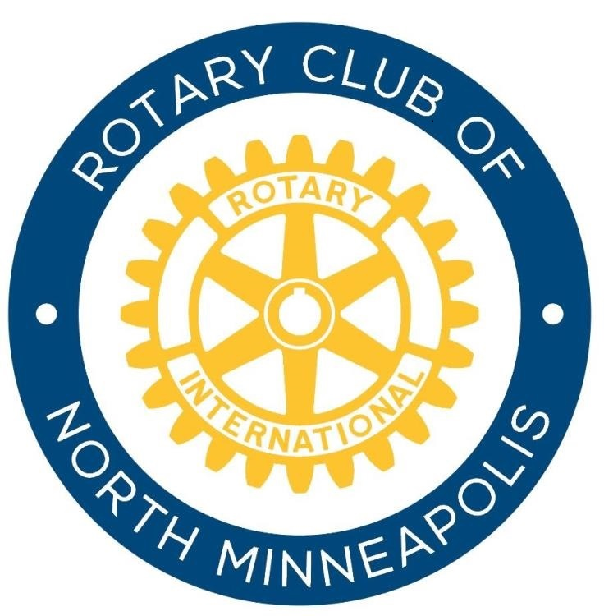

Getting To the HEART of the Matter

A Community Forum organized by the

Rotary Club of North Minneapolis

Goal: To launch a long-term, community-based process of examining and reforming the current criminal justice system to one that brings about community restoration and peace.

Hello Bishop Jenkins,

My name is VJ Smith and I am a member of the Rotary Club of North Minneapolis.

We are 1.2 million neighbors, friends, and community leaders who come together to create positive changes in our community and around the world.

Our mission is to provide service to others, promote integrity, advance understanding and goodwill through our fellowship. We are devoted to Service Above Self, which is our international motto.

Established in 1905, Rotary has been a leader in **peace movements** (advocates for peace in Syria, Iran, America, etc.), **medical advancements** (eradicating polio) and **humanitarian efforts** across the globe (providing water, sanitary items, school buildings, etc.) Our club, the Rotary Club of North Minneapolis, was chartered on November 27, 2012. We are vibrant and thriving with approximately 25 leaders who are committed to serving our North Minneapolis community. As a service organization, we partner with other community members, businesses and organizations to make a difference.

Our Club has chosen to impact our community by concentrating efforts on three major areas of service: Literacy and Education, Maternal and Infant Health, and Peace & Conflict Resolution.

With the recent occurrences of conflicting events involving the criminal justice system and our neighborhood community that are particularly affecting the North Minneapolis Community, our Club is very interested in being a part of the solution. We have decided to facilitate a Peace Forum, Getting To The HEART of The Matter, which will bring key leaders of the community together to launch a Long-term, community-based process of examining and reforming the current criminal justice system to one that brings about community restoration and peace.

# Rotary club of north minneapolis

***Chartered 2012***

HEALTH  PEACE  LITERACY

In order for this process to be successful, we **know** that leaders like you, from key organizations, must be present. In-depth information will be discussed at the pre-forum meeting.

This is a personal invitation to you or a key member of your organization to attend the pre-forum meeting for Getting to the HEART of the Matter on:

Thursday, February 18, 2016

4:00-5:30 p.m.

at

**EMERGE Career and Technology Center**

**1834 Emerson Avenue North**

**2nd floor**

**Minneapolis, MN  55411**

*Refreshment will be served*

During this necessary step we will:

1. Introduce you to the Rotary Club of North Minneapolis.
2. Be introduced to your organization and its mission.
3. Create an agenda for the upcoming Peace Forum, which is scheduled for March 19, 2016
4. Determine anticipated outcome of Peace Forum.

Thank you for your consideration to be a part of the solution with Rotary. Please contact our Peace and Conflict Resolution Committee Chair, Rotarian VJ Smith at (612) 366-0271 or by email at vjsmith@minneapolismaddads.org if you have any questions or to confirm your presence at this meeting. We absolutely look forward to working with you!

Sincerely,

Rotarian VJ Smith

Rotary Club of North Minneapolis