Dr. Bhuvan Unhelkar (Ph.D., M.Sc., MBA, BE)

(IT/Management Consultant, Fellow of the Australian Computer Society; Associate Professor of Information Technology)

Phone: +61-413-821-454; Email. Bhuvan.unhelkar@gmail.com; bhuvan@methodscience.com

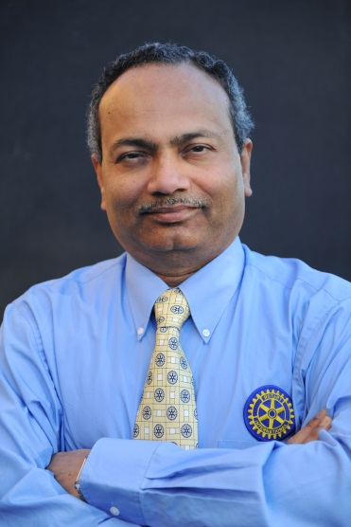
On Rotary front:
Rotarian PP, PHF (Sapphire), AG, Bhuvan Unhelkar was elected on 11th December 2002 to the membership of Rotary club of St. Ives, Sydney, Australia (Zone: 8; District: 9685 Club Number: 18041). On his move from Sydney to Sarasota, Florida (USA), he transferred his membership to Rotary Club of Sarasota Sunrise (Area 9; District: 6960). His Rotary classification is Software Engineering/Professor. He was twice Assistant Governor (AG) for the City North Zone (in Sydney) with the newly formed District #9685 (2013-14 and 2014-15). While he held Community Services and Vocational Services chairs in his club in early years of Rotary, Bhuvan won the club Oscar as Membership chair in 2009-10 for working to invite 5 new members to the club during that year. This was followed by the enjoyable role as President of St. Ives Rotary club in 2011-12 (when Kalyan Banerjee was RI president) – and before that for most part of the previous year as Acting President (as the then president was incapacitated due to injury). In the acting president capacity, I was involved in organizing the District Conference in Canberra and had the honor of toasting RI for the first evening in Parliament house dinner (this was when St. Ives had DG George Papallo). Under Bhuvan’s leadership the club was selected as one of 200 worldwide to experiment with “Innovative and Flexibility” initiatives. These initiatives were taken up wholeheartedly by the club and included recording (with permission) the guest speaker and putting the speech on Youtube, electronic (SurveyMonkey-based) voting by the board and members on various issues and trying out different meeting times (e.g. early morning breakfast meeting instead of the regular evening dinner) and application of OH&S principles (e.g. creating dinner tags to prevent tilting of chairs and tripping of members) – to name but a few. For the RI convention in Sydney (1-4 June, 2014), Bhuvan is invited by RI President Ron D. Burton to deliver a ‘reading’ representing the Hindu faith at the Interfaith Service. Bhuvan is an avid Rotarian and is extremely proud of his membership. He is actively involved in various Rotary projects of Sunrise club in Florida. He also participated in the DGE home hosting program of Rotary club of Bayside and hosted DGE Dr. Pramod and Dr. Premlata Kumars at his home for a week (Jan’2016). He is particularly fascinated by Rotary’s global nature that facilitates friendships across the globe as work travels take him in many countries/regions.
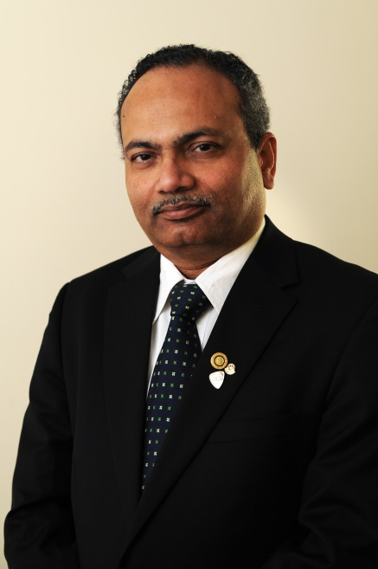
On professional front:
Dr. Bhuvan Unhelkar (BE, MDBA, MSc, PhD; FACS, CBAP®) is an Associate Professor of Information Technology at the University of South Florida (Sarasota-Manatee) campus, where he leads the IT program. He also has more than two decades of strategic as well as hands-on experience in the Information and Communication Technologies (ICT) industry. As a Founder and Consultant at MethodScience he has developed mastery in many ICT disciplines including Agile methods, Mobile business and Green IT/Sustainability. Bhuvan is thought-leader and has authored 17 books and many executive reports (published by Cutter out of Boston, USA). He is winner of the Computerworld Object Developer Award (1995), Consensus IT professional award (2006) and IT writer award (2010). His Doctorate is in the area of “object orientation” from the University of Technology, Sydney (UTS), in 1997 – supervised by Prof. Brian Henderson-Sellers. He was also an academic (and later adjunct) at the Western Sydney University and UTS and has supervised 7 successful PhDs. Bhuvan is an engaging and sought-after speaker, a Fellow of the Australian Computer Society (FACS), Life member of Computer Society of India, Life member of Baroda Management Association, Certified Business Analysis Professional (CBAP), Volunteer at New South Wales parks and wildlife (since 2006), and a previous TiE (The Indus Entrepreneur) Mentor.
On personal front:
While Bhuvan has lived in in Wahroonga (a Sydney suburb) with his wife Asha for almost 3 decades, he has now moved to the beautiful beachside town of Sarasota, Florida, USA. His daughter Sonki (past RYLArian) is a medical doctor (MBBA) from the University of Wollongong; and his son Keshav (past MUNA + 4way Test participant) is completing at the University of NSW his studies in Criminology and Law. Personal interests include Classical Indian music (listening and singing), writing and reciting Poetry, reading, cooking (vegetarian curries), photography and Meditation (particularly from a global peace perspective).

Bhuvan and Asha invited Rotarians from India (Vadodara, Indore, Chennai and other cities) and Malaysia (Kuala Lumpur) for the RI convention in Sydney;

Bhuvan doing the Rotary Bridge climb to promote the event globally (particularly India)

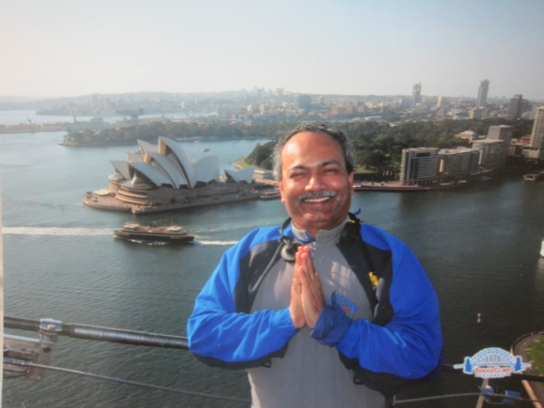

Zone: 8 ; District: 9685 Club Number: 18041

