RUTH WEISS
Ruth (Asroff) Weiss was born October 25, 1930, in Philadelphia, PA. She grew up there and graduated from Olney High School. After high school, she was employed in a variety of secretarial positions. She married Newton (Newt) Weiss on January 3, 1954, and moved out of the big city to
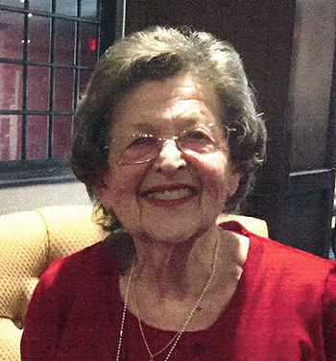

the small town of Paulsboro, NJ. Their first daughter Ellen was born in April of 1955, followed by Susan the very next April, and by Philip five years later. Once the children got a little older, Ruth worked with Newt in their hardware and appliance store for many years until her retirement, doing all the billing and bookkeeping for the store with meticulous detailed handwritten entries. During this time, she was also involved in Hadassah and Sisterhood and ran the gift shop at Beth Israel Synagogue in Woodbury.

Ruth enjoyed traveling with Newt on GE-sponsored trips to places all over the world. She also enjoyed the Jersey shore, and the family had a long-time membership at the Gibbstown Swim Club. After her grandchildren Neal, Stephen, Sarah, and Michael were born, she loved hosting big family gatherings at her home, with zucchini casserole, homemade cranberry sauce, and other delicacies among her specialties. It could be difficult at times to get her out of the kitchen to sit down at the table to eat with everyone else, and then to get her out of the kitchen again from cleaning up. She was a voracious reader of fiction and kept an extensive book collection at her home. She also liked to do the cryptograms and other puzzles from the newspaper. In later years, when Newt became active with the other survivors of the 106th Infantry Division who fought in the Battle of the Bulge in 1944 and 1945, Ruth enjoyed traveling around the country to attend the association’s annual reunions. After Newt passed away in 2018, she kept busy at Brandywine Living at Voorhees with exercise classes, movies, bingo, discussions of current events, and religious services.

Ruth Weiss was never Ruth Weiss’ first priority. She was devoted to her husband, her immediate and extended family, the hardware store, her synagogue, and the towns of Paulsboro and Gibbstown. She will be missed terribly by all who knew her. The family is grateful for all those who helped her and made her comfortable during her last few months.

Contributions can be made to the Paulsboro Pegasus Education Foundation, www.paulsboro.k12.nj.us or Cong. Bnai Tikvah Beth Israel, www.cbtbi.org

.

